Hi Marley Accelerator for ClaimCenter 9.0.2
Reference Implementation
A Detailed Design Document
Table of Contents
What is included in this accelerator 3
Who should read this document 4
What is not included in this reference implementation 4
Terms of Use 5
Further Assistance 5
Functional Design 6
Functional Overview 6
Open Case in Hi Marley once claim is created with enroll in Hi Marley texting in ClaimCenter 6
Ad Hoc Case Transcript Download 15
Receive Updates from Hi Marley 17
Sending SMS as "Super User" will throw an "unknown" does not exist error (new) 19
Disable Hi Marley Messages in Claim notes. 21
Hi Marley Permissions 21
Parties Involved - Contacts - Hi Marley Cases card 30
Case synchronization 31
Technical Design 33
Open Case in Hi Marley 33
Case Close/Open status update from Hi Marley to ClaimCenter 35
Opt-In/Opt-Out status update from Hi Marley to ClaimCenter 36
SMS Message update from Hi Marley to ClaimCenter 37
Hi Marley Note update from Hi Marley to ClaimCenter 38
Update Claim transcript information to Hi Marley 39
Claim updates to Hi Marley 40
Send Claim Closure updates to Hi Marley 41
Automatic Resend Welcome Message to Hi Marley 42
View Hi Marley Case transcript document in ClaimCenter 43
Parties Involved - Contacts - Hi Marley Cases card 43
Case synchronization 43
Integration Components 45
Messaging 45
Hi Marley Outbound Integration 45
Hi Marley Inbound Integration 45
Hi Marley Batch Process Integration 45
Data Model Extensions 45
Entity Modifications 45
Typelist Modifications 45
User Interface Modifications 46
Entry/Exit Points 46
Claim Screens 46
Deployment 47
ClaimCenter 47
config 47
gsrc 50
Running this Reference Implementation 53
Known Issues 55
About Guidewire Software 56

Overview
Hi Marley accelerator for ClaimCenter will establish a baseline of packaged and deployable code for insurance carriers utilizing Guidewire ClaimCenter 9.0.10 and Hi Marley application. Carriers will have the ability to customize and configure ClaimCenter for Hi Marley API services using this accelerator.
The accelerator allows providers to quickly integrate their Guidewire ClaimCenter with Hi Marley, enabling operators (adjusters/underwriters/customer service reps/etc.) to seamlessly include communication via Hi Marley into their everyday life. There are many APIs built to help with this process and minimize any manual work for operators.
The accelerator will function with the out-of-the-box version of ClaimCenter. Included will be Entity Extensions, Web Services, Exception Handling and Validation Rules supporting processes for below use cases.

Open Case in Hi Marley once claim is created with enroll in Hi Marley texting in ClaimCenter
Opt-In/Opt-Out status update from Hi Marley to ClaimCenter
Claim updates to Hi Marley when key fields are changed/updated in ClaimCenter Operator, Adjuster email, Phone number, Privacy)
Reopen/close update to Hi Marley
Display Hi Marley details section and navigate to Hi Marley application’s text screen for specific case from ClaimCenter
Send/Receive SMS messages from ClaimCenter
Instant download of SMS transcript from Hi Marley within ClaimCenter

What is included in this accelerator
Following lists the aspects of the solution that will be included in the accelerator:
Hi Marley Case Creation for claim participant
- One claim can have multiple Hi Marley cases (one per claim participant)
Reassign Hi Marley case(s) when claim owner changes
Change Hi Marley case(s) when claim action is taken
- Hi Marley case(s) closed when claim is closed
Synchronize data from Hi Marley to Claims Center
- New Messages
- Download PDF Transcript on case closure or on-demand
- Download multimedia files such as images and videos.
- Opt-status of claim participant
- Hi Marley Case Notes
Send SMS Messages via Claims Center (template messages or new messages)
Claims Center admin can configure accelerator in Claims Center
- Enable/Disable functionality
  - Disable files download into claim
  - Disable Case Transcript download button
    - Disable Case Visibility Settings
      - disables all features for setting case to public or private
      - all cases are public
    - Disable Case Notes integration
    - Disable Automatic Operator Creation
    - Disable Send Message on Claim
  - Add new SMS template from Hi Marley to Claims Center
- Limit Hi Marley functionality based on Claims Center permissions
  - New permissions created for Hi Marley operations
  - New permissions can be added to new/existing ClaimCenter roles

Who should read this document
- Carrier Business Sponsors
- Carrier Technical Sponsors
- Carrier ClaimCenter Developers
- Carrier IT Architects

What is not included in this reference implementation
- Business specific configurations / configurations for custom ClaimCenter implementations
- Hi Marley’s native user application
Note that for Guidewire’s functional review, all non-functional requirement (NFR) testing such as Performance, Security, Reliability, Usability etc. is out of scope.

Applicable Product Versions
This accelerator has been developed to work with Guidewire ClaimCenter version 9.0.10. It has been tested on version 9.0.10 and should work with all minor versions of Version 9 with minimum changes. As currently designed, this version of accelerator will not work with ClaimCenter version 8 or version 10.

Terms of Use
We have made this document and accompanying accelerator files available to you as we thought that you might find them useful. As such, they are provided to you "as is", which means that we do not offer you any assurances with respect to them. You will be solely responsible for any changes made to your configuration as a result of you downloading and implementing any of our materials.
You also understand that we own the intellectual property rights to any accelerator documentation/file downloads we make available to you. You must not use them in any way that would adversely affect our rights under applicable law.

Further Assistance
You may wish to make changes to any of the accelerator content provided in this solution. For example, you might want to extend the solution, or to adapt it to suit your unique needs. If during your implementation you require assistance with any of these changes, please contact your Guidewire or partner Implementation Manager to discuss options for consulting assistance.

Functional Design

Functional Overview
Following describes the functional objective of this reference implementation:
- Integrate with Hi Marley APIs & Webhooks to give insurance carriers access to Hi Marley platform via Claims Center v9.
Following are functional features of this accelerator:
- Create case (case/actions/open) for any customer on the claim
- Direct link to the conversation in Hi Marley will be noted on the claim in GW after creating the case
- Reflect opt-in status in GW claims user interface (via Hi Marley’s opt in web hook)
- Assign/reassign operator in Hi Marley based on actions in GW
- Close case in Hi Marley on claim closure
- Ability to show all Hi Marley cases in a tabular format with columns including Name, Claim Number, Consent Status, Case Status, Case Privacy
- Redirect to Hi Marley webapp via link URL
- Feature flags – certain integrations/functions that can be enabled/disabled based on carrier preference
- Ability to create message Templates as an Admin
- Live updates of SMS messages into the claim notes (enablement based on webhook subscription)
- Live update of Hi Marley Case Notes into ClaimsCenter in claim notes
- Download Case Transcript and storing into Claims File
- Download Hi Marley Transcript at any time within ClaimCenter
- Close all related cases upon claim closure
- Reopen all related cases upon claim reopen
- Option to change Hi Marley case visibility to either ‘Private’ or ‘Public’
- User experiences changes (“UX Changes”) in reference implementation
  - New Reference Graphic User Interface
  - New Administration Entries

Open Case in Hi Marley once claim is created with enroll in Hi Marley texting in ClaimCenter

Create Hi Marley Claims Case from FNOL Wizard
- During FNOL save and Assign user has the option to enroll in Hi Marley texting. Upon selecting that option and completing FNOL, Claim is created. A work item is created for Hi Marley case creation and the information is asynchronously sent to Hi Marley. The work queue processes the work item and once complete, a case is created in Hi Marley and in ClaimCenter.

- Click on Hi Marley Case in the Navigational Bar on the left of main Claim screen, the case summary screen will appear. Two links created, one for viewing case detail within ClaimCenter, the other for go to Hi Marley web application
- When open the Hi Marley Case Details screen, the case initially shown as Requested status. At this status, ClaimCenter user will not be able to do certain functions such as “Opt Out”, “Send SMS”, “Re-Open Case”, etc.

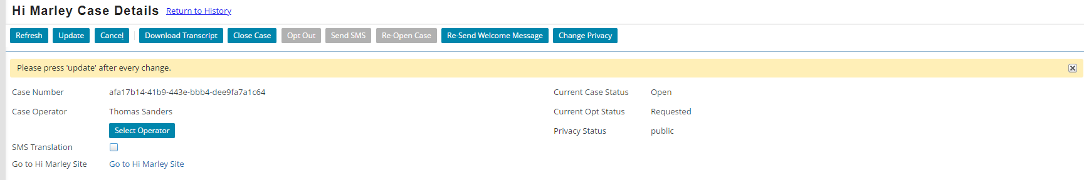

Create Hi Marley Claims Case for any customer on existing open claim
- In Hi Marley Cases summary screen, click on the “Open Case” button will open the screen to open a new Hi Marley Case in existing claim.
Fill out the form and click on “Create New Case”, it will attempt to open a new case in Hi Marley.
Note: This operation could fail if:
  - Then phone is not a mobile number
  - The mobile has more than allowed limit of open cases in Hi Marley (across different claims)
  - Customer was opt out from other claims
Check log for error detail, if the operation fails

Re-send Welcome Message to Customer
- Hi Marley, sends welcome text to the end user via SMS when case initiated. If required, user can also re-send the Welcome Message to Customer by clicking on the “Re-Send Welcome Message” button
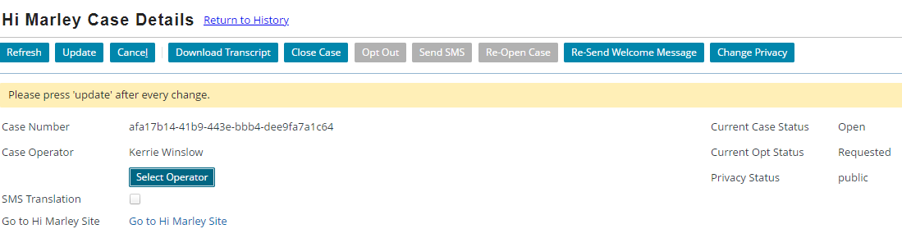
After clicking the button, Hi Marley will resend Welcome Message as shown below in Hi Marley web application:
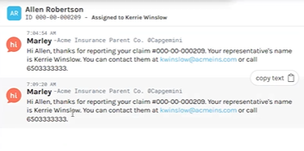
Reflect opt-status of each customer
- Hi Marley sends customer response as Opt-In status to ClaimCenter.
When customers text “Start” and then “Yes” from their phone, Hi Marley in turn sends Opt-in Status to ClaimCenter and ClaimCenter updates the Opt status.
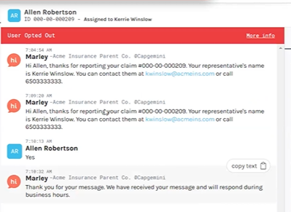
Following screenshot displays the current opt status of all cases, still in Requested status.
Once the customer has opted in, if ClaimCenter does not automatically refresh the status, selecting the “Refresh” button will update the case to show “opt-in”.
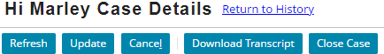

- Hi Marley, sends customer response as Opt-out status to ClaimCenter. (Opt out from phone)
When customers text “Stop”, the Hi Marley then sends the opt Out Status to ClaimCenter and ClaimCenter updates it as seen in the screenshot below.
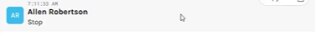

Following screen shows the case in Opt-out status:
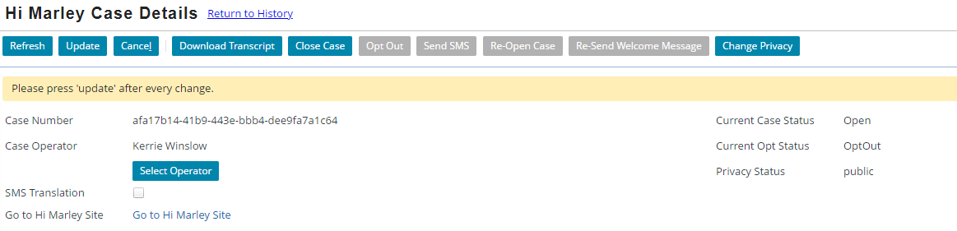
If status is not immediately updated, once the refresh button has been selected, the opt status is updated accordingly.

Sending free text SMS and Sending SMS with templated message
- Send free text SMS from ClaimCenter
To send an SMS from ClaimCenter, in free text mode, the operator can type a text and hit the send button.
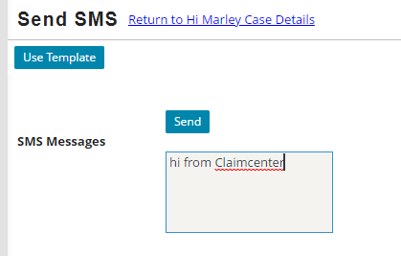
Hi Marley web application also shows this SMS transaction: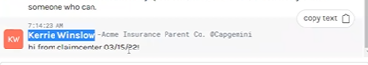
- Send SMS using Templates
The second way to send an SMS is by selecting a template as seen in the screenshots below.
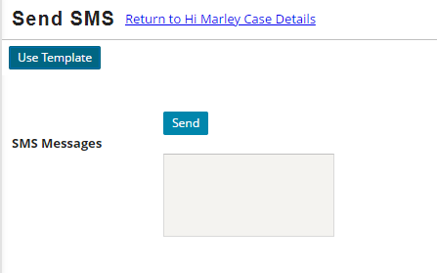
Click on “Use Template”, it will open the “Find SMS Template” screen.
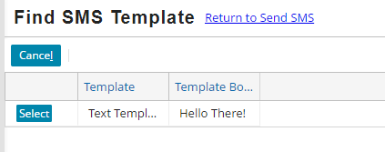
To use any of these templates, click the select button. The text box will be prefilled with the selected SMS template. In this example, the first SMS template has been selected.
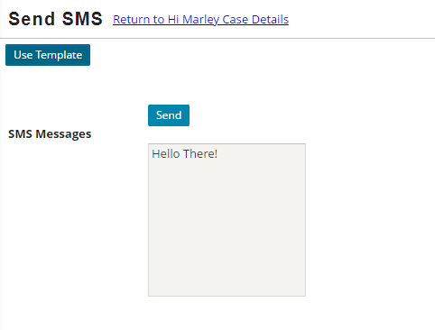

Once sent, Hi Marley will show the SMS with predefined content based on the template.
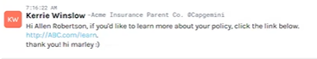

- Receiving SMS in ClaimCenter
All SMS messages received in ClaimCenter will be shown as Notes in ClaimCenter. Notes will be added to the Case level as below:
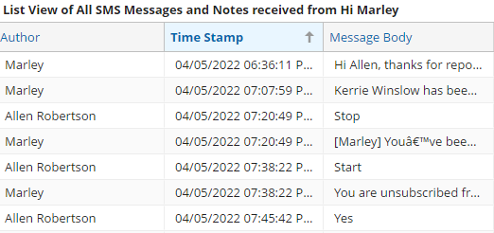

Hi Marley Language translation feature
- Hi Marely supports auto translation of following languages:
Language | Shorthand – language Preference value
English (Default) | en
Spanish | es
Russian | ru
Simplified Chinese | zh
Korean | ko
Portuguese | pt
German | de
Urdu | ur
Arabic | ar
Polish | pl
French | fr
Bosnian | bs
Haitian | ht
Hindi | hi
Japanese | ja
Somali | so
Thai | th

English is the default preferred language. The preferred language can be changed by clicking the dropdown button and the other language options will be displayed.

Selecting Language Preference:
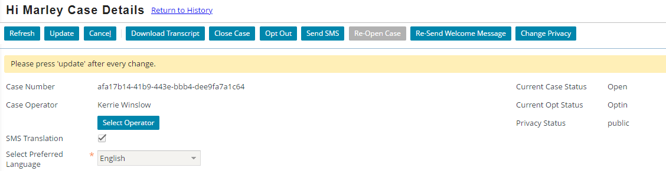

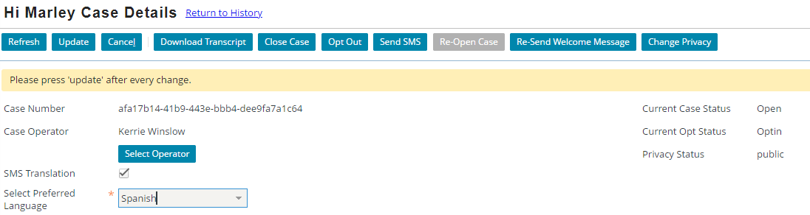

Once a language has been selected, the translation in Hi Marley will be displayed as seen in the screenshot below.
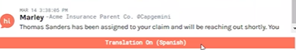

Text in English will change to Spanish on Customer’s phone.
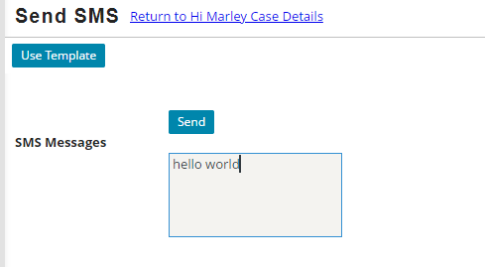
The auto translation here is the result of the Spanish selection for preferred language.
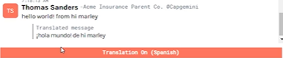

Close Hi Marley Cases
- Closing Cases individually by selecting “Close Case” button:
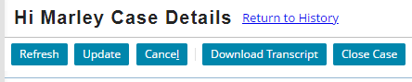

Selecting the close case button will close the case. Case 000103 is the case that will be closed in this example.
The case status now shows case 000103 as now closed.

- Closing a claim to all open Cases
To close a claim on open cases, select the workplan tab

Make sure complete/skip all open items
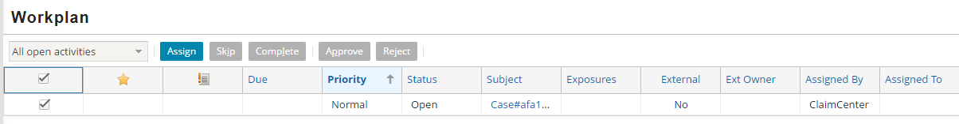
Close Claim, and all Hi Marley cases should be closed in ClaimCenter and Hi Marley
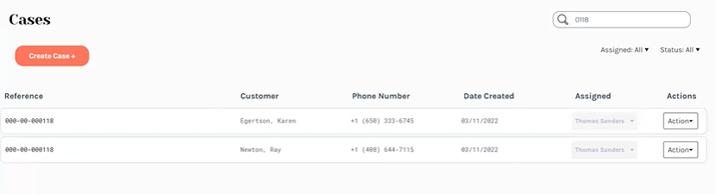
Note: Open/Close a claim does NOT affect the Opt status since it is associated at phone number level could across multiple claims.

Re-Open Hi Marley Cases
- Reopen Cases individually
To re-open the case, select the “Re-Open Case” button.
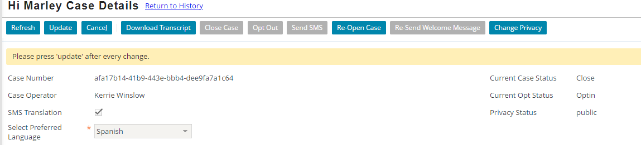
The case status is now showing as opened.
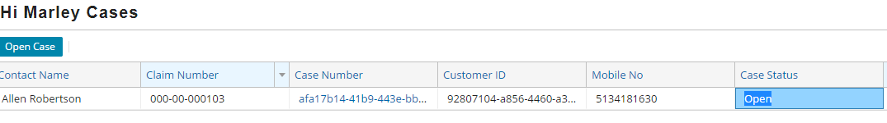

- Reopening a claim to reopen cases
Select a closed claim, and clicking the “Reopen Claim” button will reopen the claim.
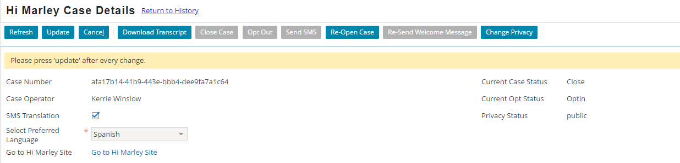
After claim is reopened, all closed cases in the claim should be reopened as well.
Hi Marley should also reflect on this change.
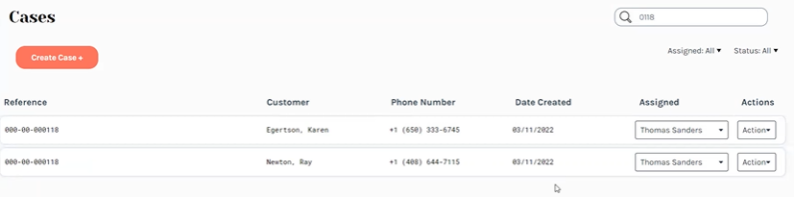

Ad Hoc Case Transcript Download
- Downloading Transcripts
On Hi Marley Case Details screen, click on “Download Transcript” button
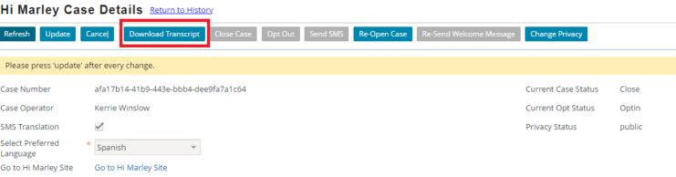

If download is successful, a Confirmation Screen will appear as below:
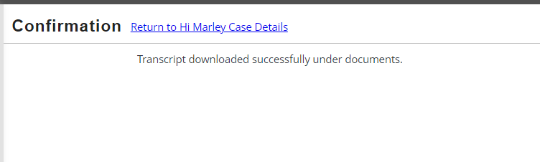
Newly downloaded transcript will be attached as Claim Level document. To view downloaded transcript, go to “Document” section of the claim by clicking on “Document” in the Navigational bar in the main claim screen.

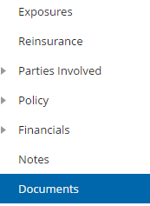
The transcript that is downloaded will be attached inside the document section:
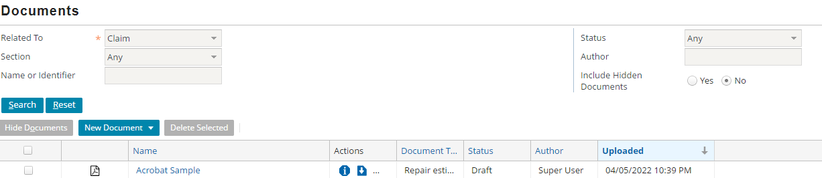

Sample transcript will be a PDF file similar to below:

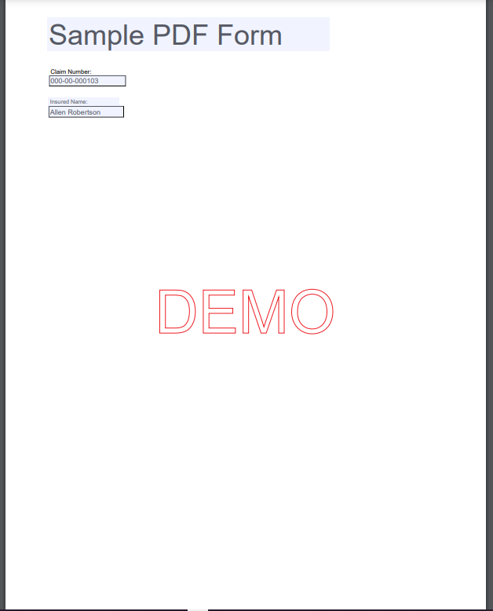
Note: Every Carrier has its own implementation of document management. The transcript downloading approach here is assuming the OOTB document system, which is for reference purposes ONLY. Carrier should implement their own integration for Ad Hoc transcript downloading into their document management system.

Receive Updates from Hi Marley
- ClaimCenter will receive updates from Hi Marley via Webhook. This function requires registration of ClaimCenter’s API/Servlet End Points with Webhook. See technical section for registration details.
- Hi Marley will send SMS messages and Case updates to ClaimCenter. All text based SMS messages and Case updates will be stored as Notes at case level in the claim, as shown below:
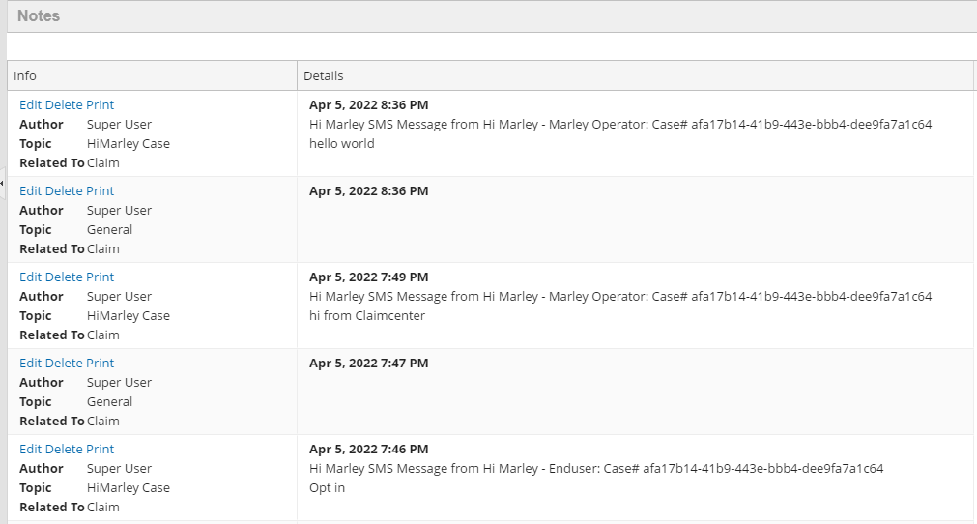
- Multimedia files such as images and videos will be stored as claim level documents and can be found in Document section.
A sample of image file as below:
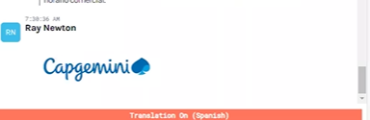

Note: Every Carrier has its own implementation of document management. The multimedia file handling approach here is assuming the OOTB document system, which is for reference purposes ONLY. Carrier should implement their own integration of multimedia files into their document management system.

Change Case Visibility of Hi Marley case
- Changing the privacy of a case.
All Hi Marley Cases defaults to “Public” visibility
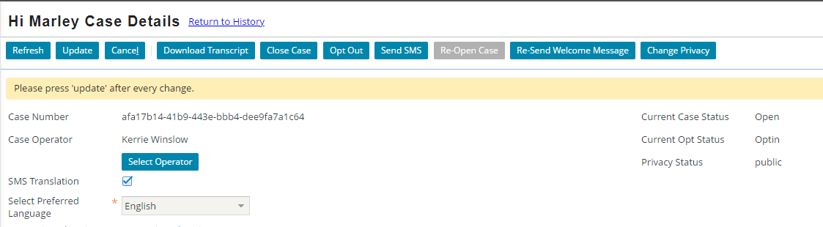
To change Visibility, choose “Change Privacy” button
The privacy status of the case will now be listed as private
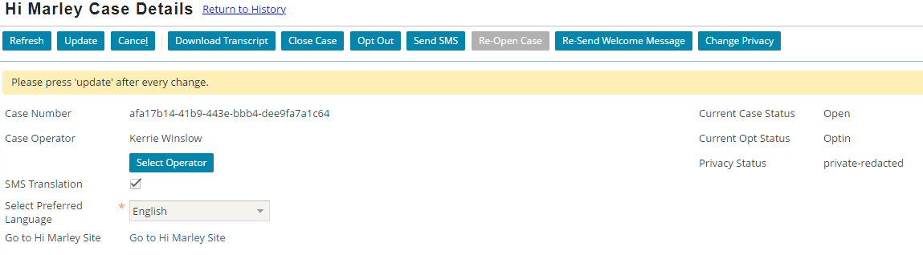
The case detail is only accessible to Super User and Assigned Operator of the Case.

Update operator of Hi Marley case from ClaimCenter
- Change an operator individually
Click on the “Select Operator” button to change the operator
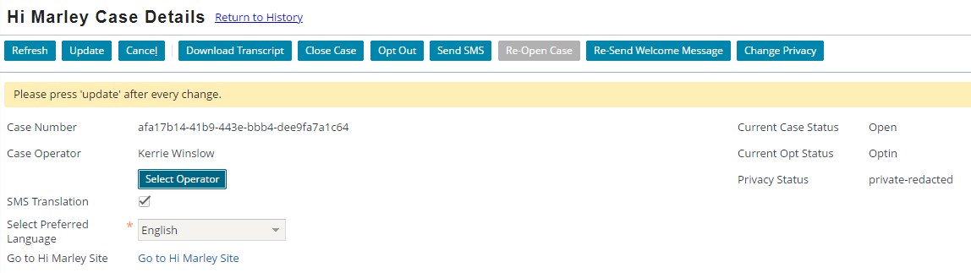

In next screen, choose new operator from the drop down, and click “Change Operator”:
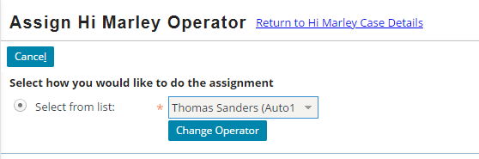

- Operator change during re-assignment of Claim. When re-assign a claim from one Adjuster to a new Adjuster, all Hi Marley cases’ operators will change to the new Adjuster if the original operator of the case was same as the previous adjuster. However, any case with non-adjuster operator should remain the same.

Note: Both operations may take a while for new operator to be reflect on Hi Marley side since if an operator does not exist in Hi Marley before, ClaimCenter will attempt to register the new operator with Hi Marley first. This auto-registration will fail if this option is turned off in Admin tab hence causing the reassignment fail.

Sending SMS as "Super User" will throw an "unknown" does not exist error (new)

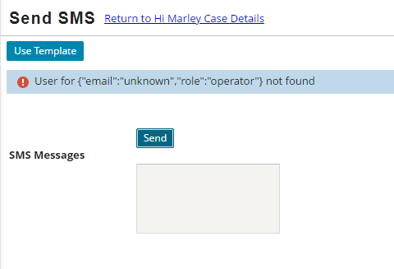
Hi Marley Admin Permissions
- Change system level permissions in the Admin tab.
Following are system level permissions than can be found under the new “Hi Marley Operator” entry under “Administration”
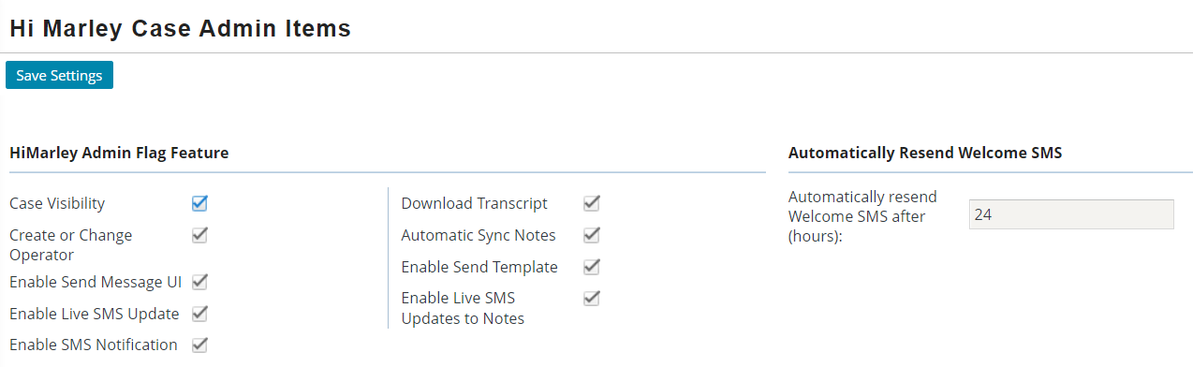
Each system level permission can be turned on/off by checking its checkbox.

Behaviors of these system level permissions are as follows:
Permission | Behavior
Case Visibility | Enable/Disable accessibility of Hi Marley cases
Create or Change Operator | Enable/Disable of change/create a case operator
Enable Send Message UI | Enable/Disable SMS to allow SMS to be sent from ClaimCenter
Enable Live SMS Update | Enable/Disable ClaimCenter receiving SMS messages from Hi Marley via Web Hook
Download Transcript | Enable/Disable Ad Hoc Downloading of Transcript
Automatic Sync Notes | Enable/Disable ClaimCenter receiving Hi Marley case updates
Enable Send Template | Enable/Disable using template for sending SMS from ClaimCenter
Enable Live SMS Updates to Notes | Enable/Disable ClaimCenter updating SMS messages from Hi Marley to Claim Notes
Enable SMS Notification | Enable/Disable ClaimCenter creating Activity as a notification of a new SMS message from Claimant

- Change duration of “Automatically resend Welcome SMS”. This option is default to 24 hours after the first “Welcome SMS” is sent. User can adjuster this number to required duration by business.
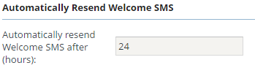
Note: By default, none of the permission is turned on. Please turn on these permissions when enabling Hi Marley in carrier’s implementation after deployment to an environment.

Disable Hi Marley Messages in Claim notes.
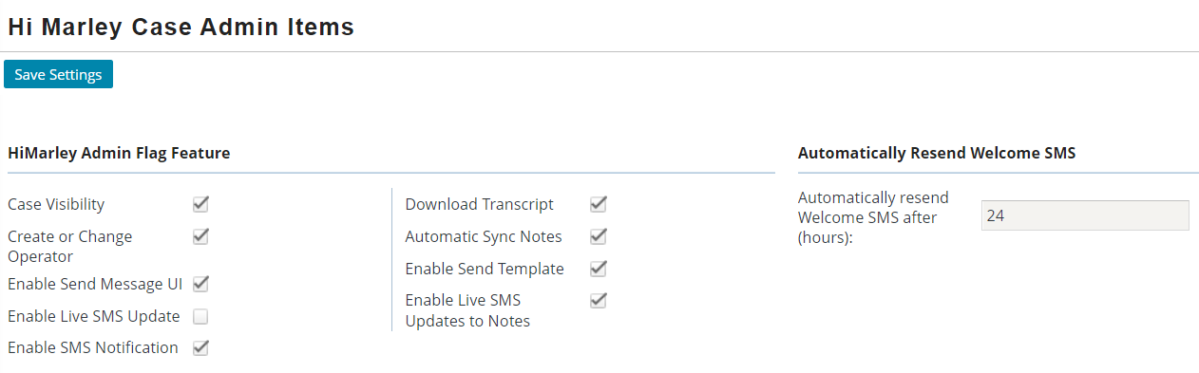
To disable Hi Marley messages in claim notes, uncheck the enable live update flag feature.

Hi Marley Permissions
- Following Hi Marley permissions were created and can be added to any ClaimCenter role:
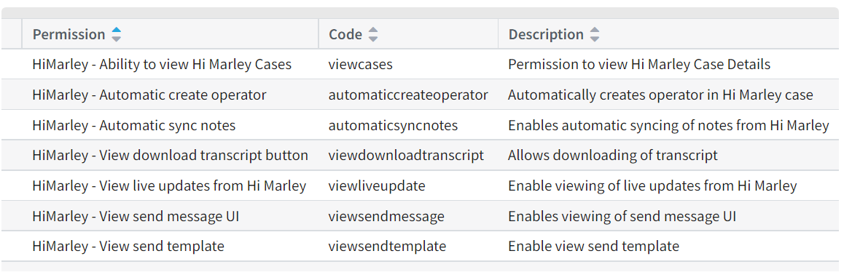
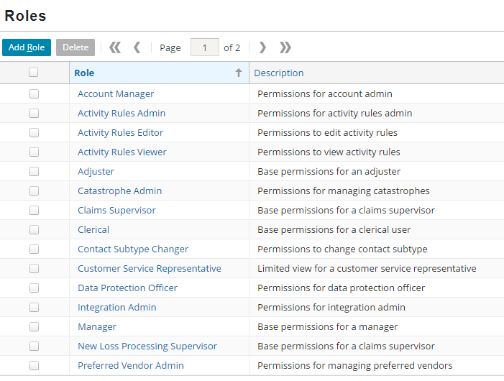

Note: Although these permissions can be added to any ClaimCenter role, in order to show clear responsibility for handling Hi Marley cases, it is recommended that Carrier to create a new “HiMarley Operator” role with these permission added during implementation time.

Administration of SMS Templates
- Add/Remove SMS templates
Select new “Hi Marley Operator” entry under “Administration”, then choose “Hi Marely Case Admin Add/Remove Template” in Navigational bar on the left:

This will show the list of templates that can be used by SMS.

Select existing Template can allow it to be Deleted.

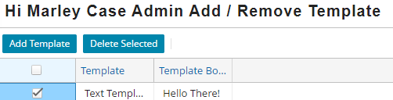

Clicking on “Add Template” will open the “New Template” screen to add new template:

Note: SMS templates use same syntax as ClaimCenter’s “Template” object.
Note: SMS templates can only be added/removed but NOT editable
Administration of SMS Templates
- Add/Remove SMS templates
Select new “Hi Marley Operator” entry under “Administration”, then choose “Hi Marely Case Admin Add/Remove Template” in Navigational bar on the left:
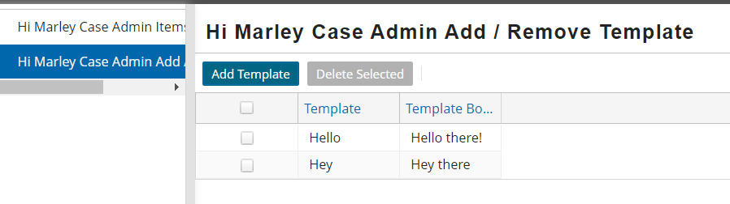

This will show the list of templates that can be used by SMS.

Select existing Template can allow it to be Deleted.
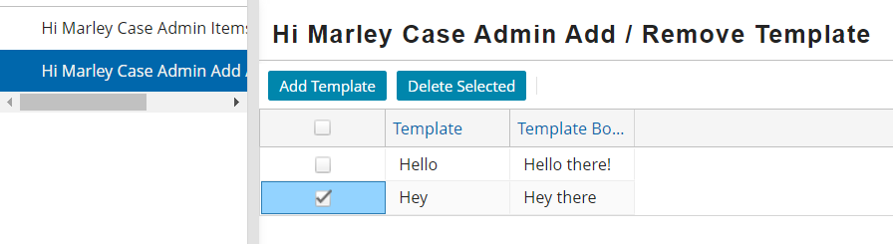

Clicking on “Add Template” will open the “New Template” screen to add new template:
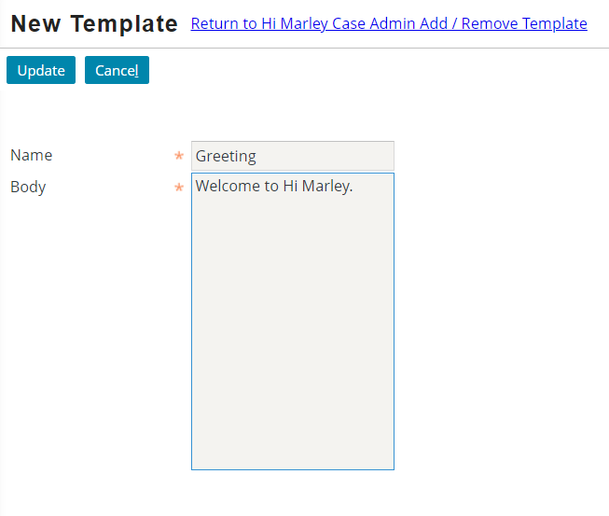

Note: SMS templates use same syntax as ClaimCenter’s “Template” object.
Note: SMS templates can only be added/removed but NOT editable.
ClaimCenter Variables in Message Templates
- Usage of ClaimCenter variables to autofill message templates
Message template will be in this type of format
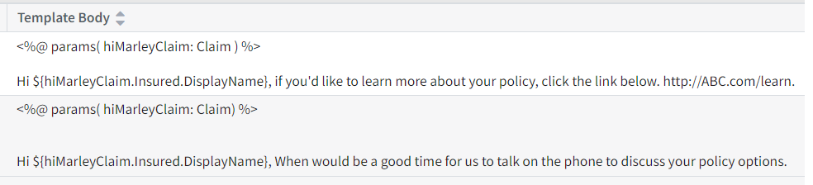
Inside the left and right angle brackets (<%params( )%>), you declare the parameters that the template would use
Ex: <%@params(hiMarleyClaim: Claim)%>
In the next line, you would put the template with the parameter(s) and its associated variables.
Ex: Hi $(hiMarleyClaim.Insured.DisplayName)
This is getting the Display Name of the Insured under the Hi Marley Claim.
Some more examples include hiMarleyClaim.Insured.EmailAddress1.CityStateZip, hiMarleyClaim.Insured.HomePhone, and hiMarleyClaim.Insured.EmailAddress1.
For further reference, request a dictionary zip file from Guidewire for a list of all possible parameters:
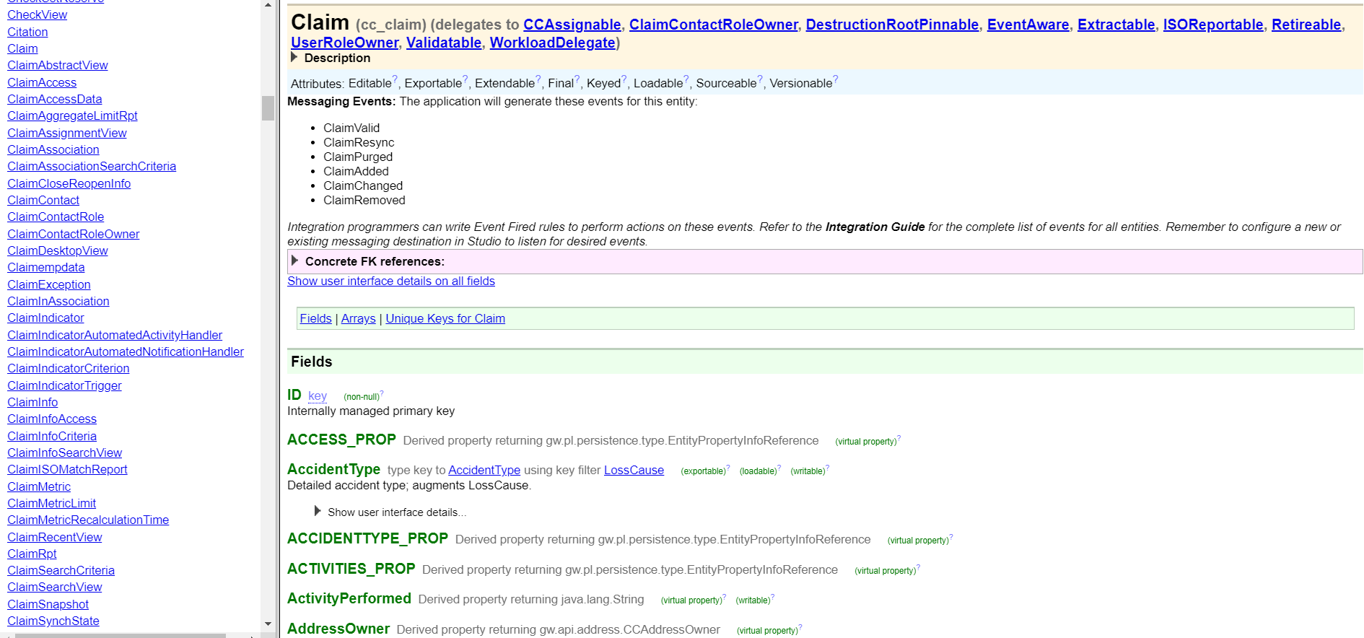
Generated and Disable Activities
- Activities that are generated by accelerator
The accelerator can send SMS, translate SMS through multiple languages, change case privacy, download transcript, close case manually, resend welcome message, set it so it automatically resends welcome message if user is not opted in, and receive SMS, notes, opt status, and claim status through webhooks.

- To disable some of the features, navigate to the Hi Marley Operator page.
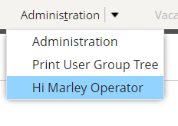
Under “Hi Marley Case Admin Items”, disable and enable the activities you want. To change the auto welcome resend, change the parameter under “Automatically Resend Welcome SMS.”
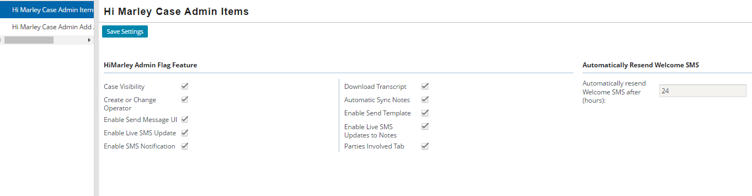

Implement Send SMS API
- Code to implement the Send SMS API call into any ClaimCenter workflows for automated SMS notifications during an event.
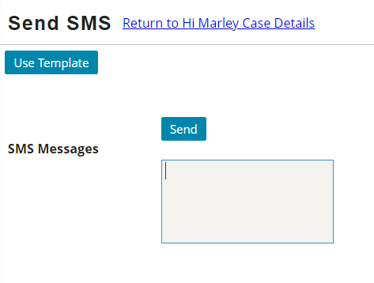
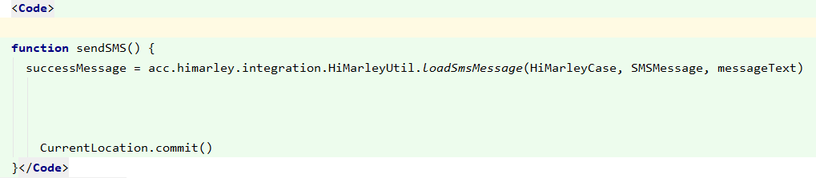
Send button will trigger an activity run the send SMS API.
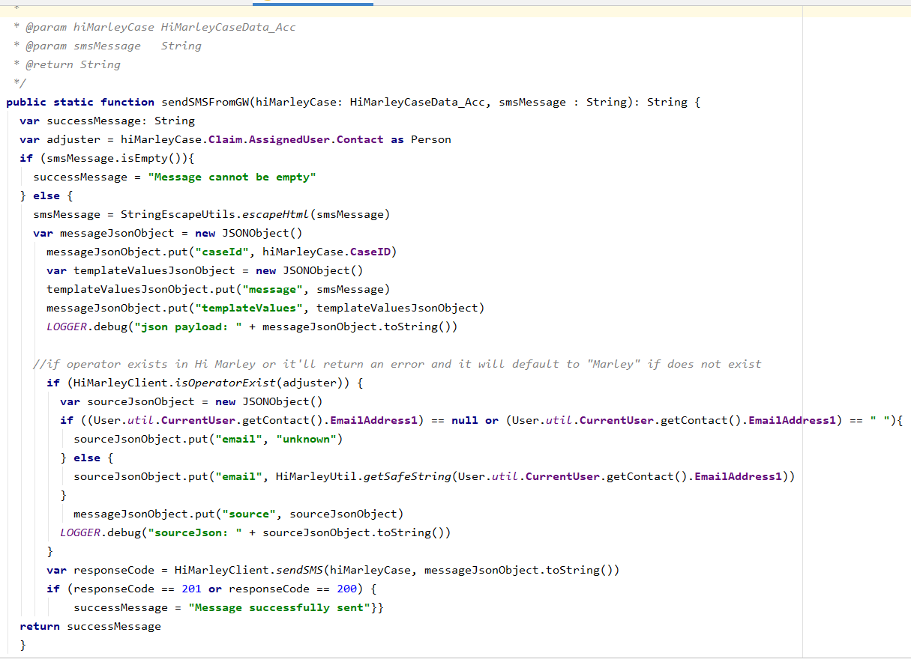
ClaimCenter will check if the user currently logged in exists in Hi Marley before sending the SMS from ClaimCenter. If logged in as “su”/super user, then it will return an “unknown” email does not exist notification.
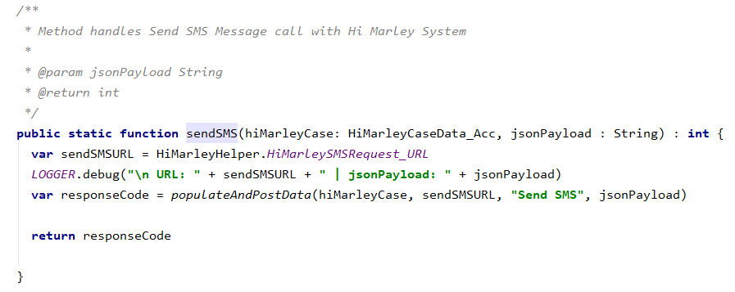
If the email exists within Hi Marley, then the sendSMS function will be called and the send SMS API URL is generated.
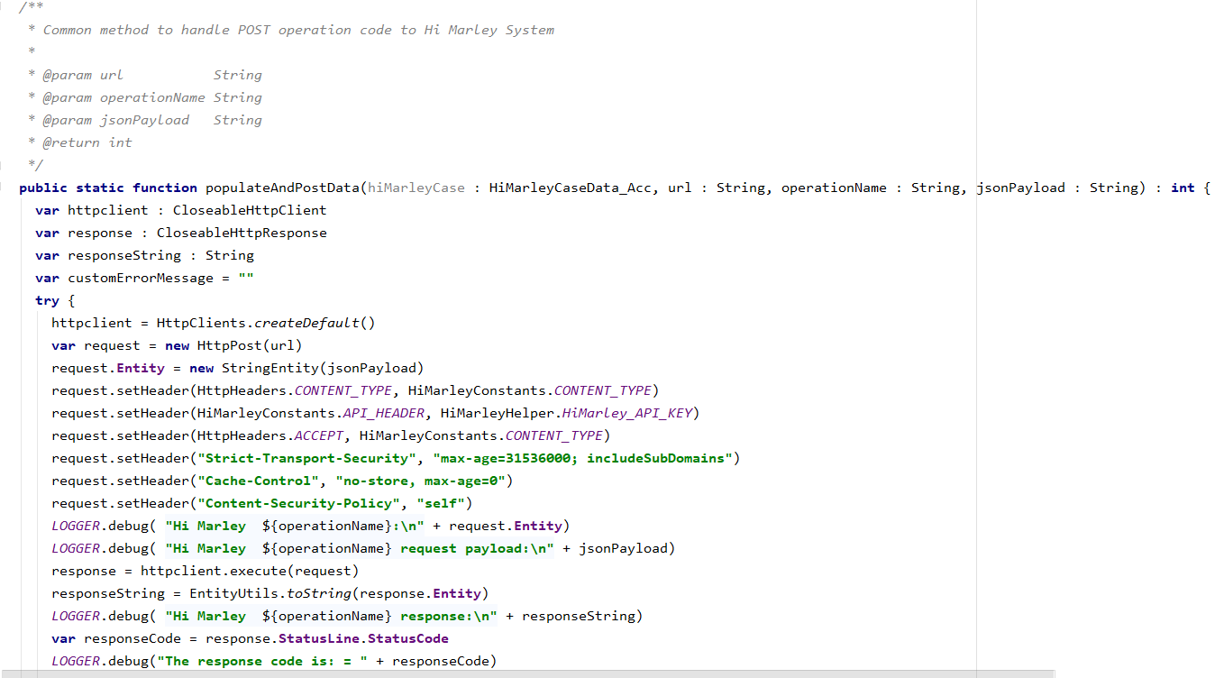
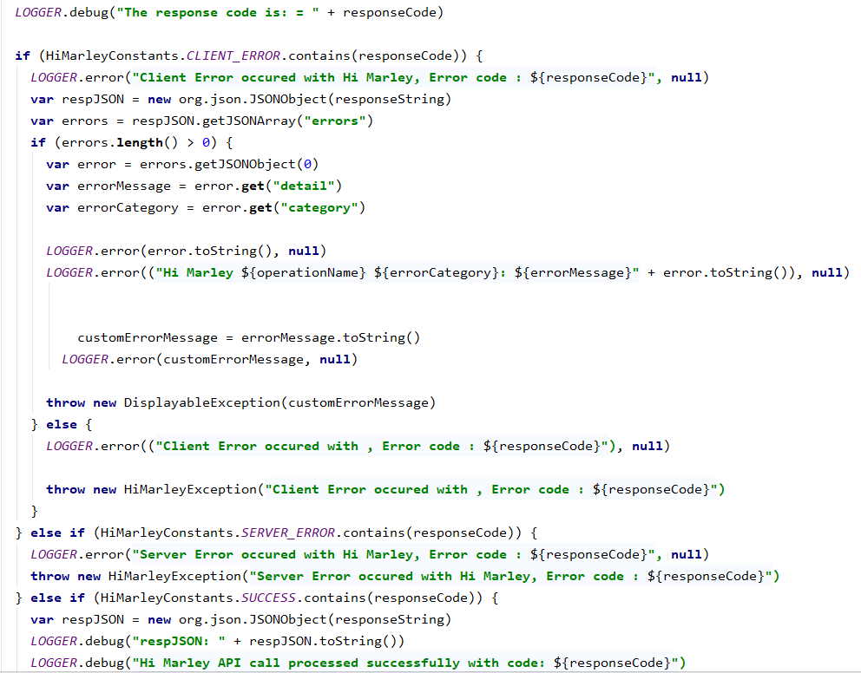
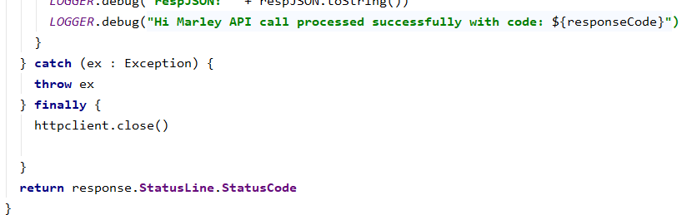
The JSON payload for the API call gets populated and using the generated URL, the SMS message gets posted to Hi Marley using RESTful API.
Error Handling
- Common error handling patterns in accelerator.
All errors will be logged. However, there are some that will show errors in the ClaimCenter UI:
  - Duplicate combination of customer mobile + claim number
  - Reached max open case limit
  - Operator (Hi Marley PrimaryContact) doesn't exist in org
  - Customer mobile is a landline
  - Brand name mismatch
  - Customer is Opted Out
  - Sending SMS as "Super User" will throw an "unknown" does not exist error
  - PrimaryContact doesn't exist in org
Adding new languages
- Adding a new language supported by Hi Marley to the Case Creation and Update APIs.
To add a new language supported by Hi Marley, go to Guidewire Studio and open the file “HiMarleyPrefLanguage_Acc.HiMarley.tti”
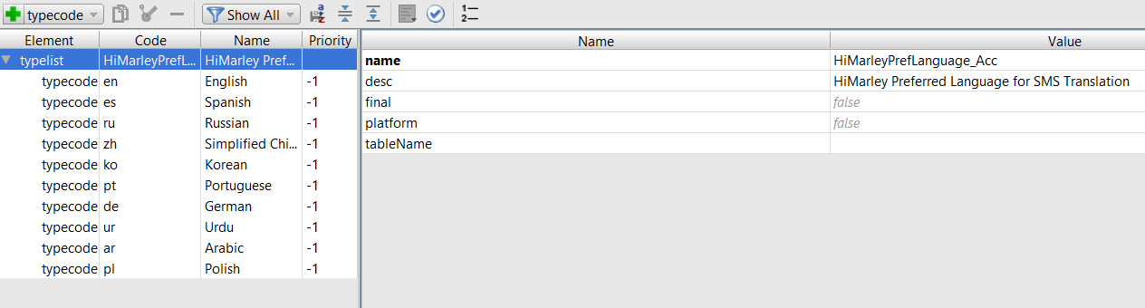

Click on the “+ typecode” button.
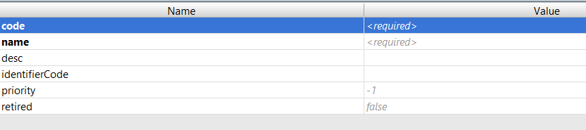
Fill out the following table. Use the existing typecodes as a reference on how to add the new language.
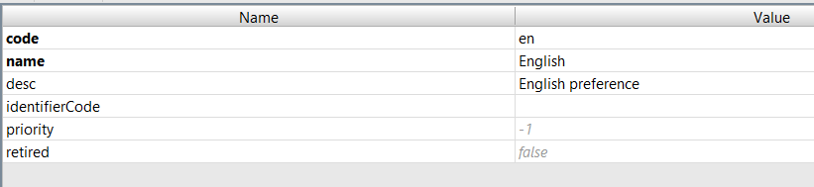

Parties Involved - Contacts - Hi Marley Cases card

On the claim, in the Parties involved - contacts tab, you will find a list of contacts. Each contact has a 'HiMarley Cases' tab. If a case is created for a given contact, it will be visible on the list. Only one case can be created for each contact.

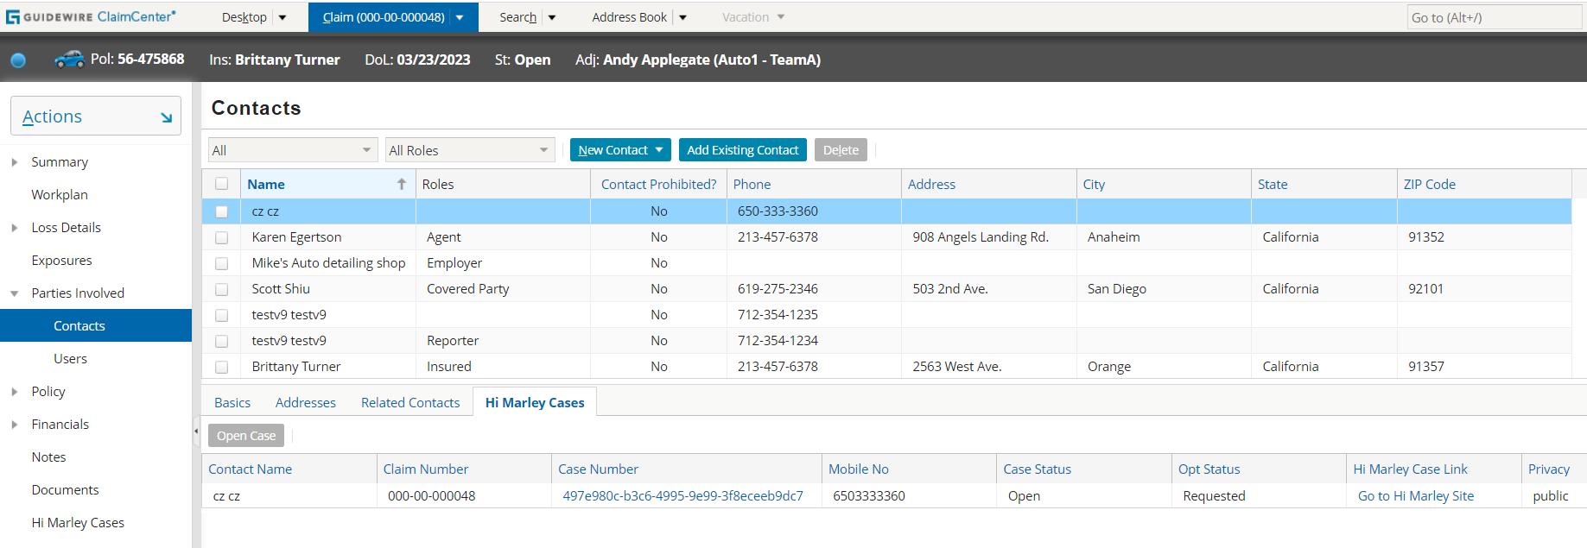

If the contact is not assigned to any case, we can open a new case for this contact. To open a new case, click the ‘Open Case’ button. Then you will be redirected to the new case creation page.

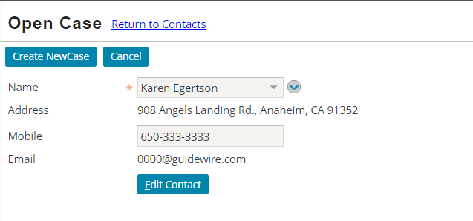

The "Open Case" button will be unavailable if the contact already has a case assigned to it or if the contact is not the "person" type. (screen below)

Case synchronization
On the page ‘Hi Marley Case Details' there is a ‘Refresh’ button which allows the user to synchronize the data from Hi Marley to the Claim Center. Under this button there is a method which sends two requests to Hi Marley. First is responsible for the update of the field ‘Current Opt Status’ in the Claim Center, the second sends the request to check the current status of the case. After clicking on the ‘Refresh’ button, the following data will be updated:
- Case Operator
- Current Opt Status
- Privacy Status
- SMS Translation
- Preferred Language (the field is visible only when the SMS translation is set up to yes)

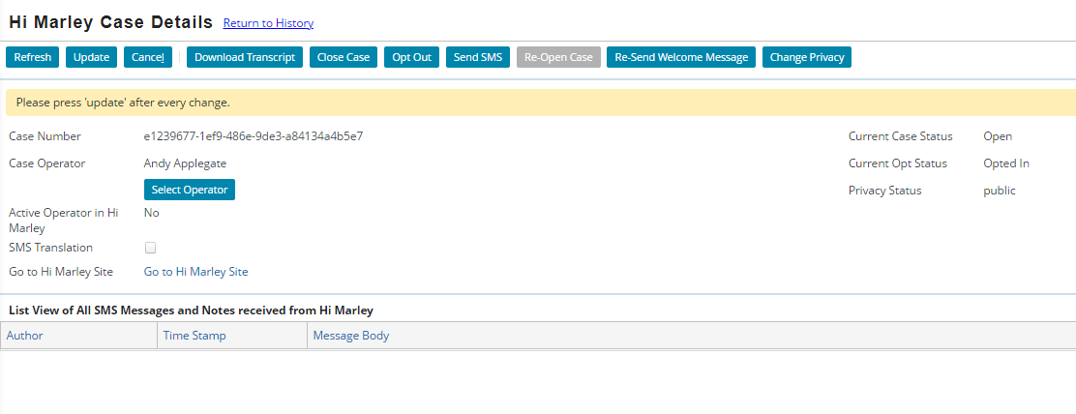
In the Claim Center there is also an automatic synchronization of the case data, when the .json file with the SMS message will be received from the webhook. It is possible when the flag ‘Live updates’ on the admin page are set to true. When this payload is received, then the work item will be added to the work queue ‘HiMarleyMessagingWorkQueue’. This synchronization updates the following fields on the case:
- Case Operator
- Privacy Status
- SMS Translation
- Preferred Language
There is no information about the ’Current Opt Status’ on this kind of payload. That’s why, this field isn’t updated.

Technical Design
Technical Overview
Following provides a high-level overview of the architecture of this reference implementation.

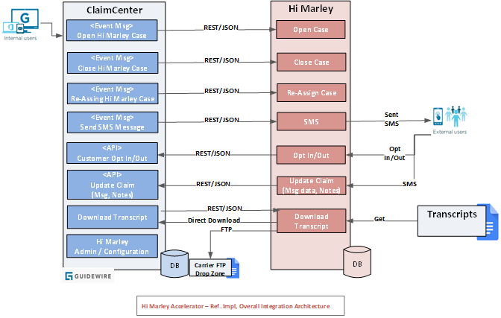

As shown in above reference implementation diagram, ClaimCenter and Hi Marley will be integrated via the Hi Marley accelerator leveraging a direct client-server architecture. Any middleware tier implementation will be the responsibility of carrier.

ClaimCenter will consume APIs exposed by Hi Marley to perform required functions (i.e. Open case, Close case, assigning case, send SMS, etc.)

ClaimCenter also will expose APIs and Plugins to allow Hi Marley to perform required functions (i.e. Send Customer data, Send messages, Download case transcripts, etc.)

Since this accelerator will be based on previous accelerator for ClaimCenter v9.x, for downward compatibility, this accelerator will inherit application and integration architecture from previous accelerator unless unique new features in ClaimCenter v9bb.x can significantly improve the functionality, reliability, and performance of the accelerator.

Open Case in Hi Marley
ClaimCenter events will trigger an integration between ClaimCenter and Hi Marley. This integration will invoke Rest webservice call and notify Hi Marley of an event and Hi Marley sends text message to the Claimant accordingly.
• Guidewire ClaimCenter has an OOTB event where, when a claim creation is finished that event gets triggered at initial stage in the Claim lifecycle (FNOL).
• When this OOTB event is triggered, an Event Fired rule will be invoked with Open status which sends a JSON Payload to a predefined messaging destination configured in ClaimCenter. The event fired rule is an OOTB feature in GW rules engine
• This Messaging destination will use a Message Asynchronous Transport plugin that will be used to send the message about the claim information to Hi Marley.
• Hi Marley will use the message sent from ClaimCenter to create a text message that will be sent to the Claimant.
Open Case from FNOL
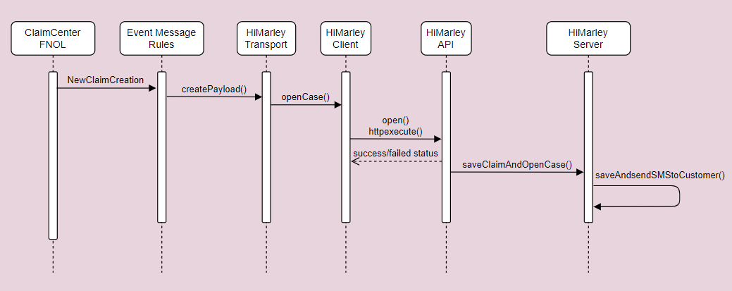
Open Case from an existing Claim
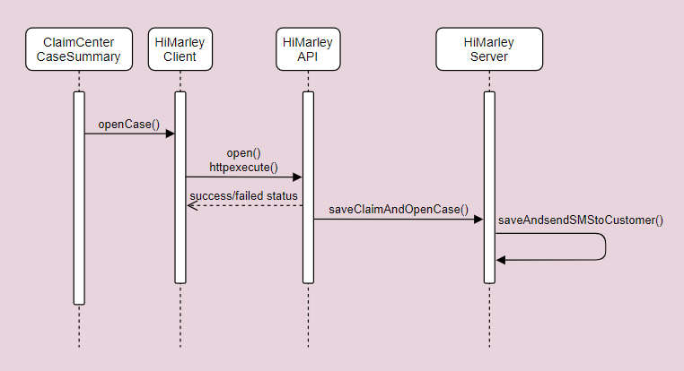

Case Close/Open status update from Hi Marley to ClaimCenter
Subscription to webhook sends updates back to carrier system based on changes in Hi Marley (case close/open).
Hi Marley sends update to ClaimCenter whether Hi Marley case is closed or reopened. Based on webhook status, ClaimCenter updates Hi Marley details in ClaimCenter.
Carrier has to subscribe to Hi Marley webhook to update Hi Marley case details in ClaimCenter.
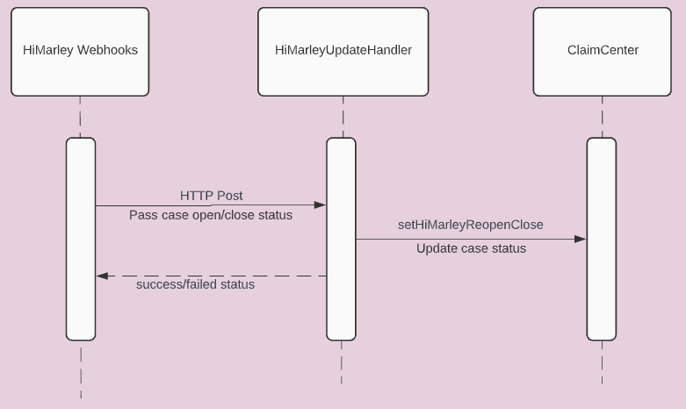

Opt-In/Opt-Out status update from Hi Marley to ClaimCenter
Subscription to webhook sends updates back to carrier system based on changes in Hi Marley (user opt in/out).
Hi Marley sends update to ClaimCenter whether Customer Opted or Opted out. Based on webhook status, ClaimCenter updates Hi Marley details in ClaimCenter.
Carrier has to subscribe to Hi Marley webhook to update Hi Marley case details in ClaimCenter.
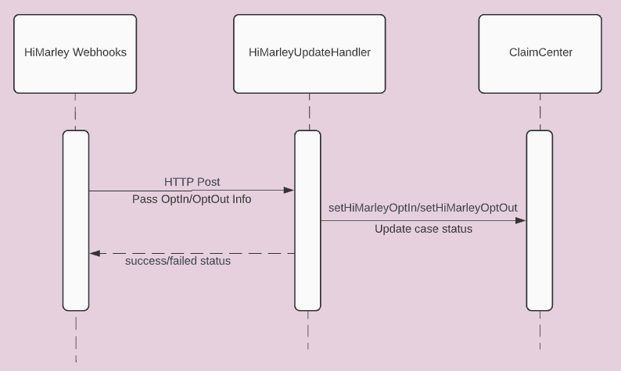

SMS Message update from Hi Marley to ClaimCenter
Subscription to webhook sends updates back to carrier system based on messages received and sent in Hi Marley.
Hi Marley sends update to ClaimCenter whenever Operator, Claimant, or Hi Marley AI sends or receives a message. Based on webhook status, ClaimCenter updates Claim Notes in ClaimCenter and adds to corresponding Case message list.
Carrier has to subscribe to Hi Marley webhook to update Hi Marley messages in ClaimCenter.
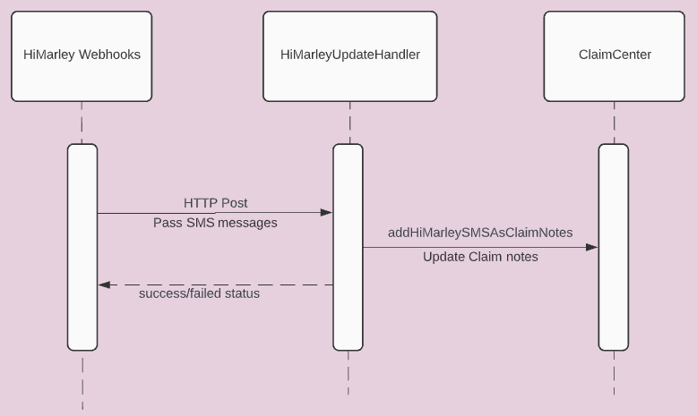

Hi Marley Note update from Hi Marley to ClaimCenter
Subscription to webhook sends updates back to carrier system based on notes updated in Hi Marley.
Hi Marley sends update to ClaimCenter whenever Operator makes a note. Based on webhook status, ClaimCenter updates Claim Notes in ClaimCenter.
Carrier has to subscribe to Hi Marley webhook to update Claim notes in ClaimCenter.
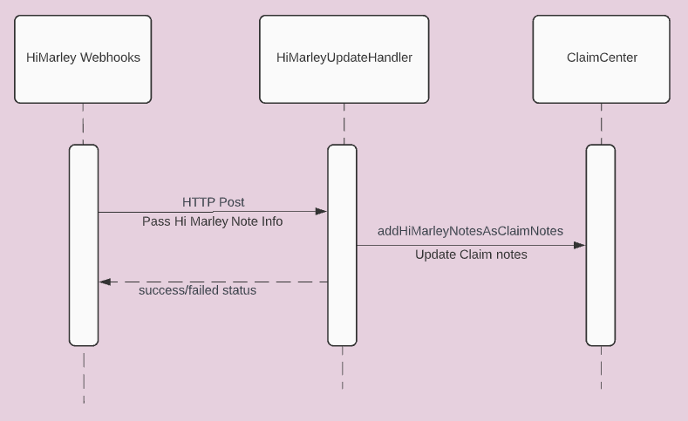

Update Claim transcript information to Hi Marley
Download transcript – Initiates the download transcript call to save case transcript PDF to ClaimCenter Documents
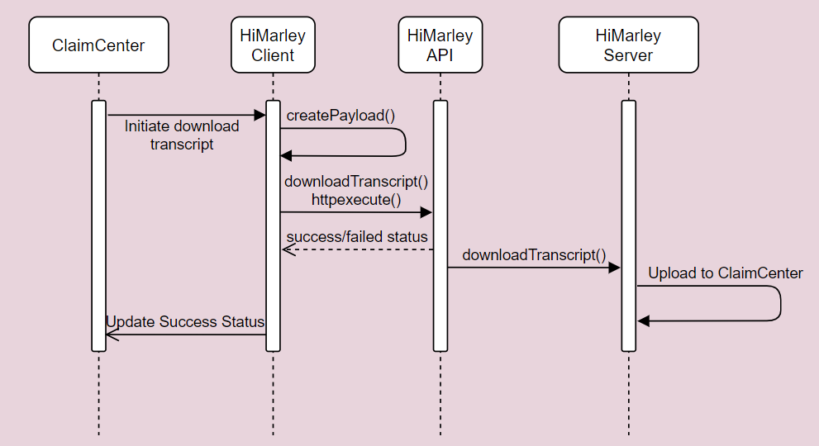

Claim updates to Hi Marley
Assign/Reassign operator, Change Privacy, Turning On/Off Auto-Translation, Claimant OptOut Status, and Case Open/Close Status –triggers update to Hi Marley
The body of the request must include a primary Contact and one of email/mobile/id for that identity and the case id which may be required in the url parameter instead.

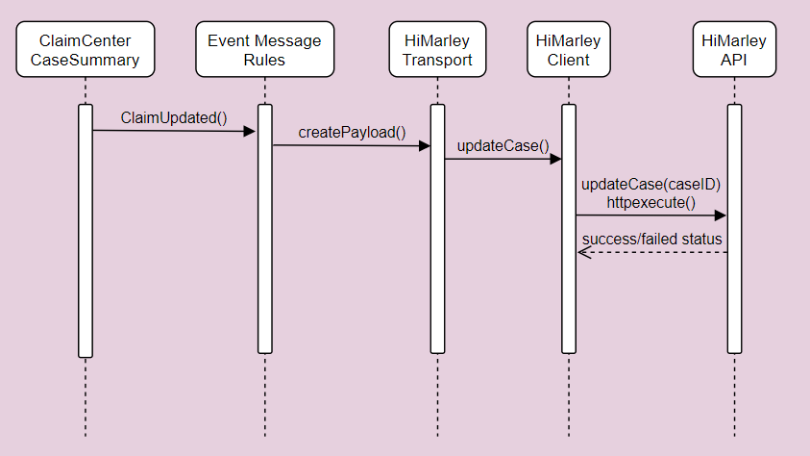

Send Claim Closure updates to Hi Marley
Close case – Once ClaimCenter closes a Claim, Claim Close request is sent to Hi Marley. Hi Marley closes the case in their application.

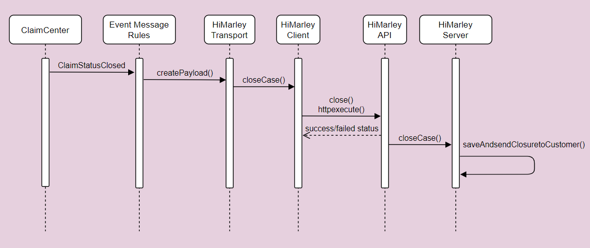

Automatic Resend Welcome Message to Hi Marley
Automatic Resend Welcome Message – Every period (default to 24 hours), Welcome message request is automatically sent to Hi Marley by batch process. Hi Marley Operator can change the time to resend Welcome message. Resend Welcome message is only sent to Claimants that have not opted in (in the request phase).

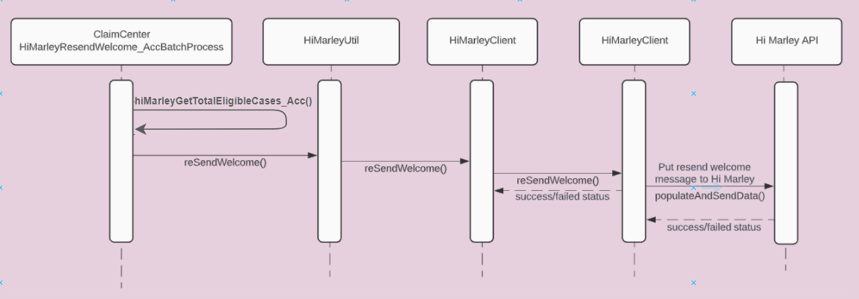

View Hi Marley Case transcript document in ClaimCenter
Once Hi Marley Transcript downloading Process is run, it creates a document entity, and attach document to Claim. ClaimCenter retrieves the document and displays under Documents tab along with other documents.

Note: This approach is assuming OOTB document management solution, and it is for reference only. Carrier must implement their own document management solution

Parties Involved - Contacts - Hi Marley Cases card

Open Case from an existing Claim - On existing claim users can create a new Case from Parties Involved tab. The Case will be sent to HiMarley to Open a new Case. If the case is open correctly, it will be visible in the case list.

Open Case from an existing Claim

Case synchronization
When the case is changed by using the ‘Update’ button in edit mode, first the data is validated inside ValidationRules, then inside the EventFired the payload and the message is created. If the previous steps are successful, the request is sent to HiMarley with the changes in payload. When the data is correct, the successful request is received from Hi Marley API.
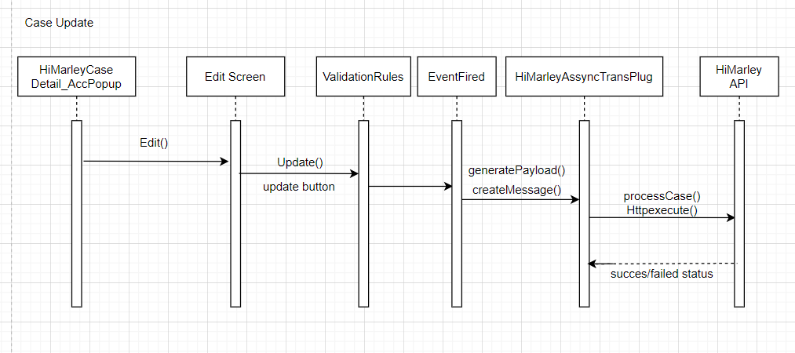
When the SMS is received in the Claim Center, the Hi Marley webhook sends the request to HiMareyUpdateHandler. Inside this class the new work item is created for each message, which is later processed by HiMarleyMessagingWorkQueue. This work queue actualises the data of the case in the Claim Center.
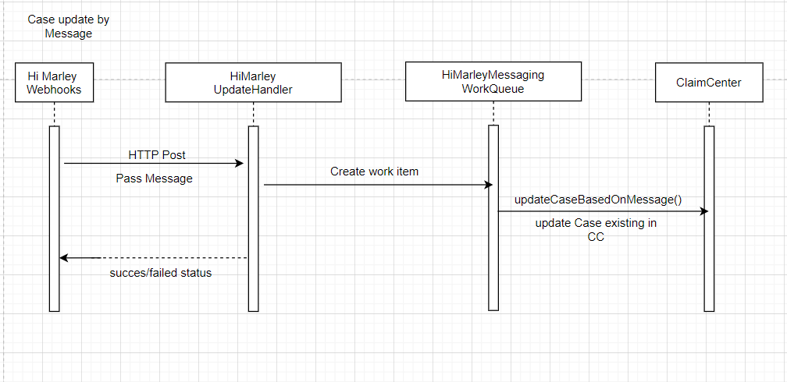
The data on the case can be also updated by using the refresh button. This button retrieves the case data and opt status of the client from Hi Marley chat. When the response is successful, the data on the case is updated in the Claim Center.

Integration Components

Messaging

Hi Marley Outbound Integration
- Uses Message Transport and event fired mechanism to send messages to Hi Marley by consuming Hi Marley REST API

Hi Marley Inbound Integration
- Servlets that subscribe to Hi Marley webhook to receive update from Hi Marley for:
  - Case Open/Close status
  - OptIn/OptOut
  - SMS detail
  - Hi Marley case notes
  - Transcript

Hi Marley Batch Process Integration
- Batch Process read and generate transcript document
- Batch process resends welcome message to claimant after a number of hours, default is 24 hours

Data Model Extensions

Entity Modifications
- Claim.HiMarley.etx - New entity extension added with one-to-many relation to HiMarleyCaseData_Acc entity with the new column EnrolledInHiMarley_Acc
- HiMarleyCaseData_Acc.HiMarley.eti - New entity added with following new columns: CaseID, CustomerID, PushTranscriptInitiated, UploadedToDMS, HiMarleyEnrollStatus, PreferredLanguage, Operator, Privacy, HiMarleyTranslationOnOff, HiMarleyCaseStatus, LastTimeResendWelcomeSent, HiMarleyOptStatus, FutureReOpenClaim, LastTimeManualResendWelcome and events with new columns HiMarleyCaseDataChanged and ClaimChanged
- HiMarleyAdmin_Acc.HiMarley.eti – New entity added with following new columns: ViewCases, AutoCreateOperator, SendSMS, LiveUpdate, DownloadTranscript, AutoSyncNotes, SendTemplate, and AutoReSendWelcomeTimer
- HiMarleyNote_Acc.HiMarley.eti – New entity extention added with the following new columns: Body, Confidential, Subject, AuthoringDate, Activity, Author, Topic, SecurityType, Language, PostType, CaseId, HiMarleyAuthor, HiMarleyCase
- HiMarleyTemplate_Acc.HiMarley.eti – New entity added with the following new columns: TemplateBody and TemplateName
- HiMarleyWorkItem_Acc.HiMarley.eti -- New entity added with the following new columns: Claim, ClaimNumber
- Note.HiMarley.etx - New entity extension added with the following new columns: PostType, CaseId, and HiMarleyAuthor

Typelist Modifications
- BatchProcessType.HiMarley.ttx-- New typelist extension added for BatchProcessType with type code AutoReSendWelcome_Acc, HiMarleyWorkQueue_Acc.
- HiMarleyCaseStatus_Acc.HiMarley.tti – New typelist added added to show Hi Marley case status
- HiMarleyOptStatus_Acc.HiMarley.tti – New typelist added to show Hi Marley opt status
- HiMarleyPrefLanguage_Acc.HiMarley.tti – New typelist added for preferred language for translation
- NoteTopicType.HiMarley.ttx – New typelist added for adding SMS to ClaimCenter
- HiMarleyEnrollStatus_Acc.HiMarley.tti-- New typelist added it shows the HiMarley System Customer Case Enrollment Status
- SystemPermissionType.HiMarley.ttx – New typelist added for system permissions

User Interface Modifications

Entry/Exit Points
- HiMarleyText_Acc.pcf—Added a new exit point to redirect to Hi Marley System Texting
- HiMarleyTranscriptDownload_Acc.pcf — Added new exit point which redirect to download transcript

Claim Screens
- FNOLWizard_AssignSaveScreen.pcf—Added Hi Marley Enrollment Check box
- ClaimStatus.pcf-- Update Claim summary PCF with new HiMarley Details section and status details

Deployment

ClaimCenter

config
  - extensions
    - entity
      - Claim.HiMarley.etx — New entity added which extends Claim entity and having foreign key relation to HiMarleyCaseData_Acc entity with the new column EnrolledInHiMarley_Acc
      - HiMarleyAdmin_Acc.HiMarley.eti — New entity added with following new columns: ViewCases, AutoCreateOperator, SendSMS, LiveUpdate, DownloadTranscript, AutoSyncNotes, SendTemplate, LiveSMSToNote and AutoReSendWelcomeTimer
      - HiMarleyCaseData_Acc.HiMarley.eti — New entity added with following new columns: CaseID, CustomerID, PushTranscriptInitiated, UploadedToDMS, PreferredLanguage, Operator, Privacy, HiMarleyTranslationOnOff, LastTimeResendWelcomeSent, FutureReOpenClaim, LastTimeManualResendWelcome, an array HiMarleySMS, and events with new columns HiMarleyCaseDataChanged and ClaimChanged and typekeys HiMarleyEnrollStatus, HiMarleyCaseStatus, and HiMarleyOptStatus
      - HiMarleyTemplate_Acc.HiMarley.eti — New entity added with the following new columns: TemplateBody and TemplateName
      - Note.HiMarley.etx — New entity extension added with the following new columns: PostType, CaseId, and HiMarleyAuthor
      - HiMarleyWorkItem_Acc.HiMarley.eti – New entity for a custom work item for Hi Marley asynchronous case creation
      - HiMarleyNote_Acc.HiMarley.eti - New entity added with following new columns: Body, Confidential, Subject, AuthoringDate, PostType, CaseId, and HiMarleyAuthor, typelists Topic, SecurityType, and Language, and foreignkeys HiMarleyCase, Activity, and Author
    - typelist
      - BatchProcessType.HiMarley.ttx -- New typelist added which extends BatchProcessType and having the type code AutoReSendWelcome_Acc, HiMarleyWorkQueue_Acc of typelist added from BatchProcessType as AutoReSendWelcome_Acc for sending welcome message after a certain time period.
      - HiMarleyCaseStatus_Acc.HiMarley.tti — New typelist added which contains the case status reference and used to add or modify
      - HiMarleyEnrollStatus_Acc.HiMarley.tti — New typelist added it shows the HiMarley System Customer Case Enrollment Status
      - HiMarleyOptStatus_Acc.HiMarley.tti — New typelist added which contains the customer Opt status reference and used to add or modify HiMarleyCaseData_Acc.HiMarley.eti entity for the field HiMarleyOptStatus
      - HiMarleyPrefLanguage_Acc.HiMarley.tti — New typelist added which contains list of HiMarley system multiple language reference and used to add or modify HiMarleyCaseData_Acc.HiMarley.eti entity for the field PreferredLanguage
      - NoteTopicType.HiMarley.ttx — Extension of typelist added from NoteTopicType for maintaining Note Topic category. As a new data, HiMarley case type has been added to distinguish HiMarley Note Topic.
      - SystemPermissionType.HiMarley.ttx — Added HiMarley case operational permission types. Those are, automaticcreateoperator, viewsendmessage, viewliveupdate, viewdownloadscript, automaticsyncnotes, viewsendtemplate. Those were used to reference the permissions required to maintain userwise.
  - locale
    - display.properties — Added properties for Hi Marley Integration
  - messaging
    - messaging-config.xml — Added a Hi Marley destination and event for integration
  - plugin
    - registry
      - HiMarleyAssyncTransPlug_Acc.gwp — Contains the Hi Marley asynchronous plugin configuration
  - rules
    - Event Message
      - EventFired_dir
        - HiMarleyAssyncCall.gr — Hi Marley Event rules to invoke integration
        - HiMarleyAssyncCall_dir
          - ClaimChanged_dir
            - AdjusterChanged.gr — Trigger and generate adjuster changed payload
            - Order.txt — Hi Marley rule ordering
          - Claim.gr — Hi Marley Event rules to invoke integration
          - ClaimChanged.gr – Hi Marley Event rules to invoke integration
          - Claim_dir
            - ClaimChanged.gr — Trigger and generate claim changed payload, claim closed payload, and claim updates related to adjuster and claim payload
            - Order.txt — Hi Marley rule ordering
        - Order.txt — Hi Marley rule ordering
  - scheduler
    - scheduler-config.xml — Added process AutoResendWelcome
  - security
    - security-config.xml — Added system permissions for Hi Marley permissions
  - web
    - pcf
      - acc
        - himarley
          - admin
            - HiMarleyAdminItems_Acc.pcf — Page to enable/disable feature flagging items for Hi Marley
            - HiMarleyAdminItems_AccDV.pcf — Detail view that has items for feature flagging for Hi Marley
            - HiMarleyAdminSendSMSTemplates_AccLV.pcf — List view to create and delete SMS templates
            - HiMarleyAdminTemplates_Acc.pcf — Page to create and delete SMS templates
            - HiMarleyAdmin_Acc.pcf — Location group for Hi Marley Admin pages
            - HiMarleyNewTemplate_AccPopup.pcf — Popup to create and add new SMS template
            - HiMarleyTemplateDetail_AccDV.pcf — Detail view to view SMS template
            - HiMarleyWelcome_Acc.pcf — Forwards to go to Hi Marley Admin pages
          - cases
            - HiMarleyAssignOperator_AccPopup.pcf — Popup to reassign Hi Marley Operator
            - HiMarleyCaseDetail_AccLV.pcf — List view to view Hi Marley case details
            - HiMarleyCaseDetail_AccPopup.pcf — Popup to view Hi Marley case details
            - HiMarleyClaimCases_Acc.pcf — Page to view list of Hi Marley cases for a claim
            - HiMarleyClaimCases_AccLV.pcf — List view of Hi Marley cases for a claim
            - HiMarleyConfirmation_AccPopup.pcf — Popup to confirm success of an API call
            - HiMarleyOpenCase_AccPopup.pcf — Popup to open new Hi Marley case in existing claim
            - HiMarleyPickSMSTemplate_AccPopup.pcf — Popup to select SMS template for SMS message
            - HiMarleySendSMS_AccDV.pcf — Detail view to send SMS message
            - HiMarleySendSMS_AccPopup.pcf — Popup to send SMS message
            - HiMarleySMSMessageTemplateResult_AccLV.pcf — List view to view SMS templates
          - contact
            - HiMarleyClaimContactCases_AccLV.pcf — List view to view cases based on contact in existing claim
          - ClaimHiMarleyCasesFoward.pcf – Forward to go to Hi Marley cases

      - claim
        - FNOL
          - FNOLWizard_AssignSaveScreen.pcf — Added Hi Marley Enrollment Check box
        - partiesinvoled
          - ClaimContacts.pcf — Added Hi Marley Cases card to view cases based on selected contact in claim
        - summary
          - ClaimStatus.pcf — Added Hi Marley details section which contains status and , alert bar and texting details
        - Claim.pcf — Added location reference to view Hi Marley cases
      - exitpoints
        - HiMarleyText_Acc.pcf — Added new exit point which redirect to specific case
        - HiMarleyTranscriptDownload_Acc.pcf — Added new exit point which redirect to download transcript
      - phone
        - GlobalPhoneInputSet.pcf — Validates frontend phone number pattern with a United States number pattern
      - TabBar.pcf — Added “Hi Marley Operator” section under the “Administration” tab
  - workqueue
    - work-queue.xml – Registers custom work queue for asynchronous case creation

gsrc
  - acc
    - himarley
      - integration
        - batchprocess
          - HiMarleyResendWelcomeBatchProcess.gs —Batch Process generate resend welcome message to claimant every set amount of hours
        - enhancement
          - HiMarleyCase_AccEnhancement.gsx — Enhancement class to hold Hi Marley integration properties
          - HiMarleyClaimEnhancement.gsx — Enhancement class to hold Hi Marley integration properties
        - exception
          - HiMarleyDataValidationException.gs — Class Contains Client-side data validation errors
          - HiMarleyException.gs — Generic exception class for Hi Marley integration
        - messaging
          - HiMarleyAssyncTransPlug.gs — Asynchronous message transport class which invoke Hi Marley REST API integration for opening, closing, and reopening cases and changing adjuster for Hi Marley cases
        - servlet
          - mapper
            - HiMarleyCaseDataBody.gs - Creates a class relating to case data
            - HiMarleyCaseNoteBody.gs - Creates a class relating to case notes
            - HiMarleyCloseReOpenBody.gs - Creates a class relating to case reopen and close
            - HiMarleyCustomerBody.gs - Creates a class relating to customer
            - HiMarleyOptInBody.gs - Creates a class relating to opt in
            - HiMarleyOptOutBody.gs - Creates a class relating to opt out
            - HiMarleyPrimaryContactBody.gs - Creates a class relating to case primary contact
            - HiMarleySMSBody.gs - Creates a class relating to SMS
          - validation
            - HiMarleyWebhookPayloadProcessor.gs - Class used to validate payloads coming in from Hi Marley
          - HiMarleyCaseCloseReOpenServlet.gs - Servlet class to receive webhook payloads for closing and reopening Hi Marley cases in ClaimCenter
          - HiMarleyCaseNoteServlet.gs - Servlet class to receive webhook payloads for case notes from Hi Marley to ClaimCenter’s notes
          - HiMarleySMSServlet.gs - Servlet class to receive webhook payloads for sms from Hi Marley to ClaimCenter’s notes
          - HiMarleyUserOptInServlet.gs - Servlet class to receive webhook payloads for opting in Hi Marley cases in ClaimCenter
          - HiMarleyUserOptOutServlet.gs - Servlet class to receive webhook payloads for opting out Hi Marley cases in ClaimCenter
        - himarley.properties — Properties file related to end points , API key , REST API Http operation name and service level properties. Added three new properties:
          - HiMarley.FlagFeature.SendBrand - false; used for Control if brand is needed to be sent.
          - HiMarley.FlagFeature.BrandingOverride - false; this feature is used to send brand,
          - HiMarley.FlagFeature.BrandToBeOverwritten – used to override the default brand
        - HiMarleyClient.gs — REST API Integration class with all operation details
        - HiMarleyConstants.gs — Constants class which contains all integration related variables
        - HiMarleyHelper.gs – Class with all helper get methods related to Hi Marley integration
        - HiMarleyUtil.gs — Class with all utility methods related to Hi Marley integration
        - HiMarleyWebhookHandler.gs — Class that works with Hi Marley webhooks to update Hi Marley cases
  - gw
    - plugin
      - process
        - ProcessPlugin.gs — Added new Hi Marley transcript batch process

Running this Reference Implementation
- Add or merge the accelerator code into existing ClaimCenter
  - Unzip distribution package to OOTB ClaimCenter 9.0.10 under following directory:

<ClaimCenter Installation Root>\ modules\configuration

  - Overwrite all files with same file names

  - Make sure update the API key, end point, test user email address from following properties file:

\gsrc\acc\himarley\integration\himarley.properties.
\config\credentials.xml

  - If not exist, following Guidewire’s instruction to create ClaimCenter database

  - Make sure update database connection information in following file:

\config\database-config.xml

  - Compile the code by running following command:
gwb compile
  - Build Tomcat package by running following command:
gwb warTomcatDbcp (or other options based on your need)

  - Deploy war file to application server

  - Restart the application server

- Update API key, end point, test user email address from following properties file: gsrc\acc\himarley\integration\himarley.properties.
\config\credentials.xml

- Register Webhook events by consuming postman or swagger with below sample payloads
Consuming API: https://{Hi Marley URL}/api/webhooks/register

Opt-In Sample Payload:
{
"EVENT_ID": 7,
"HTTP_POST_ADDRESS": "http://{claimcenterurl}/cc/service/acc/himarley/opt/v1/useroptin",
"HEADERS": {
"Authorization": "Basic c3U6Z3c=",
}
}

Opt-Out Sample Payload:
{
"EVENT_ID": 6,
"HTTP_POST_ADDRESS": " http://{claimcenterurl}/cc/service/acc/himarley/opt/v1/useroptout",
"HEADERS": {
"Authorization": "Basic c3U6Z3c=",
}
}

Note Received in Hi Marley Sample Payload:
{
"EVENT_ID": 16,
"HTTP_POST_ADDRESS": " http://{claimcenterurl}/cc/service/acc/himarley/sms/v1/notes",
"HEADERS": {
"Authorization": "Basic c3U6Z3c=",
}
}

Message Received or Sent in Hi Marley Sample Payload:
{
"EVENT_ID": 14,
"HTTP_POST_ADDRESS": " http://{claimcenterurl}/cc/service/acc/himarley/sms/v1/messages",
"HEADERS": {
"Authorization": "Basic c3U6Z3c=",
}
}

Re-Open Case in Hi Marley Sample Payload:
{
"EVENT_ID": 18,
"HTTP_POST_ADDRESS": " http://{claimcenterurl}/cc/service/acc/himarley/updates/v1",
"HEADERS": {
"Authorization": "Basic c3U6Z3c=",
}
}

Close Case in Hi Marley Sample Payload:
{
"EVENT_ID": 10,
"HTTP_POST_ADDRESS": " http://{claimcenterurl}/cc/service/acc/himarley/updates/v1",
"HEADERS": {
"Authorization": "Basic c3U6Z3c=",
}
}
- Go to Hi Marley Admin entries to make sure you enabled desired:
  - Claim Level flags
  - Assigned appropriate role to user
  - Assigned appropriate Hi Marley permission to role

- After create the case, verify Hi Marley status and Reply Yes to text message from mobile device and verify Opted status. This would allow sending SMS

Known Issues
- When a Hi Marley case is closed, if customer is not opt out, he/she will be able to continue to send SMS message to Hi Marley. Hi Marley will re-open the case and forward SMS to ClaimCenter. ClaimCenter will update the case with SMS message, however, ClaimCenter will NOT re-open the case. This is due to Hi Marley existing Web Hook does not send Re-Open call to ClaimCenter. This is expected to be fixed by Hi Marley once the Web Hook is updated.

About Guidewire Software
Guidewire delivers the industry platform that Property and Casualty (P&C) insurers rely upon to adapt and succeed in a time of accelerating change. We provide the software, services, and partner ecosystem to enable our customers to run, differentiate, and grow their business. We are privileged to serve more than 350 companies in 32 countries. For more information, please visit www.guidewire.com and follow us on twitter: @Guidewire_PandC.

© 2023 Guidewire Software, Inc. All rights reserved. Guidewire, Guidewire Software, Guidewire ClaimCenter, Guidewire PolicyCenter, Guidewire BillingCenter, Guidewire InsuranceSuite, Guidewire Live, Deliver Insurance Your Way, and the Guidewire logo are trademarks or registered trademarks of Guidewire Software, Inc. in the United States and/or other countries.

