Hi Marley Accelerator for ClaimCenter 10
Release 2.0
Reference Implementation
A Detailed Design Document
Table of Contents
What is included in this accelerator 3
Who should read this document 4
What is not included in this reference implementation 4
Terms of Use 5
Further Assistance 5
Things to check after starting the server for the first time 6
Functional Design 7
Functional Overview 7
Open Case in Hi Marley once claim is created with enroll in Hi Marley texting in ClaimCenter 8
Ad Hoc Case Transcript Download 18
Receive Updates from Hi Marley 20
Disable Hi Marley messages in Claim Notes 24
Sending SMS as "Super User" will throw an "unknown" does not exist error (new) 24
Disable Hi Marley Messages in Claim notes. 25
Hi Marley Permissions 25
Parties Involved - Contacts - Hi Marley Cases card 32
Synchronize groups 34
Message Alerts 41
Secondary Operators 44
Case synchronization 46
Scheduled Messages 48
HiMarley Custom Events 52
Technical Design 58
Open Case in Hi Marley 58
Case Close/Open status update from Hi Marley to ClaimCenter 61
Opt-In/Opt-Out status update from Hi Marley to ClaimCenter 62
SMS Message update from Hi Marley to ClaimCenter 63
Hi Marley Note update from Hi Marley to ClaimCenter 64
Update Claim transcript information to Hi Marley 65
Claim updates to Hi Marley 66
Send Claim Closure updates to Hi Marley 67
Automatic Resend Welcome Message to Hi Marley 68
View Hi Marley Case transcript document in ClaimCenter 69
Parties Involved - Contacts - Hi Marley Cases card 69
Synchronize groups 69
Message Alerts 72
Case synchronization 73
Schedule Message 75
HiMarley Custom Events 77
Integration Components 79
Messaging 79
Hi Marley Outbound Integration 79
Hi Marley Inbound Integration 79
Hi Marley Batch Process Integration 80
Data Model Extensions 80
Entity Modifications 80
Typelist Modifications 81
User Interface Modifications 81
Claim Screens 81
Deployment 81
ClaimCenter 81
config 81
gsrc 87
Running this Reference Implementation 90
Known Issues 92
Updates 93
Flexible schema 93
About Guidewire Software 95

Overview
Hi Marley accelerator for ClaimCenter will establish a baseline of packaged and deployable code for insurance carriers utilizing Guidewire ClaimCenter 10.12 and Hi Marley application. Carriers will have the ability to customize and configure ClaimCenter for Hi Marley API services using this accelerator.
The accelerator allows providers to quickly integrate their Guidewire ClaimCenter with Hi Marley, enabling operators (adjusters/underwriters/customer service reps/etc.) to seamlessly include communication via Hi Marley into their everyday life. There are many APIs built to help with this process and minimize any manual work for operators.
The accelerator will function with the out-of-the-box version of ClaimCenter. Included will be Entity Extensions, Web Services, Exception Handling and Validation Rules supporting processes for below use cases.

- Open Case in Hi Marley once claim is created with enroll in Hi Marley texting in ClaimCenter
- Opt-In/Opt-Out status update from Hi Marley to ClaimCenter
- Claim updates to Hi Marley when key fields are changed/updated in ClaimCenter Operator, Adjuster email, Phone number, Privacy)
- Reopen/close update to Hi Marley
- Display Hi Marley details section and navigate to Hi Marley application’s text screen for specific case from ClaimCenter
- Send/Receive SMS messages from ClaimCenter
- Instant download of SMS transcript from Hi Marley within ClaimCenter
- Synchronize groups with Hi Marley

What is included in this accelerator
Following lists the aspects of the solution that will be included in the accelerator:
- Hi Marley Case Creation for claim participant
  - One claim can have multiple Hi Marley cases (one per claim participant)
- Reassign Hi Marley case(s) when claim owner changes
- Change Hi Marley case(s) when claim action is taken
  - Hi Marley case(s) closed when claim is closed
- Synchronize data from Hi Marley to Claims Center
  - New Messages
  - Download PDF Transcript on case closure or on-demand
  - Download multimedia files such as images and videos.
  - Opt-status of claim participant
  - Hi Marley Case Notes
- Synchronize groups from Claim Center to Hi Marley (only groups which have supervisor and at least one user which exist in Hi Marley)
- Send SMS Messages via Claims Center (template messages or new messages)
- Claims Center admin can configure accelerator in Claims Center
  - Enable/Disable functionality
    - Disable files download into claim
    - Disable Case Transcript download button
    - Disable Case Visibility Settings
      - disables all features for setting case to public or private
      - all cases are public
    - Disable Case Notes integration
    - Disable Automatic Operator Creation
    - Disable Send Message on Claim
    - Disable Synchronize Groups with Hi Marley
  - Add new SMS template from Hi Marley to Claims Center
- Limit Hi Marley functionality based on Claims Center permissions
  - New permissions created for Hi Marley operations
  - New permissions can be added to new/existing ClaimCenter roles

Who should read this document
- Carrier Business Sponsors
- Carrier Technical Sponsors
- Carrier ClaimCenter Developers
- Carrier IT Architects

What is not included in this reference implementation
- Business specific configurations / configurations for custom ClaimCenter implementations
- Carrier’s SFTP location implementation
- Hi Marley’s native user application
- Note that for Guidewire’s functional review, all non-functional requirement (NFR) testing such as Performance, Security, Reliability, Usability etc. is out of scope.

Applicable Product Versions
This accelerator has been developed to work with Guidewire ClaimCenter version 10.12. It has been tested on version 10.12 and should work with all minor versions of Version 10 with minimum changes. As currently designed, this version of accelerator will not work with ClaimCenter version 8 or version 9.

Terms of Use
We have made this document and accompanying accelerator files available to you as we thought that you might find them useful. As such, they are provided to you "as is", which means that we do not offer you any assurances with respect to them. You will be solely responsible for any changes made to your configuration as a result of you downloading and implementing any of our materials.
You also understand that we own the intellectual property rights to any accelerator documentation/file downloads we make available to you. You must not use them in any way that would adversely affect our rights under applicable law.

Further Assistance
You may wish to make changes to any of the accelerator content provided in this solution. For example, you might want to extend the solution, or to adapt it to suit your unique needs. If during your implementation you require assistance with any of these changes, please contact your Guidewire or partner Implementation Manager to discuss options for consulting assistance.

Things to check after starting the server for the first time
- Login as Administrator - Administration Panel -> Utilities -> Runtime Properties
Check if the list of Runtime Properties contains elements which have the name Hi Marley in the column ‘Group’. On the list there should be 24 elements of this type.
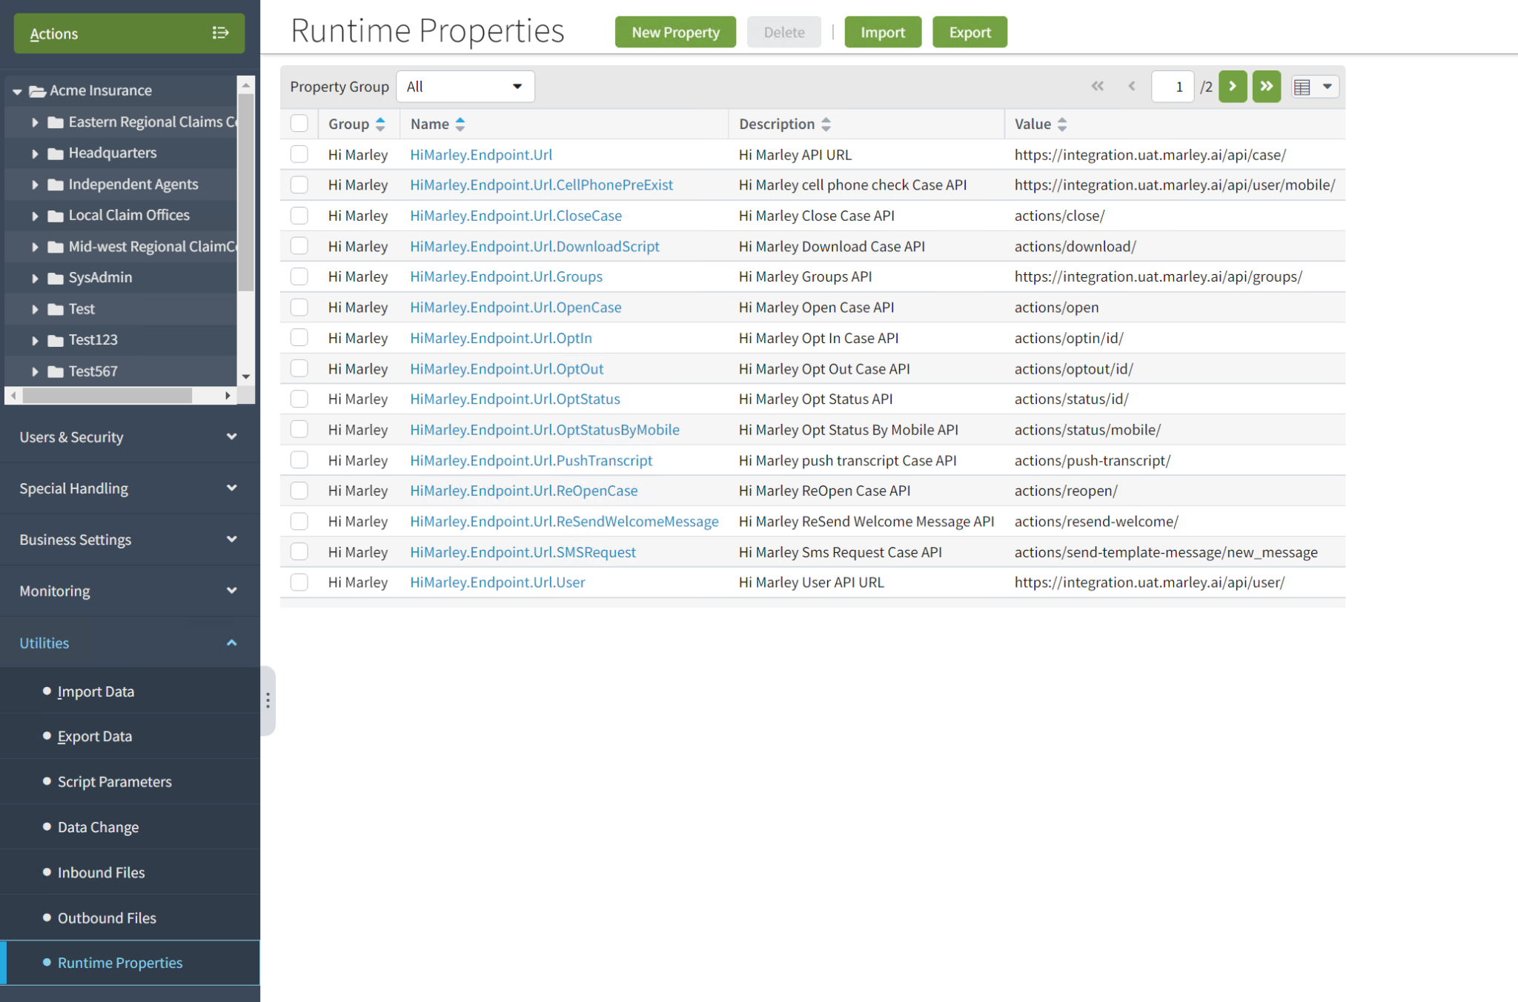
If a list of Runtime Properties is empty (that means the Runtime Properties were not loaded automatically) , then click the ‘Import’ button.
Find the path:\modules\configuration\config\runtimeproperties\HiMarleyRuntimeProperties.xml. Import that file into the ClaimCenter. After import the Runtime Properties should be visible on the list as in the image above.

- Login as Administrator. Go to ‘’ panel (Alt+Shift+T). Find a bookmark named ‘Cluster’-> ‘Members’ and check if on the list of ClusterMembers in the column ‘Server Roles’ there are roles which can be seen on the screen below - batch, workqueue, scheduler, messaging, startable, ui.

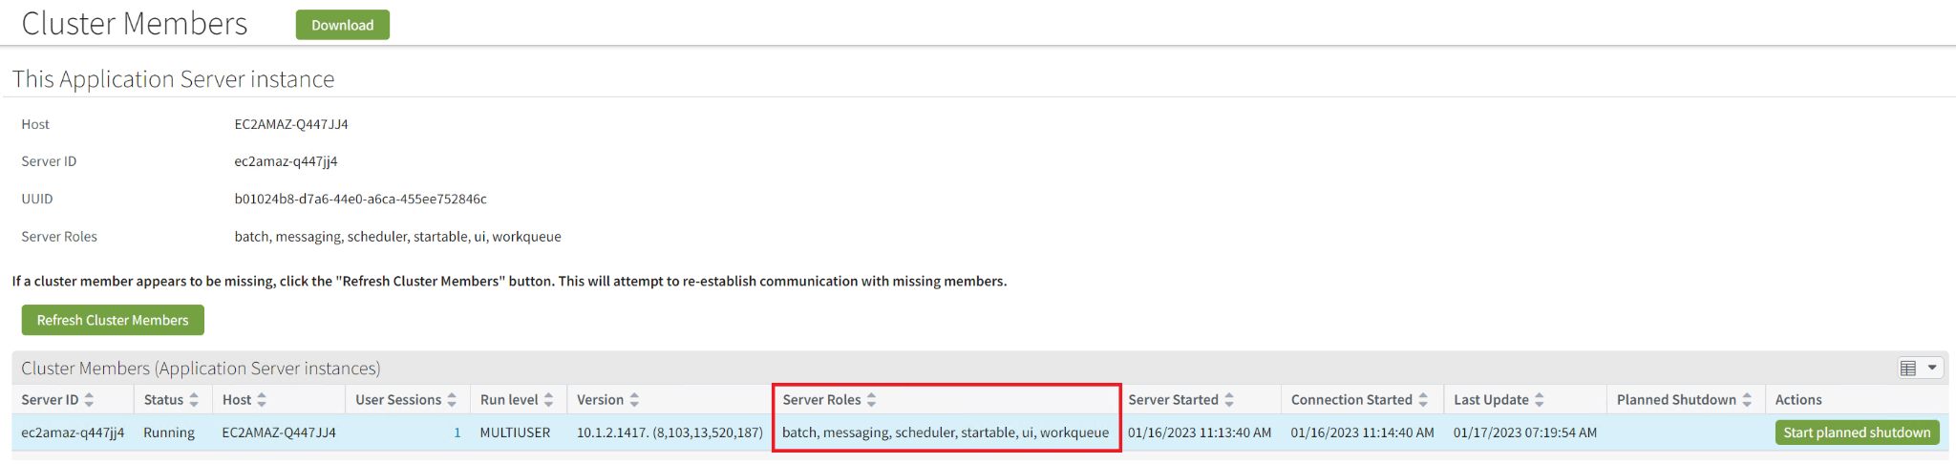
Server roles settings for the local environment are set up in the config.xml file and can be added or removed from roles list.
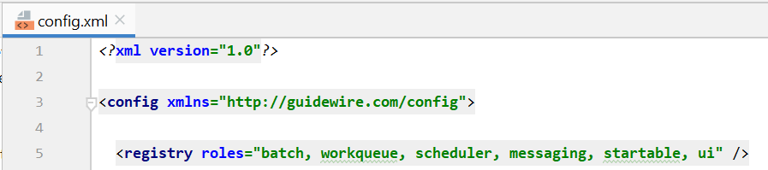

Functional Design

Functional Overview
Following describes the functional objective of this reference implementation:
- Integrate with Hi Marley APIs & Webhooks to give insurance carriers access to Hi Marley platform via Claims Center v9.
Following are functional features of this accelerator:
- Create case (case/actions/open) for any customer on the claim
- Direct link to the conversation in Hi Marley will be noted on the claim in GW after creating the case
- Reflect opt-in status in GW claims user interface (via Hi Marley’s opt in web hook)
- Assign/reassign operator in Hi Marley based on actions in GW
- Close case in Hi Marley on claim closure
- Ability to show all Hi Marley cases in a tabular format with columns including Name, Claim Number, Consent Status, Case Status, Case Privacy
- Redirect to Hi Marley webapp via link URL
- Feature flags – certain integrations/functions that can be enabled/disabled based on carrier preference
- Ability to create message Templates as an Admin
- Live updates of SMS messages into the claim notes (enablement based on webhook subscription)
- Live update of Hi Marley Case Notes into ClaimsCenter in claim notes
- Download Case Transcript and storing into Claims File
- Download Hi Marley Transcript at any time within ClaimCenter
- Close all related cases upon claim closure
- Reopen all related cases upon claim reopen
- Option to change Hi Marley case visibility to either ‘Private’ or ‘Public’
- Synchronize groups from Claim Center to Hi Marley (only groups which have supervisor and at least one user which exist in Hi Marley)
- User experiences changes (“UX Changes”) in reference implementation
  - New Reference Graphic User Interface
  - New Administration Entries

Open Case in Hi Marley once claim is created with enroll in Hi Marley texting in ClaimCenter

Create Hi Marley Claims Case from FNOL Wizard
- During FNOL save and Assign user has the option to enroll in Hi Marley texting. Upon selecting that option and completing FNOL, Claim is created. A work item is created for Hi Marley case creation and the information is asynchronously sent to Hi Marley. The work queue processes the work item and once complete, a case is created in Hi Marley and in ClaimCenter.

- Click on Hi Marley Case in the Navigational Bar on the left of main Claim screen, the case summary screen will appear. Two links created, one for viewing case detail within ClaimCenter, the other for go to Hi Marley web application

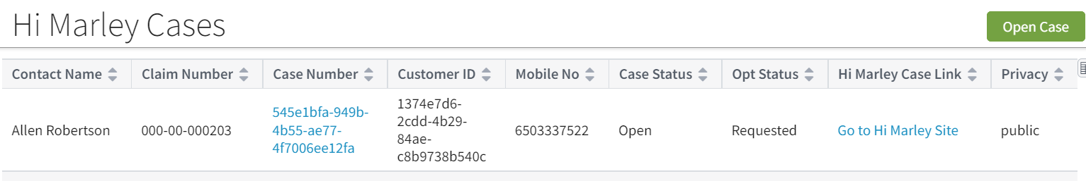

- When open the Hi Marley Case Details screen, the case initially shown as Requested status. At this status, ClaimCenter user will not be able to do certain functions such as “Opt Out”, “Send SMS” (is not visible), “Re-Open Case”, etc.

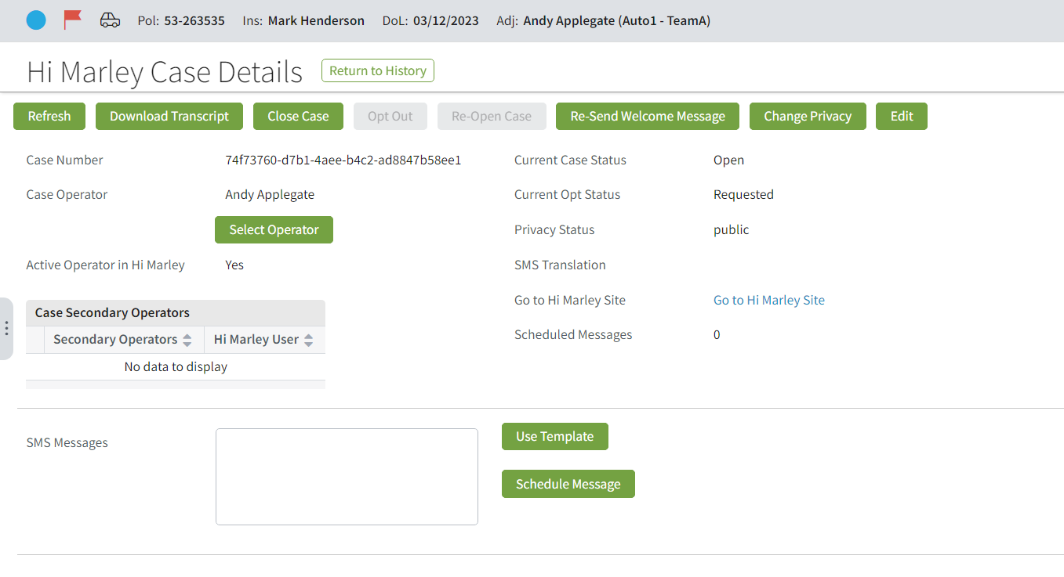

Create Hi Marley Claims Case for any customer on existing open claim
- In Hi Marley Cases summary screen, click on the “Open Case” button will open the screen to open a new Hi Marley Case in existing claim.
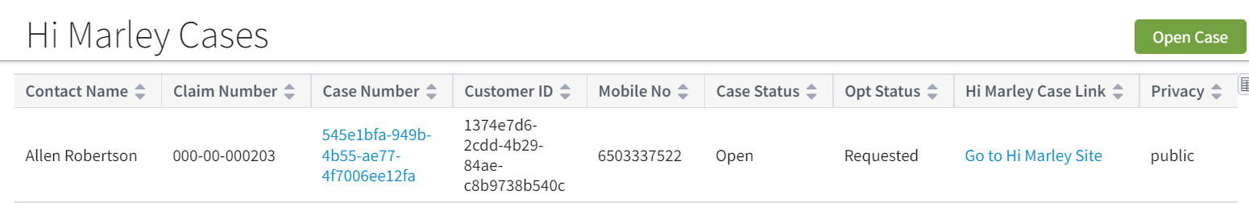
Fill out the form and click on “Create New Case”, it will attempt to open a new case in Hi Marley.
Note: This operation could fail if:
  - Then phone is not a mobile number
  - The mobile has more than allowed limit of open cases in Hi Marley (across different claims)
  - Customer was opt out from other claims
Check log for error detail, if the operation fails.
If the operator doesn’t exist in Hi Marley and the flag ‘Create or Change Operator is unchecked or the operator doesn’t have the permission autocreateoperator, then the case will be created in Hi Marley chat as unassign and in Claim Center the following error will show up.

Re-send Welcome Message to Customer
- Hi Marley, sends welcome text to the end user via SMS when case initiated. If required, user can also re-send the Welcome Message to Customer by clicking on the “Re-Send Welcome Message” button

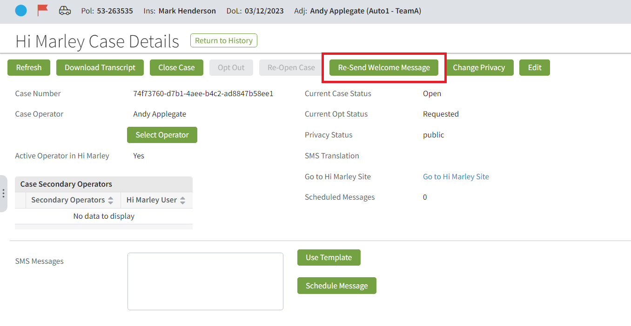
After clicking the button, Hi Marley will resend Welcome Message as shown below in Hi Marley web application:
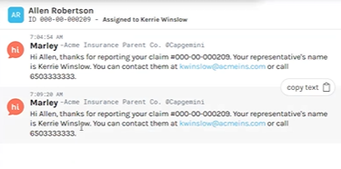
Reflect opt-status of each customer
- Hi Marley sends customer response as Opt-In status to ClaimCenter.
When customers text “Start” and then “Yes” from their phone, Hi Marley in turn sends Opt-in Status to ClaimCenter and ClaimCenter updates the Opt status.
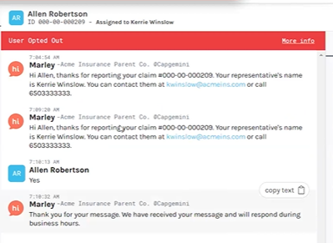
Following screenshot displays the current opt status of all cases, still in Requested status.
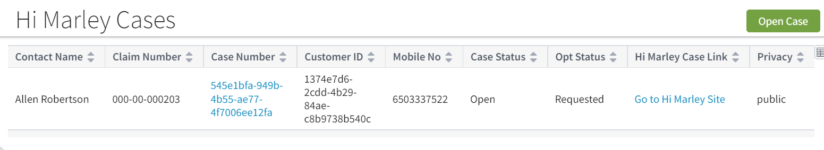
Once the customer has opted in, if ClaimCenter does not automatically refresh the status, selecting the “Refresh” button will update the case to show “opt-in”.
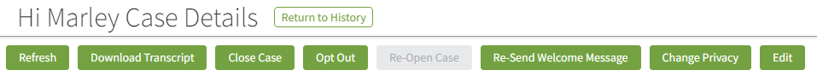

- Hi Marley, sends customer response as Opt-out status to ClaimCenter. (Opt out from phone)
When customers text “Stop”, the Hi Marley then sends the opt Out Status to ClaimCenter and ClaimCenter updates it as seen in the screenshot below.
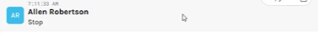

Following screen shows the case in Opt-out status:
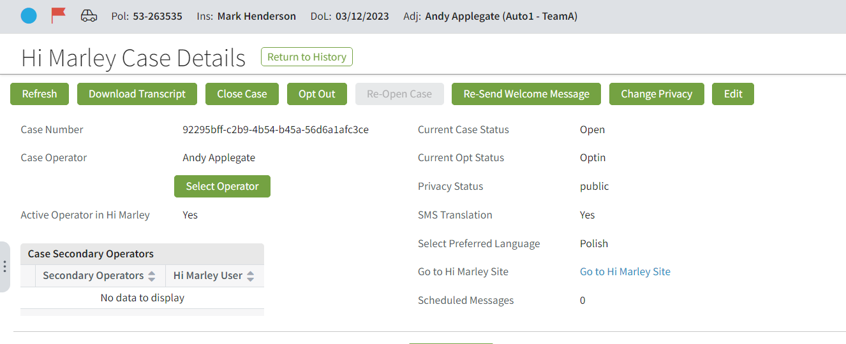
If status is not immediately updated, once the refresh button has been selected, the opt status is updated accordingly.

Sending free text SMS and Sending SMS with templated message
- Send free text SMS from ClaimCenter
To send an SMS from ClaimCenter, in free text mode, the operator can type a text and hit the send button.
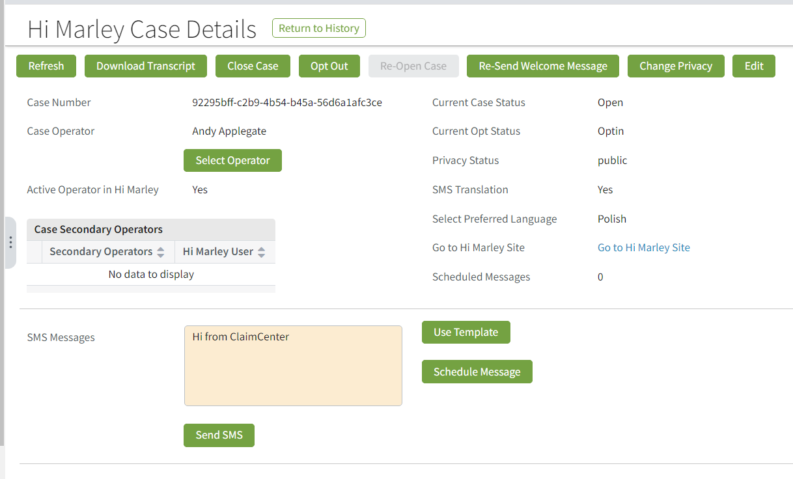

Hi Marley web application also shows this SMS transaction: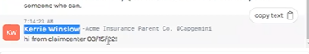
- Send SMS using Templates
The second way to send an SMS is by selecting a template as seen in the screenshots below.
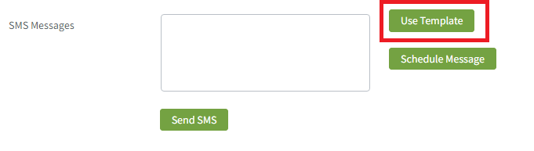
Click on “Use Template”, it will open the “Find SMS Template” screen.
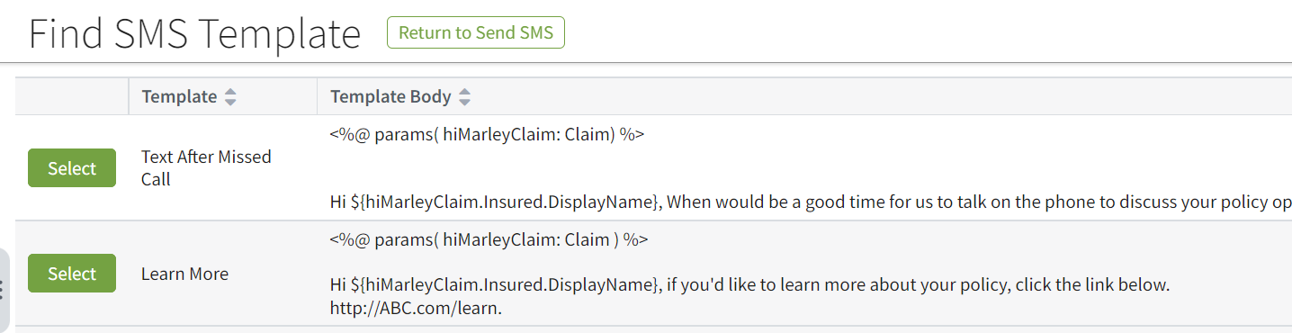
To use any of these templates, click the select button. The text box will be prefilled with the selected SMS template. In this example, the first SMS template has been selected.
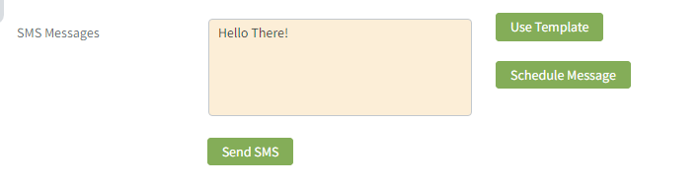
Once sent, Hi Marley will show the SMS with predefined content based on the template.
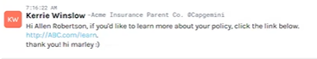

- Receiving SMS in ClaimCenter
All SMS messages received in ClaimCenter will be shown as Notes in ClaimCenter. Notes will be added to the Case level as below:
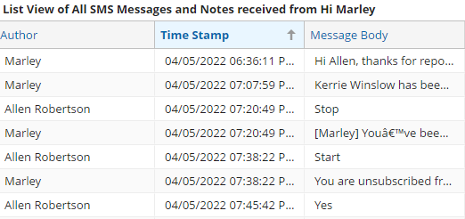
Hi Marley Language translation
- Hi Marely supports auto translation of following languages:
Language | Shorthand – language Preference value
English (Default) | en
Spanish | es
Russian | ru
Simplified Chinese | zh
Korean | ko
Portuguese | pt
German | de
Urdu | ur
Arabic | ar
Polish | pl
French | fr
Bosnian | bs
Haitian | ht
Hindi | hi
Japanese | ja
Somali | so
Thai | th
Tagalog | tl
Vietnamese | vi

English is the default preferred language. The preferred language can be changed by clicking the dropdown button and the other language options will be displayed.

Selecting Language Preference:

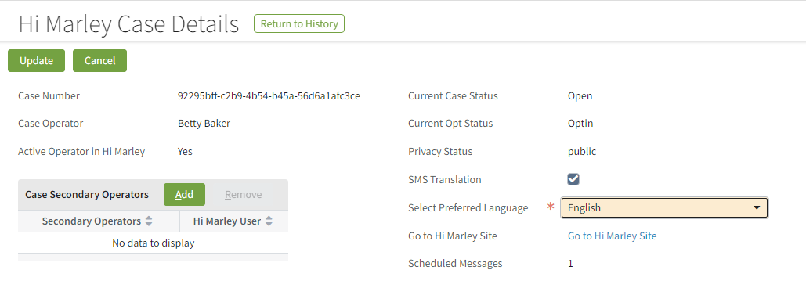

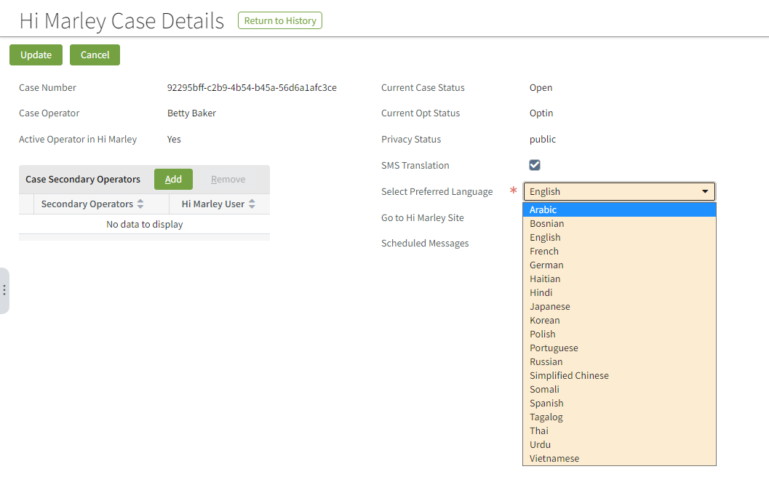

Once a language has been selected, the translation in Hi Marley will be displayed as seen in the screenshot below.
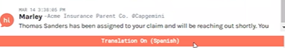

Text in English will change to Spanish on Customer’s phone.
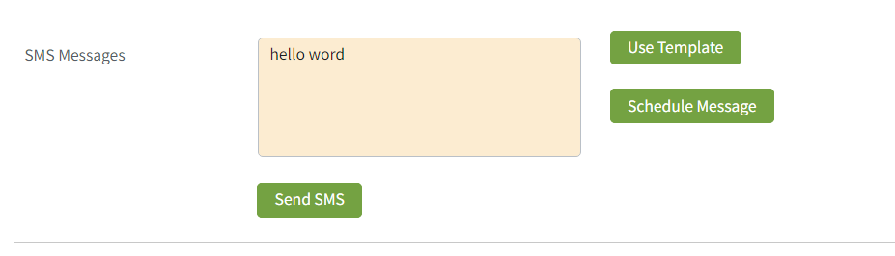
The auto translation here is the result of the Spanish selection for preferred language.
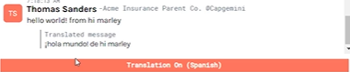

Close Hi Marley Cases
- Closing Cases individually by selecting “Close Case” button:

Selecting the close case button will close the case. Case 000-00-000203 is the case that will be closed in this example.
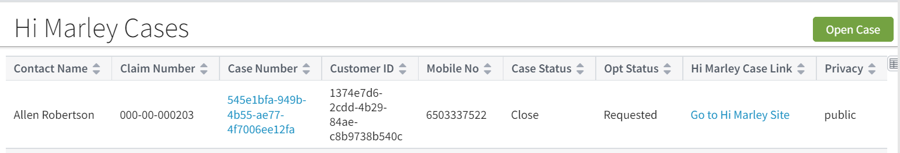
The case status now shows case 000-00-000203 as now closed.

- Closing a claim to all open Cases
To close a claim on open cases, select the ‘Workplan’ tab

Make sure complete/skip all open items
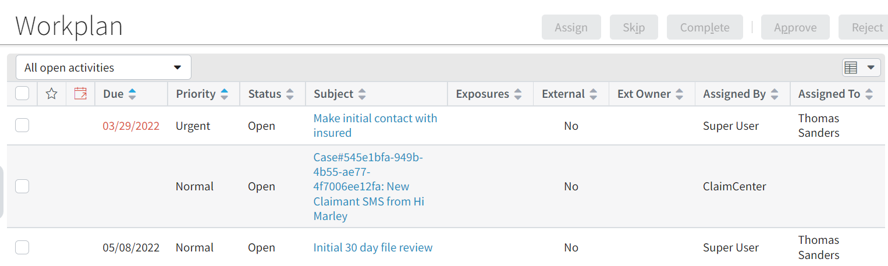
Close Claim, and all Hi Marley cases should be closed in ClaimCenter and Hi Marley
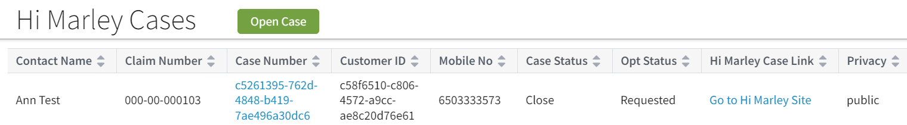
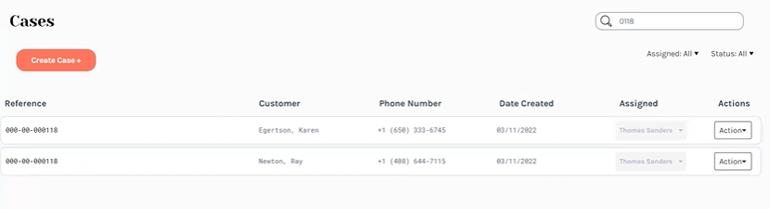
Note: Open/Close a claim does NOT affect the Opt status since it is associated at phone number level across multiple claims.

Re-Open Hi Marley Cases
- Reopen Cases individually
To re-open the case, select the “Re-Open Case” button.

The case status is now showing as opened.
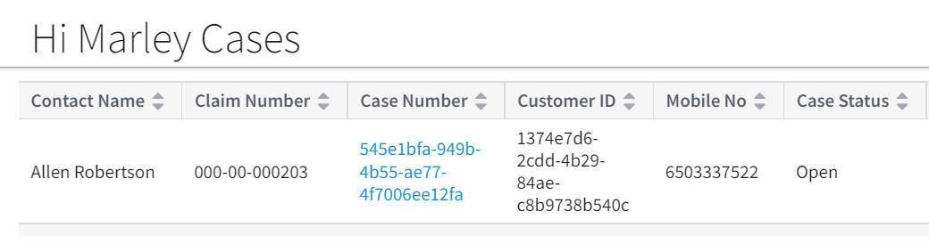

- Reopening a claim to reopen cases
Select a closed claim, and clicking the “Reopen Claim” button will reopen the claim.
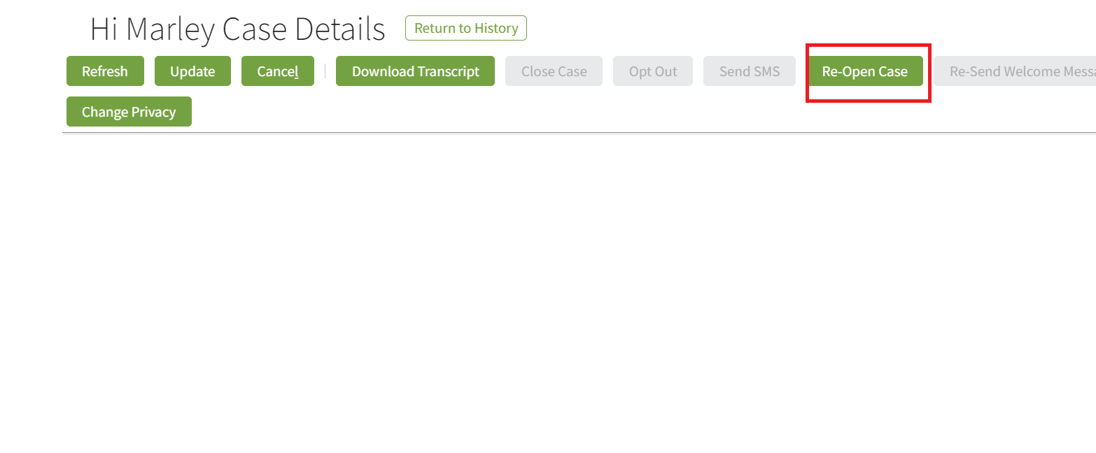
After claim is reopened, all closed cases in the claim should be reopened as well.
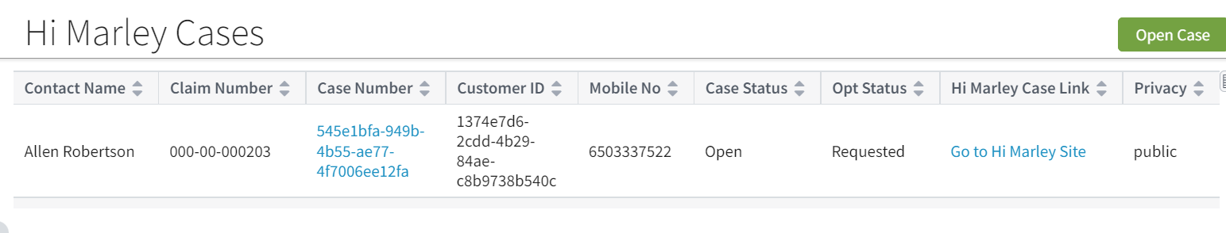
Hi Marley should also reflect on this change.
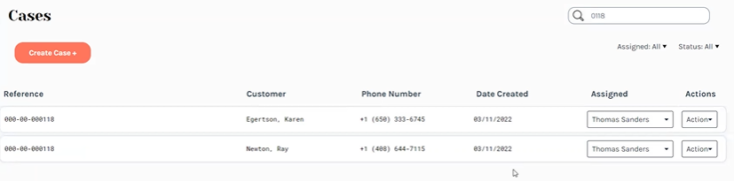

Ad Hoc Case Transcript Download
- Downloading Transcripts
On Hi Marley Case Details screen, click on “Download Transcript” button
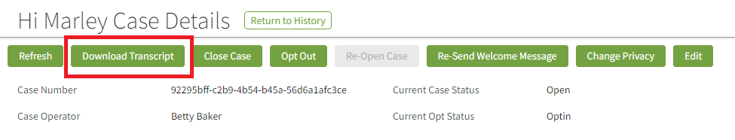

If download is successful, a Confirmation Screen will appear as below:

Newly downloaded transcript will be attached as Claim Level document. To view downloaded transcript, go to “Document” section of the claim by clicking on “Document” in the Navigational bar in the main claim screen.

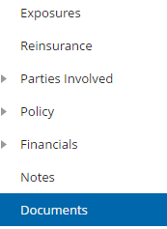
The transcript that is downloaded will be attached inside the document section:
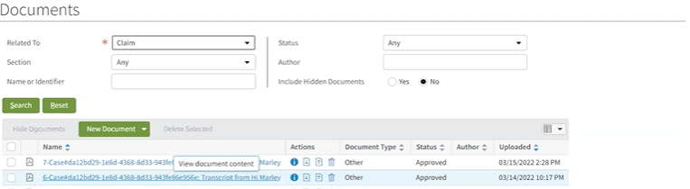

Sample transcript will be a PDF file similar to below:
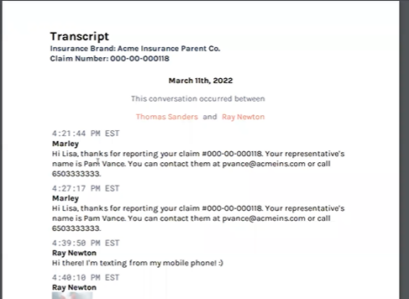

Note: Every Carrier has its own implementation of document management. The transcript downloading approach here is assuming the OOTB document system, which is for reference purposes ONLY. Carrier should implement their own integration for Ad Hoc transcript downloading into their document management system.

Receive Updates from Hi Marley
- ClaimCenter will receive updates from Hi Marley via Webhook. This function requires registration of ClaimCenter’s API/Servlet End Points with Webhook. See technical section for registration details.
- Hi Marley will send SMS messages and Case updates to ClaimCenter. All text based SMS messages and Case updates will be stored as Notes at case level in the claim, as shown below:
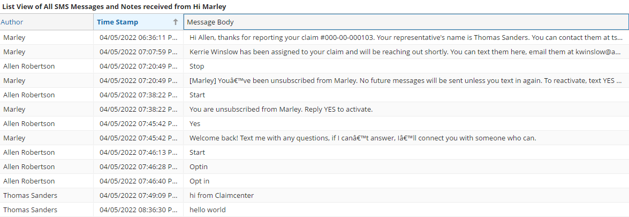
- Multimedia files such as images and videos will be stored as claim level documents and can be found in Document section.
A sample of image file as below:
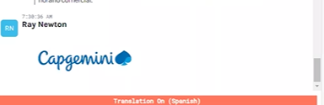

Note: Every Carrier has its own implementation of document management. The multimedia file handling approach here is assuming the OOTB document system, which is for reference purposes ONLY. Carrier should implement their own integration of multimedia files into their document management system.

Change Case Visibility of Hi Marley case
- Changing the privacy of a case.
All Hi Marley Cases defaults to “Public” visibility
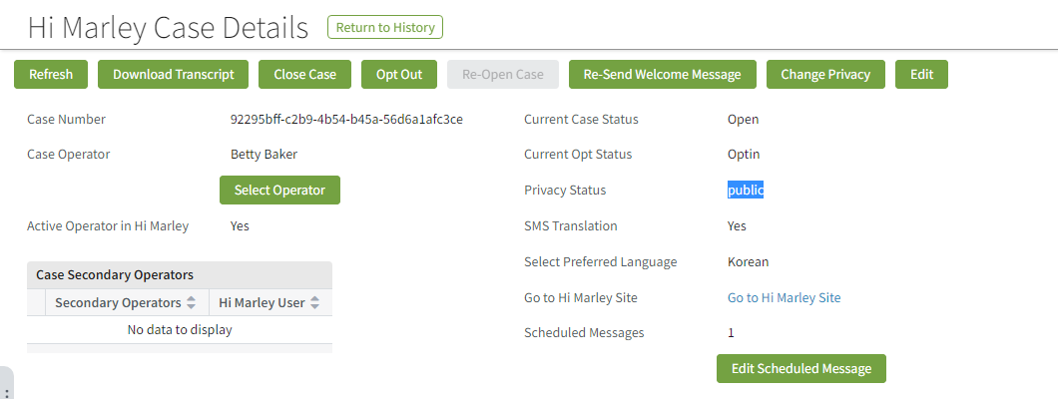
To change Visibility, choose “Change Privacy” button
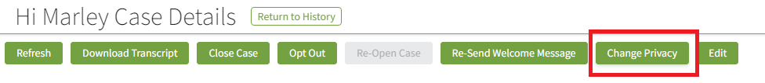
The privacy status of the case will now be listed as private
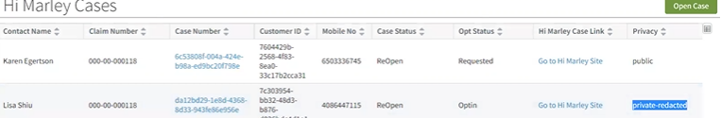
The case detail is only accessible to Super User and Assigned Operator of the Case.

Update operator of Hi Marley case from ClaimCenter
- Change an operator individually
Click on the “Select Operator” button to change the operator
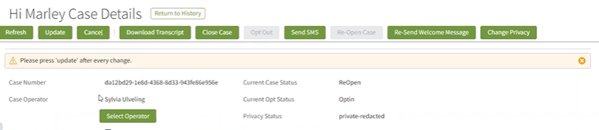

In next screen, choose new operator from the drop down, and click “Change Operator”:
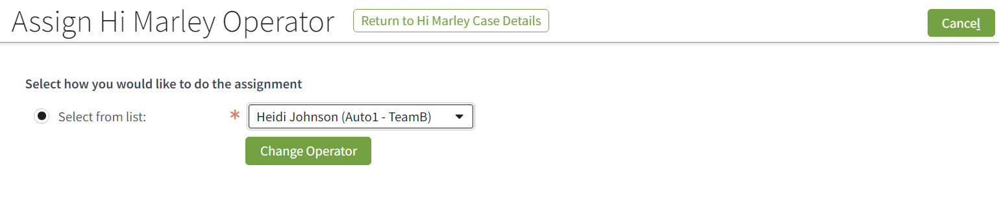
When we change the operator and the selected operator is assigned as a secondary operator, then it will be removed from the list of secondary operators and set as an operator.

- Operator change during re-assignment of Claim. When re-assign a claim from one Adjuster to a new Adjuster, all Hi Marley cases’ operators will change to the new Adjuster if the original operator of the case was same as the previous adjuster. However, any case with non-adjuster operator should remain the same.

Note: Both operations may take a while for new operator to be reflect on Hi Marley side since if an operator does not exist in Hi Marley before, ClaimCenter will attempt to register the new operator with Hi Marley first. This auto-registration will fail if this option is turned off in Admin tab hence causing the reassignment fail.

Hi Marley Admin Permissions
- Change system level permissions in the Admin tab.
Following are system level permissions than can be found under the new “Hi Marley Operator” entry under “Administration”
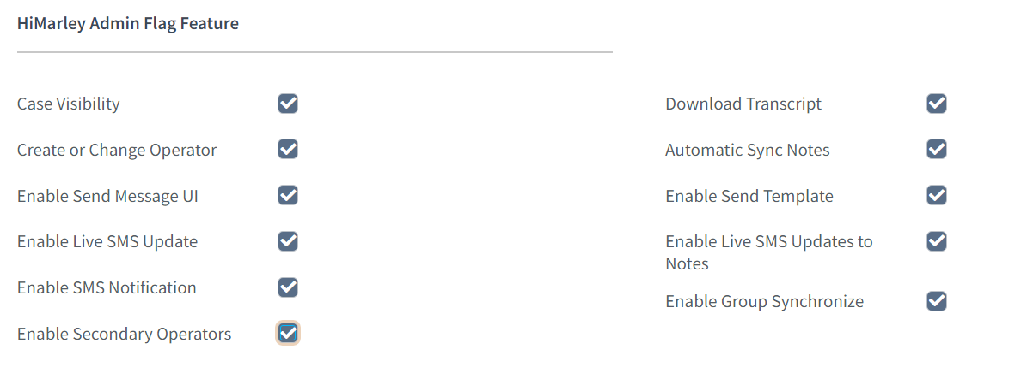
Each system level permission can be turned on/off by checking its checkbox.

Behaviors of these system level permissions are as follows:
Permission | Behavior
Case Visibility | Enable/Disable accessibility of Hi Marley cases
Create or Change Operator | Enable/Disable of change/create a case operator
Enable Send Message UI | Enable/Disable SMS to allow SMS to be sent from ClaimCenter
Enable Live Update | Enable/Disable ClaimCenter receiving SMS messages from Hi Marley via Web Hook
Download Transcript | Enable/Disable Ad Hoc Downloading of Transcript
Automatic Sync Notes | Enable/Disable ClaimCenter receiving Hi Marley case updates
Enable Send Template | Enable/Disable using template for sending SMS from ClaimCenter
Enable HiMarley Group Update | Enable/Disable synchronization of groups from Claim Center to HiMarley
Enable Secondary Operators | Enable/Disable adding/removing Secondary Operators

- Change duration of “Automatically resend Welcome SMS”. This option is default to 24 hours after the first “Welcome SMS” is sent. User can adjuster this number to required duration by business.
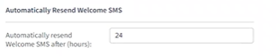
Note: By default, none of the permission is turned on. Please turn on these permissions when enabling Hi Marley in carrier’s implementation after deployment to an environment.

Disable Hi Marley messages in Claim Notes
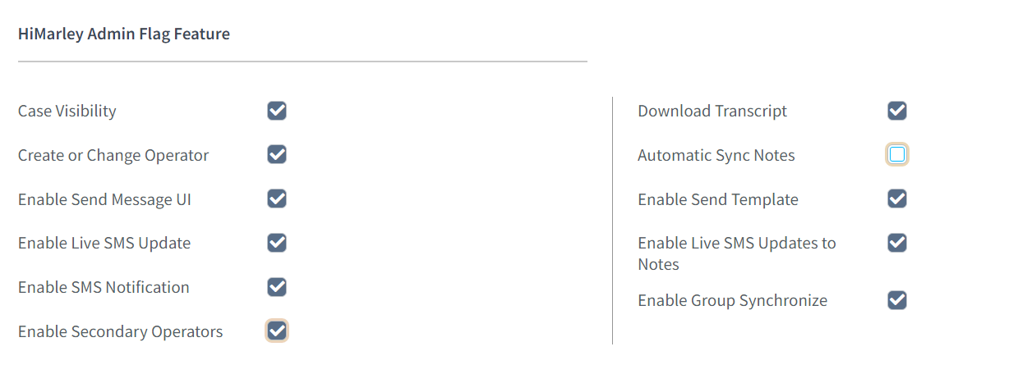
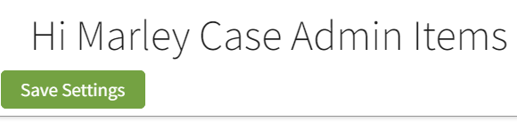
To Disable Hi Marley Case notes in Case Details from syncing, uncheck the ‘automatic sync notes’ and then select the ‘save settings button.’

Sending SMS as "Super User" will throw an "unknown" does not exist error (new)
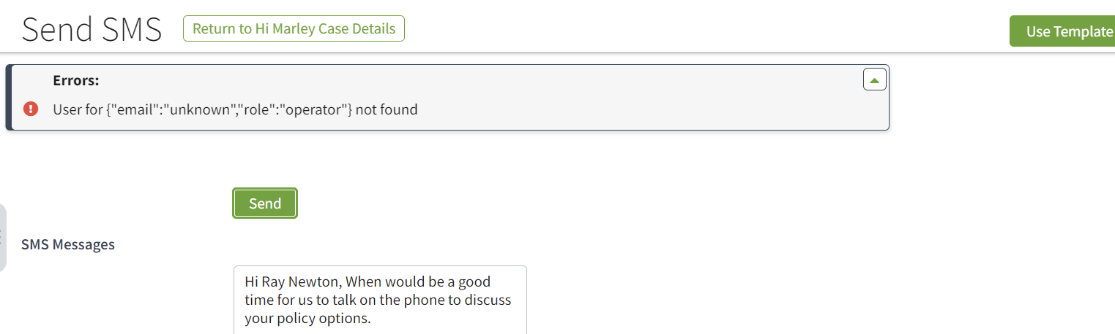
When the “Super User” is selected as the operator, the error message above will be received.

Disable Hi Marley Messages in Claim notes.
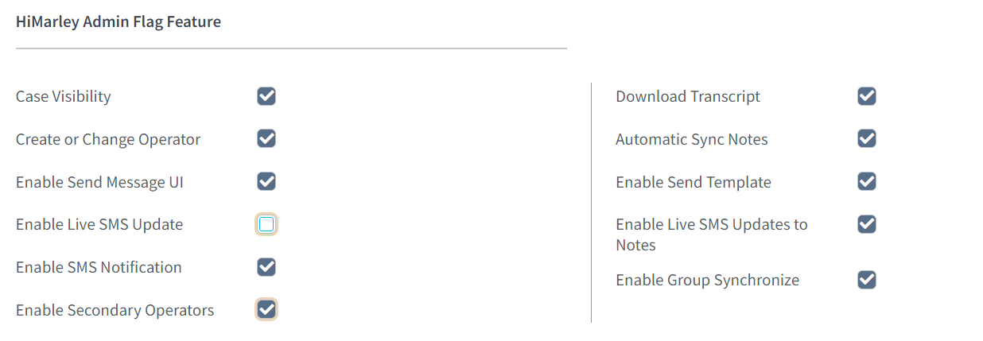
To disable Hi Marley messages in claim notes, uncheck the enable live update flag feature.

Hi Marley Permissions
- Following Hi Marley permissions were created and can be added to any ClaimCenter role:
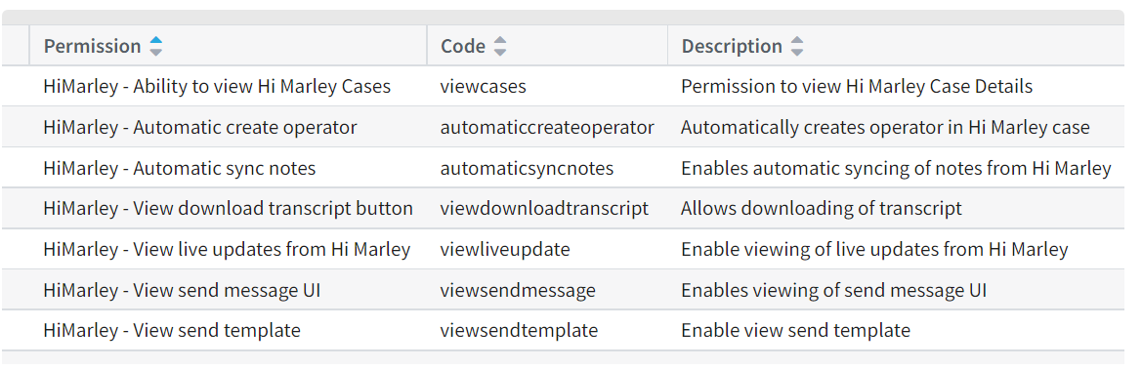

Note: Although these permissions can be added to any ClaimCenter role, in order to show clear responsibility for handling Hi Marley cases, it is recommended that Carrier to create a new “HiMarley Operator” role with these permission added during implementation time.

Administration of SMS Templates
- Add/Remove SMS templates
Select new “Hi Marley Operator” entry under “Administration”, then choose “Hi Marley Case Admin Add/Remove Template” in Navigation bar on the left:
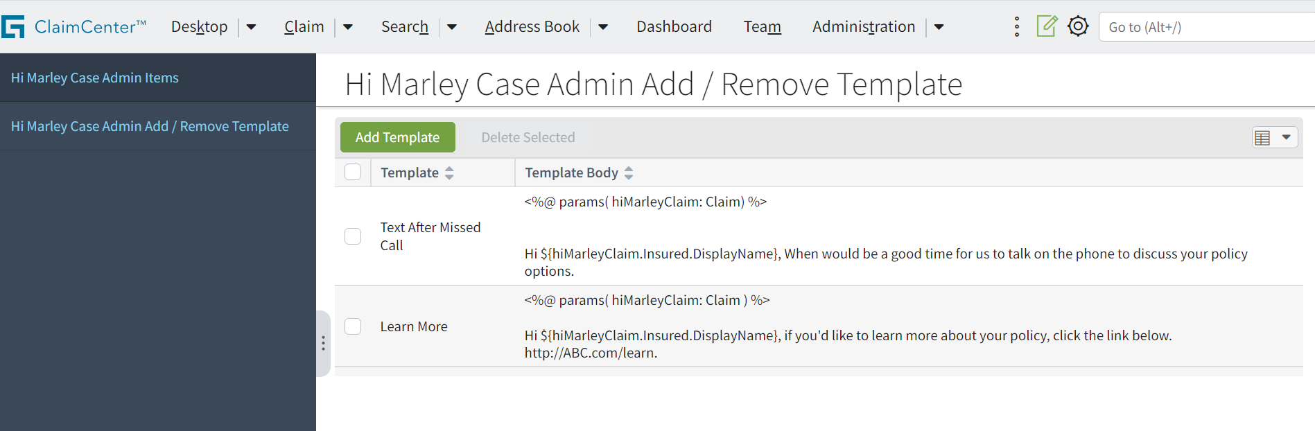

This will show the list of templates that can be used by SMS.

Select existing Template can allow it to be Deleted.
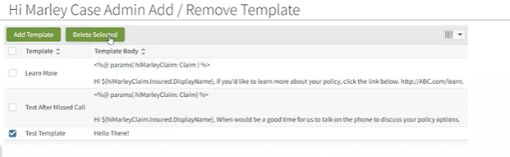

Clicking on “Add Template” will open the “New Template” screen to add new template:
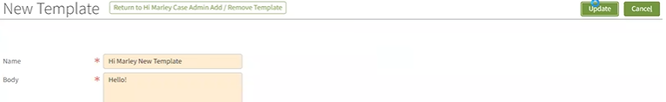

Note: SMS templates use same syntax as ClaimCenter’s “Template” object.
Note: SMS templates can only be added/removed but NOT editable.
ClaimCenter Variables in Message Templates
- Usage of ClaimCenter variables to autofill message templates
Message template will be in this type of format
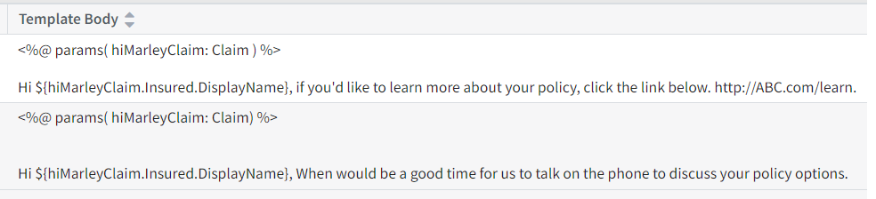
Inside the left and right angle brackets (<%params( )%>), you declare the parameters that the template would use
Ex: <%@params(hiMarleyClaim: Claim)%>
In the next line, you would put the template with the parameter(s) and its associated variables.
Ex: Hi $(hiMarleyClaim.Insured.DisplayName)
This is getting the Display Name of the Insured under the Hi Marley Claim.
Some more examples include hiMarleyClaim.Insured.EmailAddress1.CityStateZip, hiMarleyClaim.Insured.HomePhone, and hiMarleyClaim.Insured.EmailAddress1.
For further reference, request a dictionary zip file from Guidewire for a list of all possible parameters:
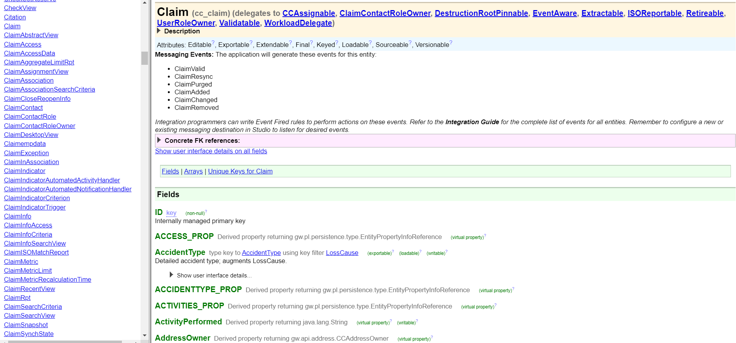
Generated and Disable Activities
- Activities that are generated by accelerator
The accelerator can send SMS, translate SMS through multiple languages, change case privacy, download transcript, close case manually, resend welcome message, set it so it automatically resends welcome message if user is not opted in, and receive SMS, notes, opt status, claim status through webhooks and synchronizing groups with HiMarley

- To disable some of the features, navigate to the Hi Marley Operator page.
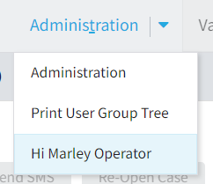
Under “Hi Marley Case Admin Items”, disable and enable the activities you want. To change the auto welcome resend, change the parameter under “Automatically Resend Welcome SMS.”
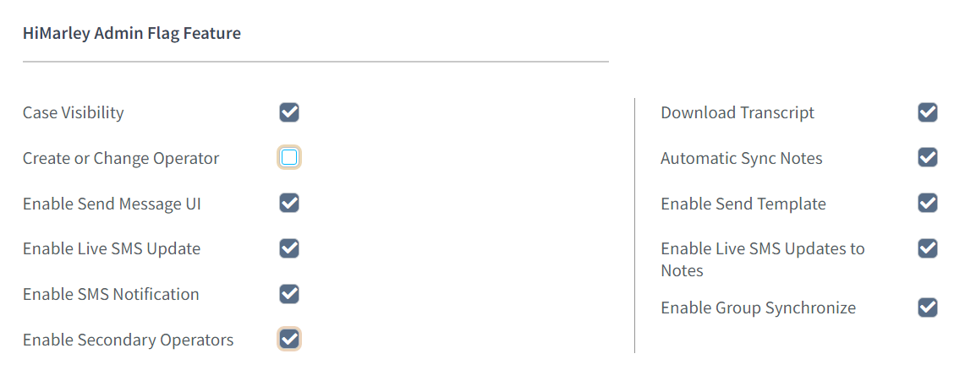

Implement Send SMS API
- Code to implement the Send SMS API call into any ClaimCenter workflows for automated SMS notifications during an event.
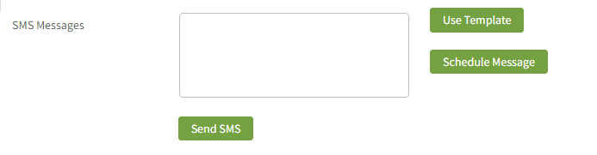
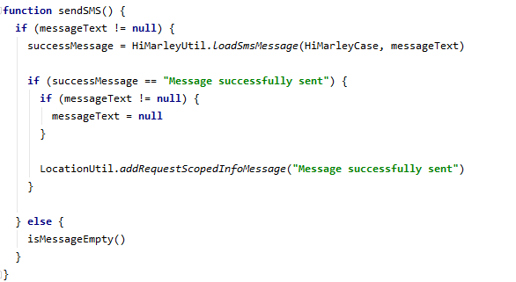
Send button will trigger an activity run the send SMS API.
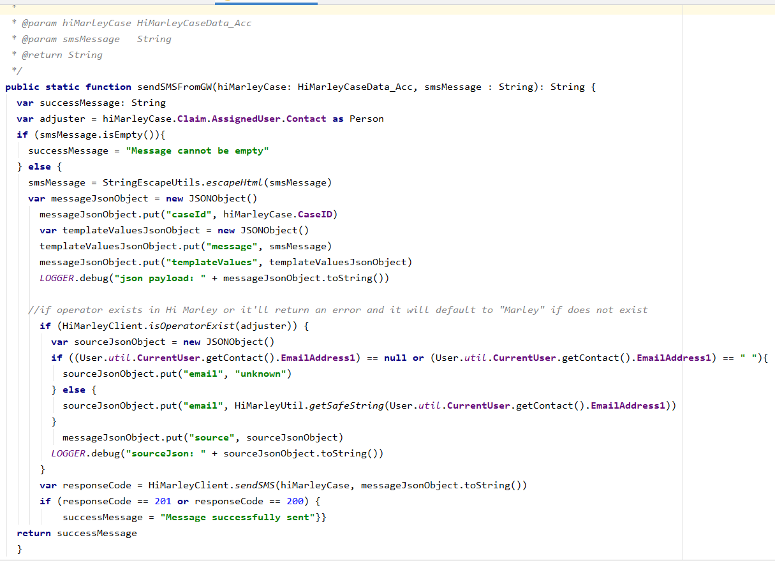
ClaimCenter will check if the user currently logged in exists in Hi Marley before sending the SMS from ClaimCenter. If logged in as “su”/super user, then it will return an “unknown” email does not exist notification.
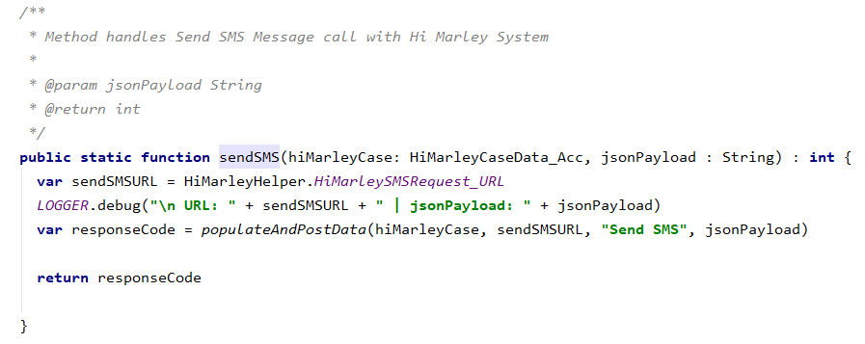
If the email exists within Hi Marley, then the sendSMS function will be called and the send SMS API URL is generated.
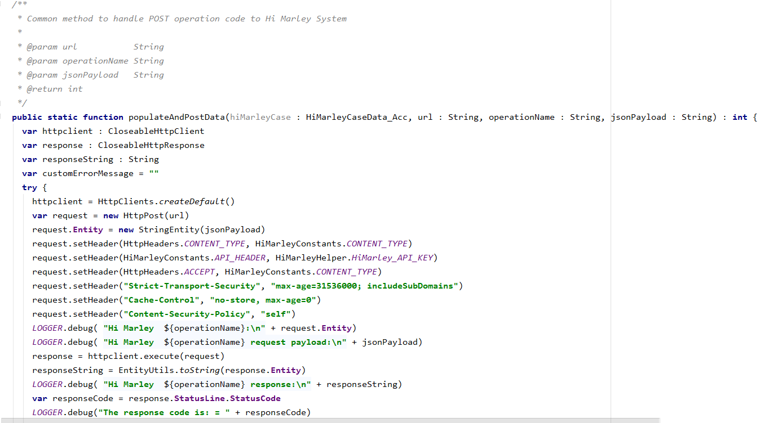
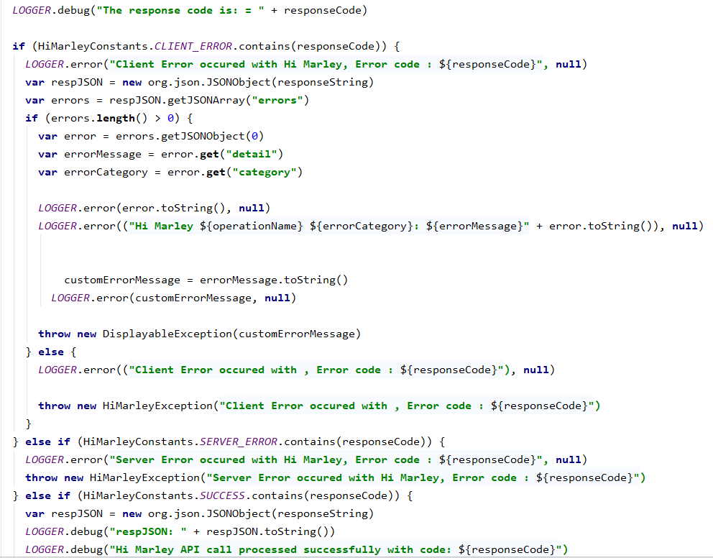
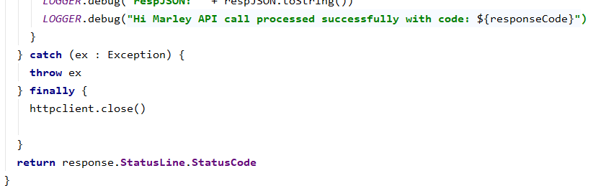
The JSON payload for the API call gets populated and using the generated URL, the SMS message gets posted to Hi Marley using RESTful API.
Error Handling
- Common error handling patterns in accelerator.
All errors will be logged. However, there are some that will show errors in the ClaimCenter UI:
  - Duplicate combination of customer mobile + claim number
  - Reached max open case limit
  - Operator (Hi Marley PrimaryContact) doesn't exist in org
  - Customer mobile is a landline
  - Brand name mismatch
  - Customer is Opted Out
  - Sending SMS as "Super User" will throw an "unknown" does not exist error
  - PrimaryContact doesn't exist in org
Adding new languages
- Adding a new language supported by Hi Marley to the Case Creation and Update APIs.
To add a new language supported by Hi Marley, go to Guidewire Studio and open the file “HiMarleyPrefLanguage_Acc.HiMarley.tti”
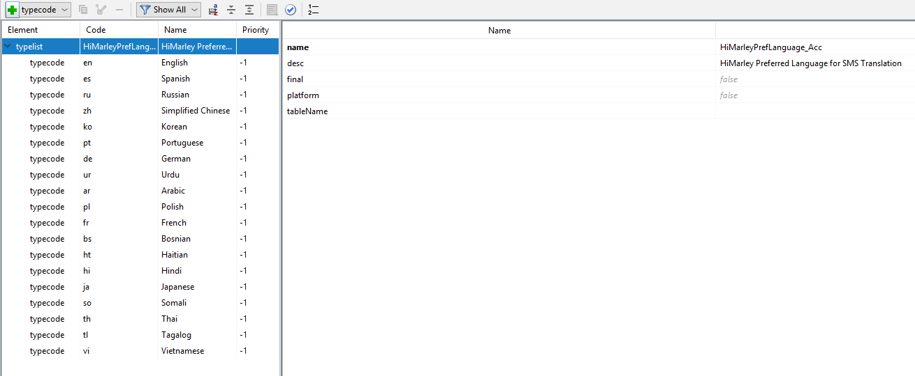
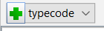
Click on the “+ typecode” button.
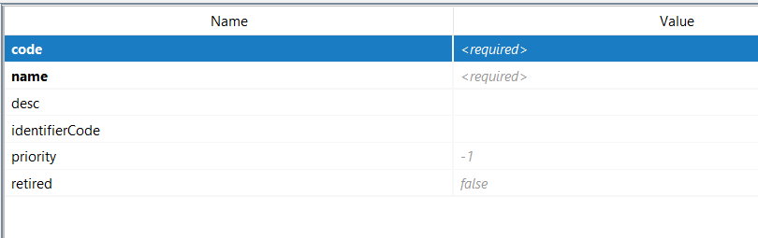
Fill out the following table. Use the existing typecodes as a reference on how to add the new language.
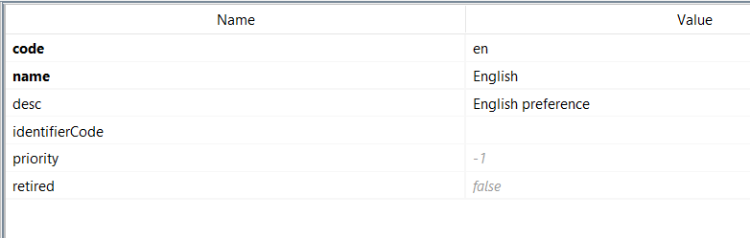

Parties Involved - Contacts - Hi Marley Cases card

On the claim, in the Parties involved - contacts tab, you will find a list of contacts. Each contact has a 'HiMarley Cases' tab. If a case is created for a given contact, it will be visible on the list. Only one case can be created for each contact.

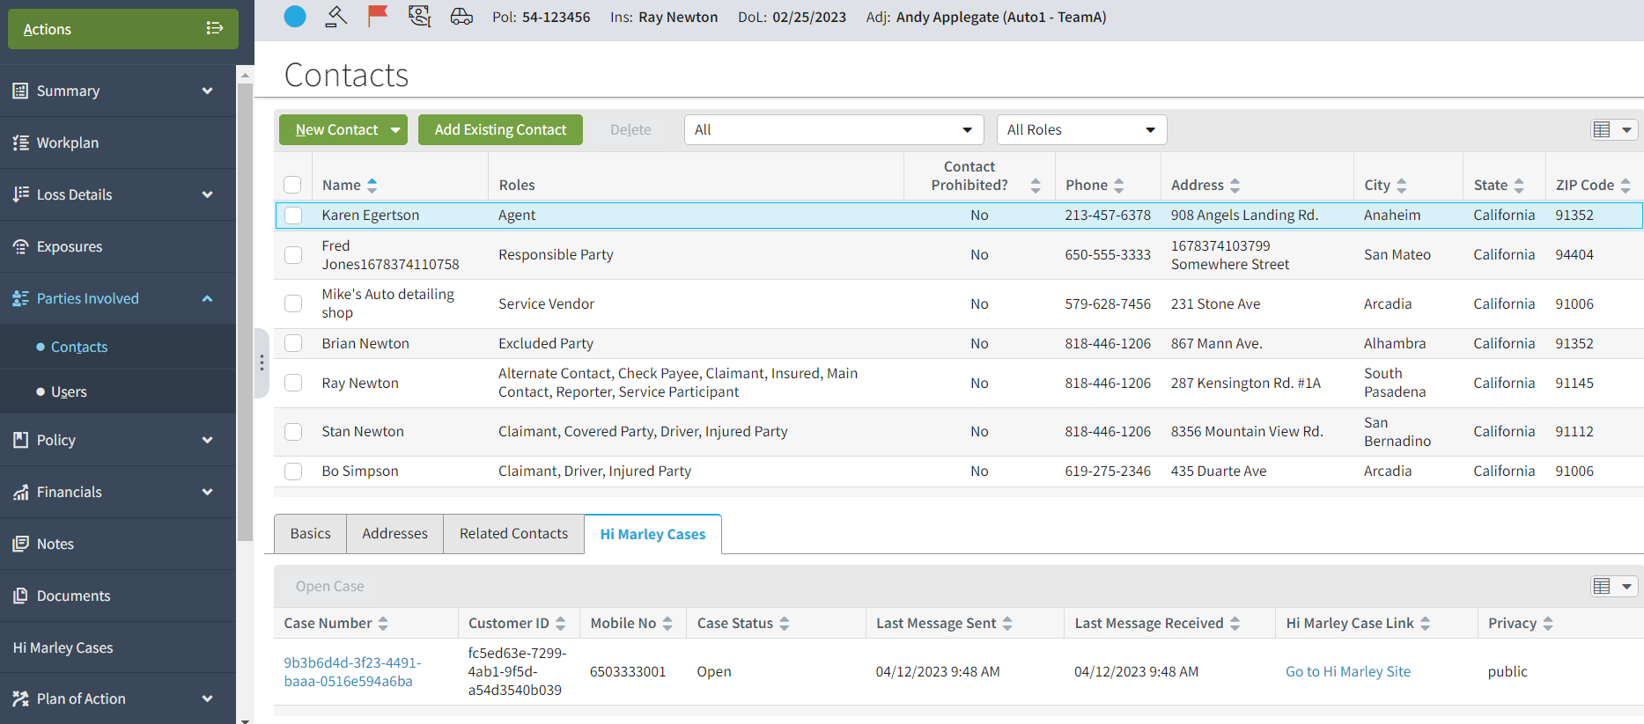

If the contact is not assigned to any case, we can open a new case for this contact. To open a new case, click the ‘Open Case’ button. Then you will be redirected to the new case creation page.
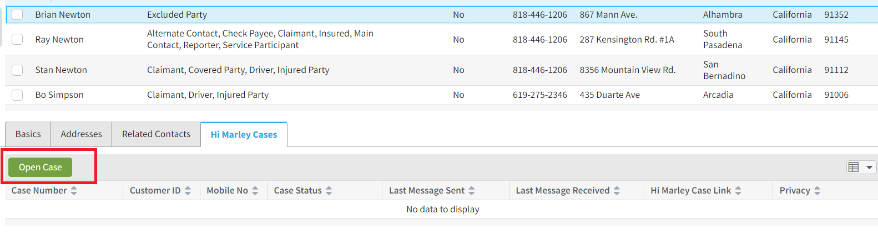

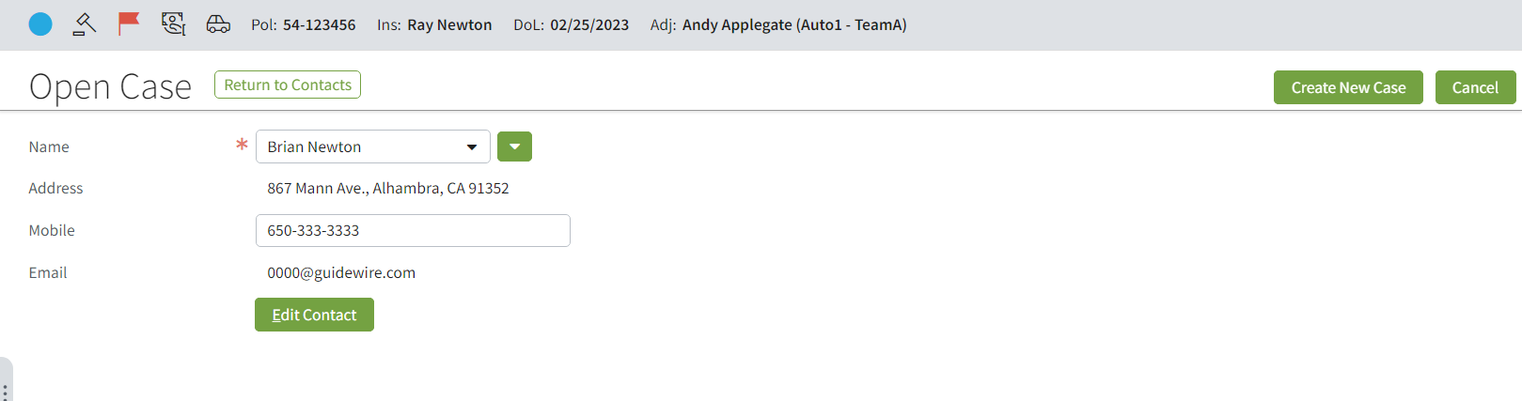

The "Open Case" button will be unavailable if the contact already has a case assigned to it or if the contact is not the "person" type. (screen below)
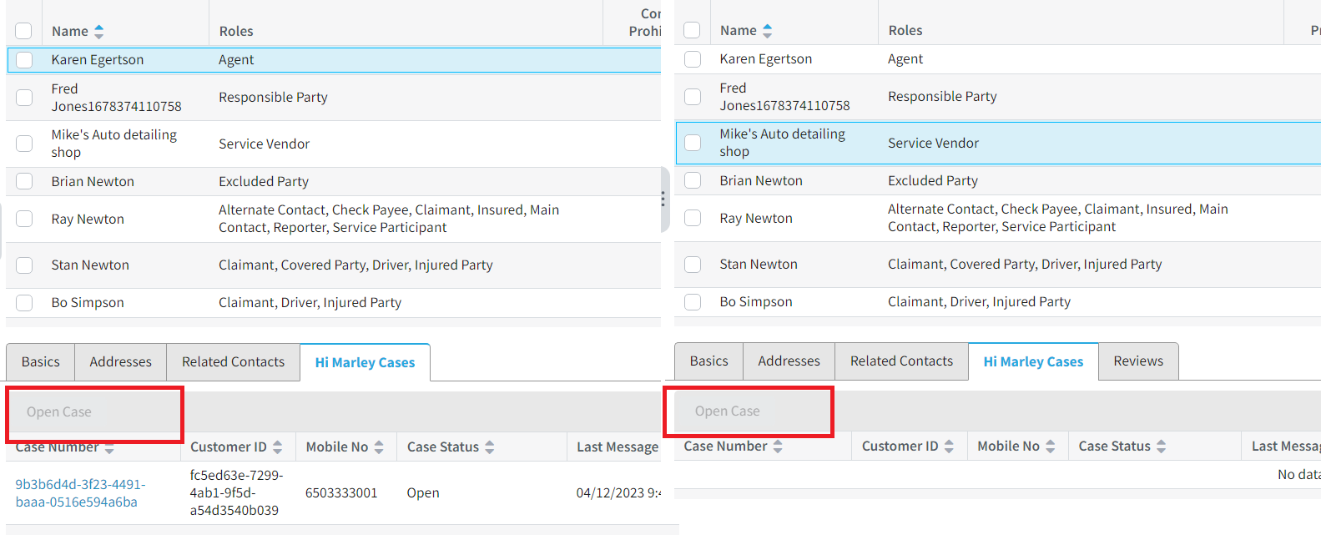

Synchronize groups
The groups can be sent from Claim Center to Hi Marley. It can be done when the user enabled activity ‘Enable Group Synchronize’ and added permission ‘HiMarley - View group synchronize’.
Enable synchronizing groups with Hi Marley
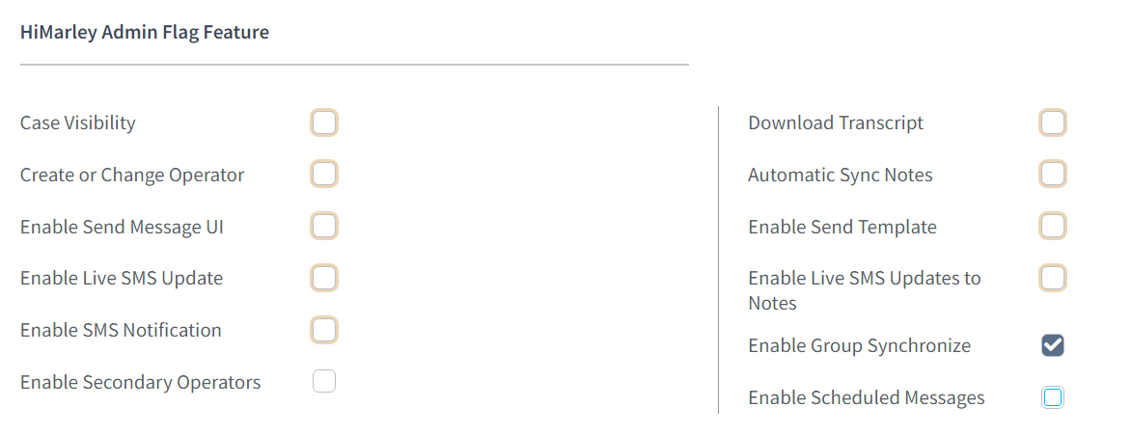
To enable a synchronization of groups with Hi Marley, mark the ‘Enable Group Synchronize’ and then select the ‘save settings’ button.
Hi Marley - view group update permission
Add ‘HiMarley - View group synchronize’ permission.
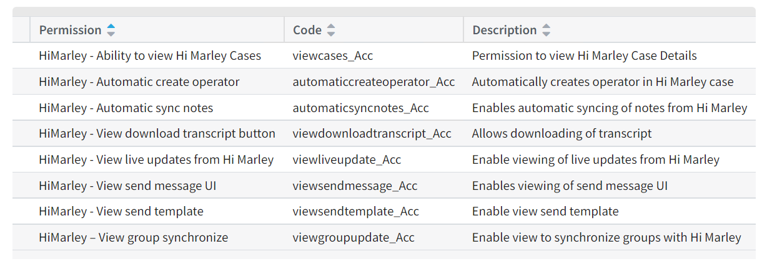
Using ‘Synchronize Group’ button
Go to Administration, click on any group. There is a ‘Hi Marley Group Sync’ button. By default this button is grayed out. It will be visible only when the user enabled activity ‘Enable Group Synchronize’ and added permission ‘HiMarley - View group synchronize’.
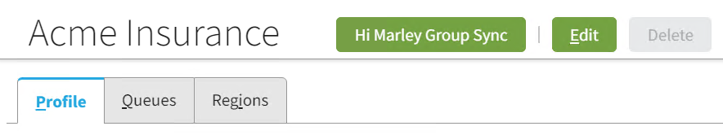
After clicking on synchronize group button, the following pop up will show up to confirm the action:
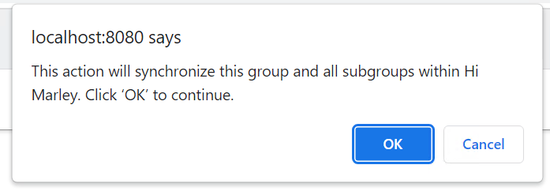

This button will synchronize the group which is currently highlighted and all the subgroups. The data will be sent asynchronously via HiMarleyGroupWorkQueue. The creation of the work items is implemented in the class HiMarleyAddonHelper. The work queue will send to HiMarley only those groups which have Supervisor which already exists in HiMarley and at least one user which is HiMarley user.
When the work item will be processed, requests will be sent to HiMarley to check the current status of the supervisor and each of the users. Each user has a new indicator ‘User is Active in HiMarley’ which by default is set up to ‘No’, it will be updated automatically after the Claim Center receives the response from HiMarley.

This indicator can be also changed manually when editing the user’s data.

The table below shows what actions can be performed when processing work items:

Group has the supervisor which is active in HiMarley and at least one user which exists in HiMarley | Group already exists in HiMarley | Action
yes | no | group created in HiMarley
no | no | group not created in HiMarley
yes | yes | group updated in HiMarley
no | yes | group removed from HiMarley
After creation of the group in HiMarley, or update of the group in HiMarley, the indicator ‘Enable GroupSync’ on the group will be set to ’ Yes’. By Default this indicator is set up to ‘No’.
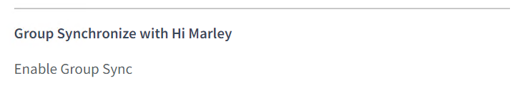
Each group in HiMarley, will have a name which contains a path with all names of parent groups. This is a way to show the structure of groups which exist in the Claim Center.
Creating new Group
Go to Administration -> Action -> New Group
On this screen there are two new indicators ‘User active in Hi Marley’ and ‘Enable Group Sync’.
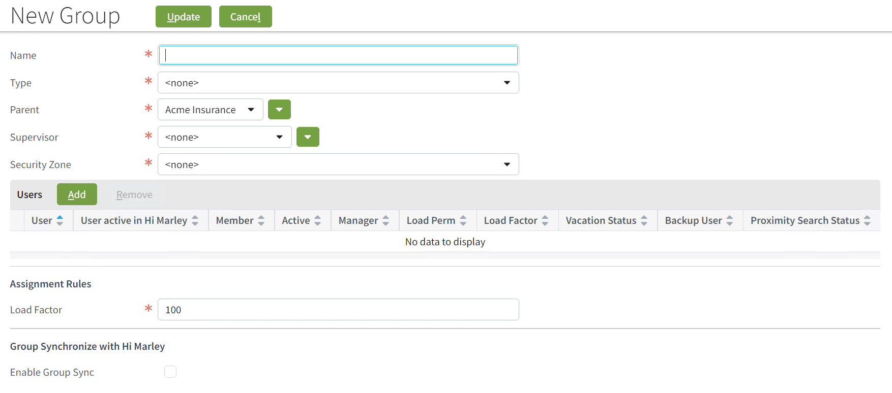
Indicator ‘User active in Hi Marley’ can be edited manually (during creation of the user and on the page with edition of the user’s data) and automatically (each time before the group synchronization is sent to HiMarley).
Indicator ‘Enable Group Sync’ can be edited manually (during creation of the group and on the page with edition of the group’s data) and automatically (during the synchronization with the usage of ‘Hi Marley Group Sync’ button).
The checkbox ‘Enable Group Sync’ can be marked only when the group contains Supervisor which exists in HiMarley and at least one user which also exists in HiMarley. When you hover the cursor over the checkbox, then the information about that will show up.

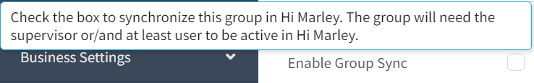

The table below shows what actions can be performed when processing the group:
Group has the supervisor which is active in HiMarley or at least one user which exists in HiMarley | Group Synchronize HiMarley Checkbox | Action
yes | no | group created in CC, group not migrated to HiMarley
no | no | group created in CC, group not migrated to HiMarley
yes | yes | group created in CC, group migrated to HiMarley
no | yes | group created in CC, group not migrated to HiMarley
The creation of the group in HiMarley uses messaging. Clicking on the button ‘Update’ will trigger rule ‘GroupAdded’.
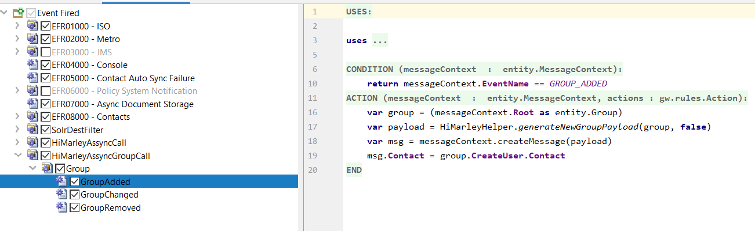
Then the code goes to HiMarleyAssyncGroupTransPlug class, to the method ‘send’. The messageRoot is a type of group in this case, so the code goes to the method process group where based on the conditions described above, the program decides which action should be taken with a group in HiMarley. All methods which are responsible for open, updating or removing a group from HIMarley during the synchronization are defined in the class HiMarleyAddonClient.
If ‘Enable Group Sync’ is checked and the list of users contains the supervisor, the following confirmation message will be shown:
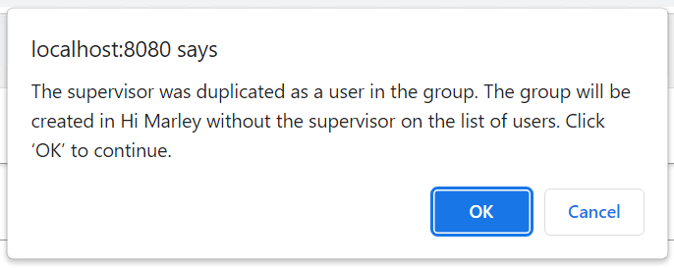
When the user clicks the ‘OK’ button the group will be created in HiMarley chat, but without the supervisor on the list of users. In the Claim Center the user will be saved as a supervisor and the user.

Updating an existing Group
Click on the group -> Edit
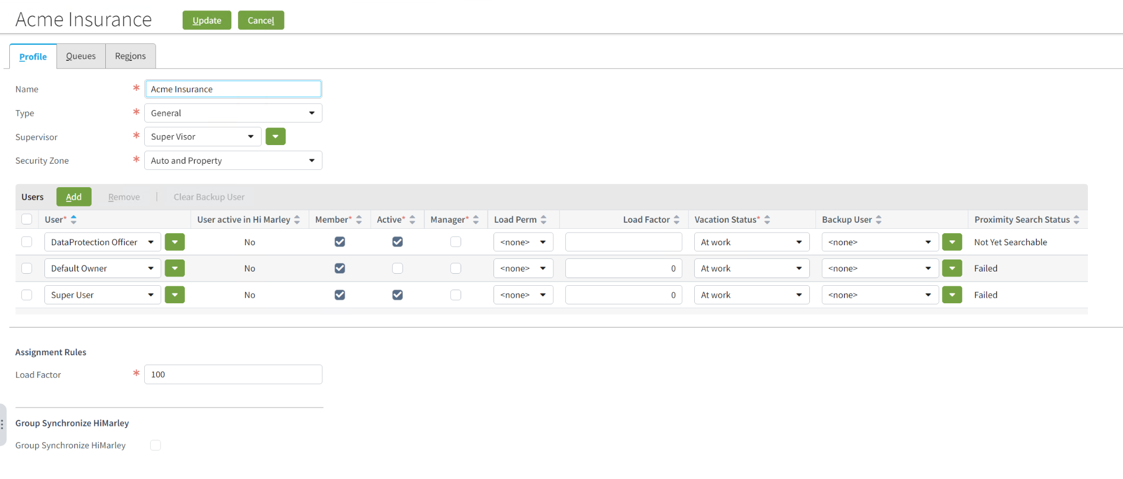
On this page there are also the new indicators - ‘User active in Hi Marley’ and ‘Group Synchronize HiMarley’ which have been described in the previous section.
The table below shows what actions can be performed when processing the group:
Group has the supervisor which is active in HiMarley or at least one user which exists in HiMarley | Group already exists in HiMarley | Group Synchronize HiMarley Checkbox | Action
yes | no | yes | group created in HiMarley
yes | no | no | group not created in HiMarley
no | no | no | group not created in HiMarley
yes | yes | no | not updated in HiMarley
yes | yes | yes | group updated in HiMarley
no | yes | no | group removed from HiMarley
Additionally, if you update the parent of the group in the Claim Center, then the parent group will be also updated in HiMarley chat - this group will be assigned to the new parent.
The update of the group in HiMarley uses messaging. Clicking on the button ‘Update’ will trigger rule ‘GroupChanged’.
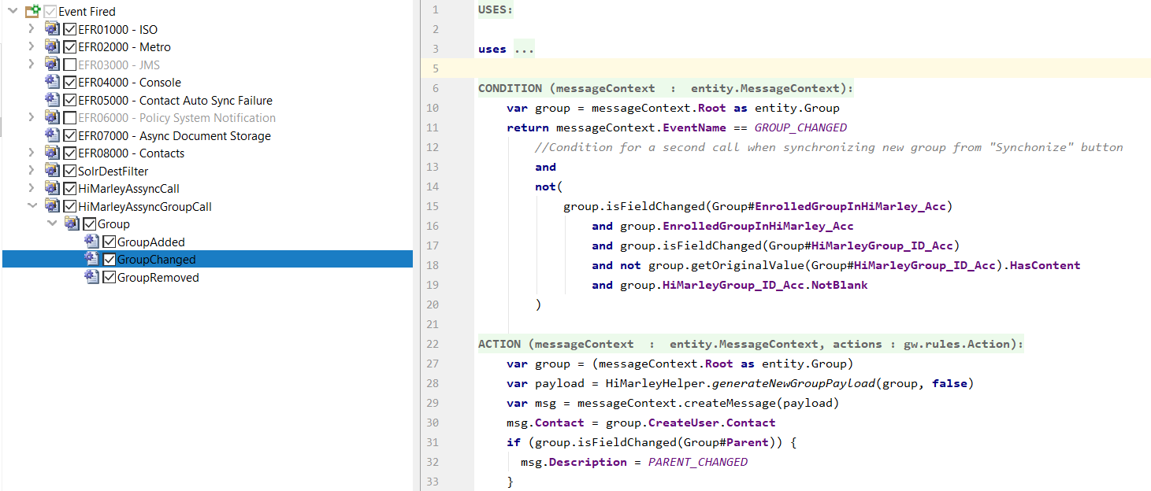

Then the code goes to HiMarleyAssyncGroupTransPlug class, to the method ‘send’. The messageRoot is a type of group in this case, so the code goes to the method process group where based on the conditions described above, the program decides which action should be taken with a group in HiMarley. During the update of a group, the code can update or remove the group in HiMarley, through the methods updateGroup or removeGroup.
If the update is made on the group which already exists in HiMarley and the users which are active in Hi Marley will be removed or the supervisor will be changed to someone who doesn’t exist in Hi Marley, then after clicking on the button ‘Update’, the following confirmation message will be shown:
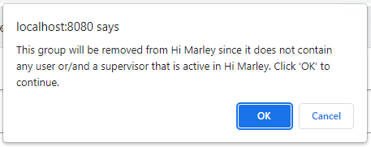
Only when ‘OK’ will be chosen, the group will be removed from Hi Marley and updated in the Claim Center. After clicking on ‘Cancel’, the group won’t be updated neither in Claim Center nor in Hi Marley.
If the group exists in Hi Marley and ‘Enable Group Sync’ will be unchecked, then the following confirmation message will be shown:
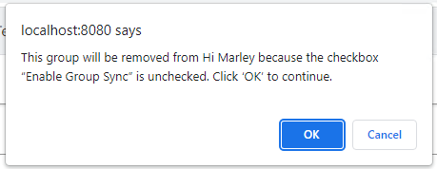
Only when ‘OK’ will be chosen, the group will be removed from Hi Marley and updated in the Claim Center. After clicking on ‘Cancel’, the group won’t be updated neither in Claim Center nor in Hi Marley.
If ‘Enable Group Sync’ is checked and the list of users contains the supervisor, the following confirmation message will be shown:
When the user clicks the ‘OK’ button the group will be updated in HiMarley chat, but without the supervisor on the list of users. In the Claim Center the user will be saved as a supervisor and the user.
Removing an existing Group
The group can be removed by clicking on the ‘Delete’ button. This button is available only when all the members and queues are removed from the group.
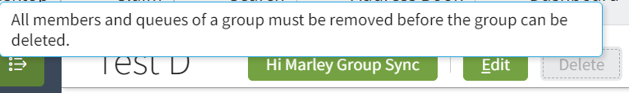
When all users and queues are removed, the user can click on the ‘Delete’ button.
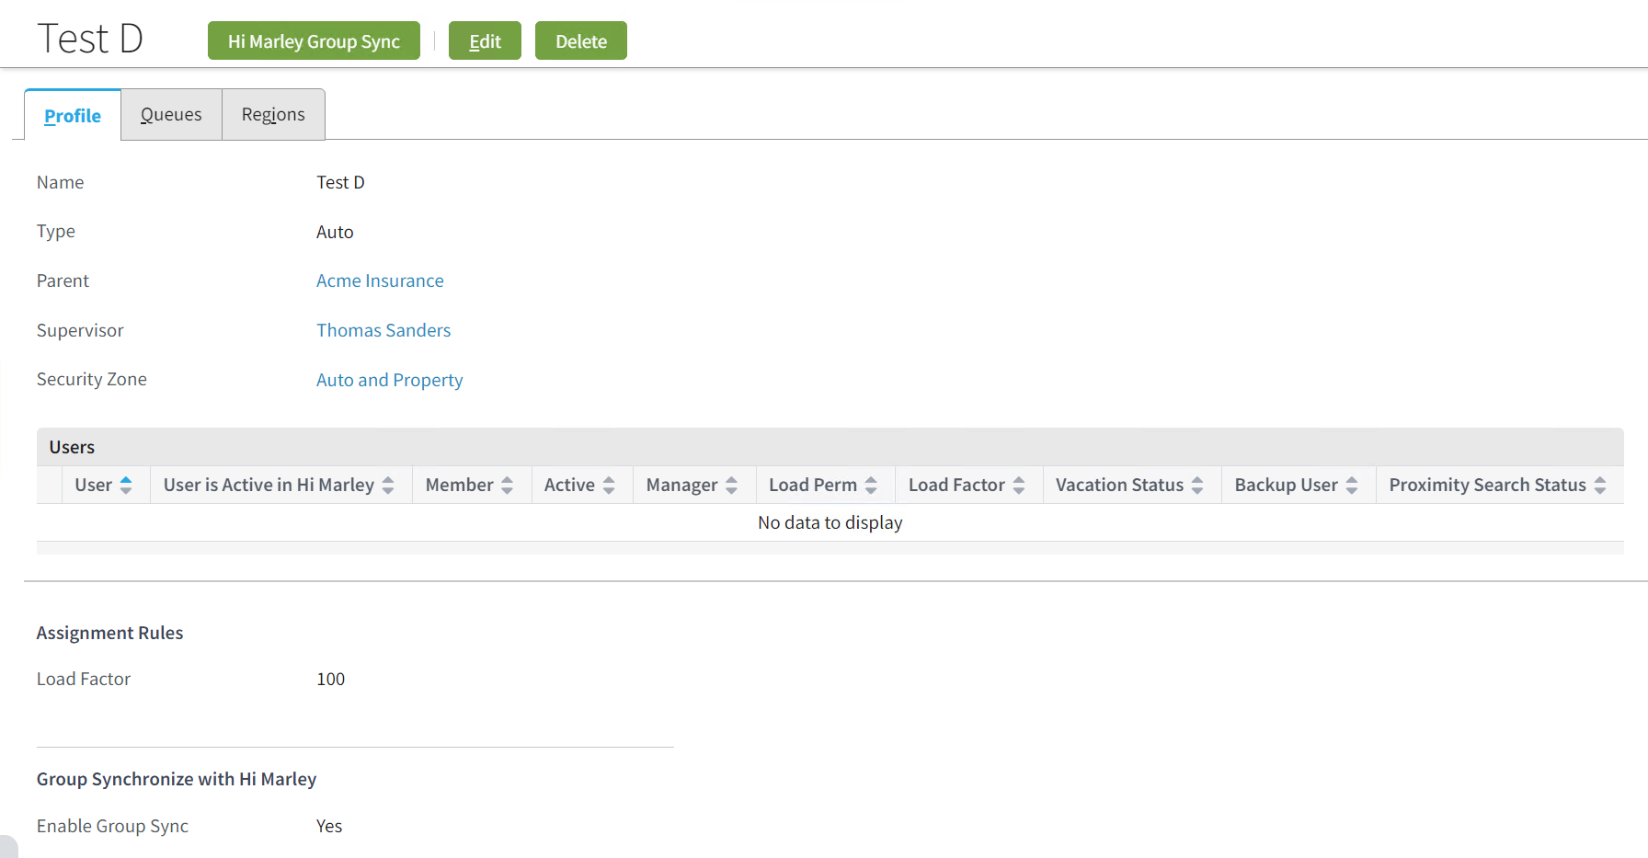

When the user clicks on the ‘Delete’ button, two types of confirmation messages can be shown.
One type of confirmation message is shown when the group doesn’t exist in Hi Marley chat. Then there is a general question about deleting the group
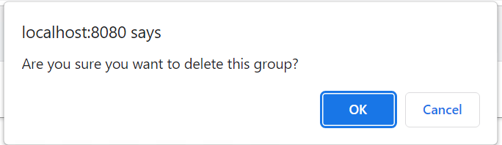
The other type is shown, when the group was synchronized with HiMarley, then there is an additional question about removing the group also from there.
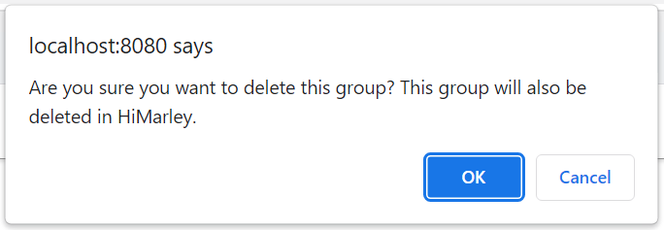
The removal of the group in HiMarley uses messaging. Clicking on the button ‘Delete’ will trigger the rule ‘GroupRemoved’.
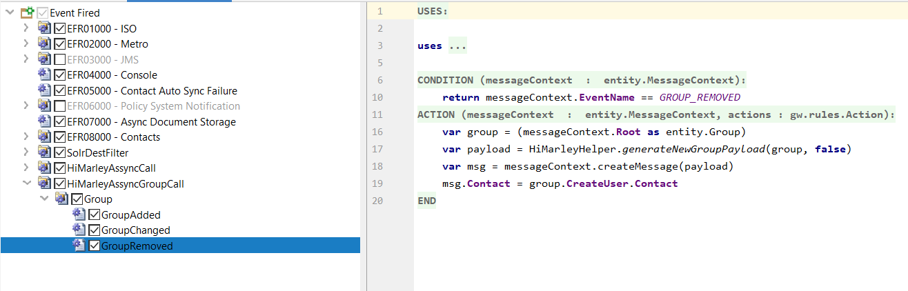
Then the code goes to HiMarleyAssyncGroupTransPlug class, to the method ‘send’. The messageRoot is a type of group in this case, so the code goes to the method process group. If the group existed in Hi Marley chat, it’s removed from there and from the Claim Center. If the group doesn’t exist in Hi Marley it’s removed only from the Claim Center.

Message Alerts
In the ‘Hi Marley Case Admin Items’ panel there is a part called ‘Coaching’ which contains checkboxes.
Coaching Alerts – Turns on the UI changes on the message level table
Generate Assigned Adjuster Activity – Generates an activity for messages that need attention for the primary operator assigned to the case
Generate Supervisor Activity – Generates an activity for messages that need attention for the supervisor of the primary operator assigned to the case
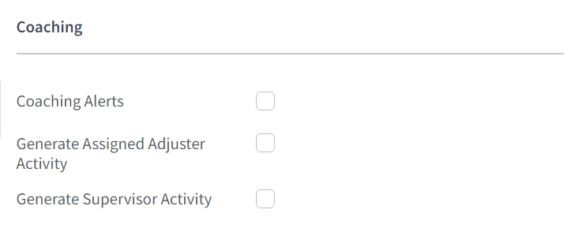
When a person hovers a cursor over one of the checkboxes there is information that the organization needs to have the coaching bundle as part of their contract in order to leverage these features and to reach out to their Customer Success manager for more information.

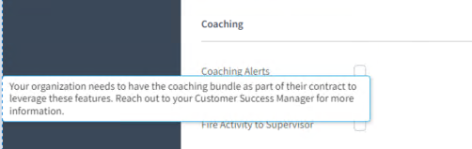
When a ‘Coaching Alerts’ checkbox is marked then on the screen ‘Hi Marley case Details’ in the table ‘List View of All SMS Messages and Notes received from Hi Marley’ there is an additional column ‘Message Alerts’. Claim Center can receive a message with different types of message alerts. Currently there are two types of message alerts: ‘needs attention’ and ‘needs action’. If this message was marked with message alerts in HiMarley, then the webhook receives another response from HiMarley which contains ‘messageClassifications’ with the flag/flags (‘needsAttention’ or ‘needsAction’). Based on this flag the message is updated in the Claim Center and the information ‘Needs attention’ or ‘Needs action’ in red is shown in the column ‘Message Alerts’. The color of this message is connected with the activities which are created when two other checkboxes (‘Fire Activity’, ‘Fire Activity to Supervisor’) are marked. It will be red as long as the activity is open. When the activity will be closed, the label ‘Needs attention’ will change color to black. If the other two checkboxes in ‘Coaching’ in the admin panel are unmarked, the label will be black from the beginning.
When the payload contains message alerts with the ‘needsAttention’ flag, or both flags - ‘needsAttention’ and ‘needsAction’, then the column ‘Message Alerts’ in the table ‘List View of All SMS Messages and Notes received from Hi Marley’ on ‘Hi Marley Case Details’ contains the information ‘Needs Attention’
When the payload contains message alerts only with ‘needsAction’ flag, then the column ‘Message Alerts’ in the table ‘List View of All SMS Messages and Notes received from Hi Marley’ on ‘Hi Marley Case Details’ contains the information ‘Needs Action’
*The flags ‘Coaching Alerts’ and ‘Live SMS Updates’ need to be enabled.
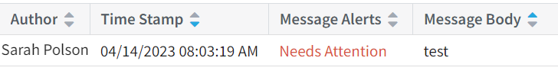
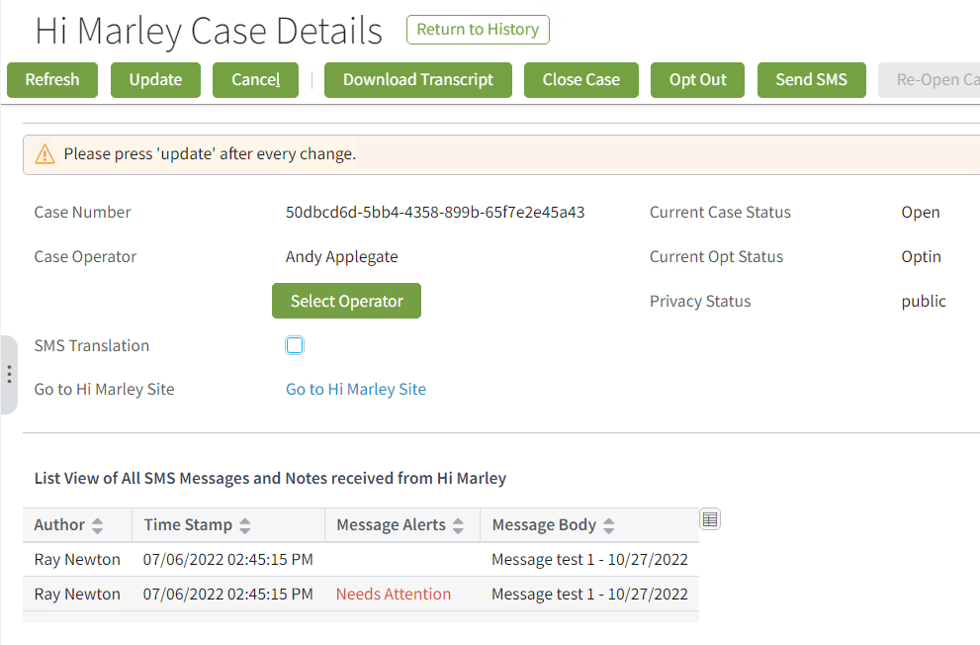
When the checkbox ‘Generate Assigned Adjuster Activity’ is marked, then the activity will be created and assigned to the operator.
When the checkbox 'Generate Assigned Adjuster Activity’ is marked, then the activity with the subject ‘Conversation Needs Attention’ will be created and assigned to the supervisor of the primary operator.
The activity has priority set up to High and due date set up as current date to alert the operator that the client is stressed out and action needs to be taken immediately.
For all the activities described above, when the payload contains message alerts with the ‘needsAttention’ flag, or both flags - ‘needsAttention’ and ‘needsAction’, then the ‘Subject’ of the activity will be set up to ‘Conversation Needs Attention’. If the payload contains only the flag ‘needsAction’, then the ‘Subject’ will be set up to ‘Conversation Needs Action’.
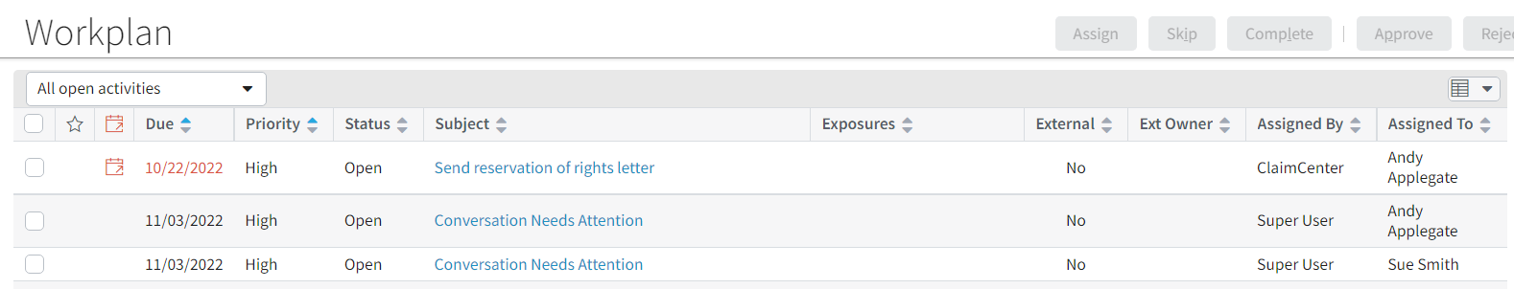
When the user clicks on the activity, the following screen will show up. For the activities with the subject ‘Conversation Needs Attention’ and ‘Conversation Needs Action’ there is an additional field - ‘Case ID’. It opens the page with the mentioned case ID.
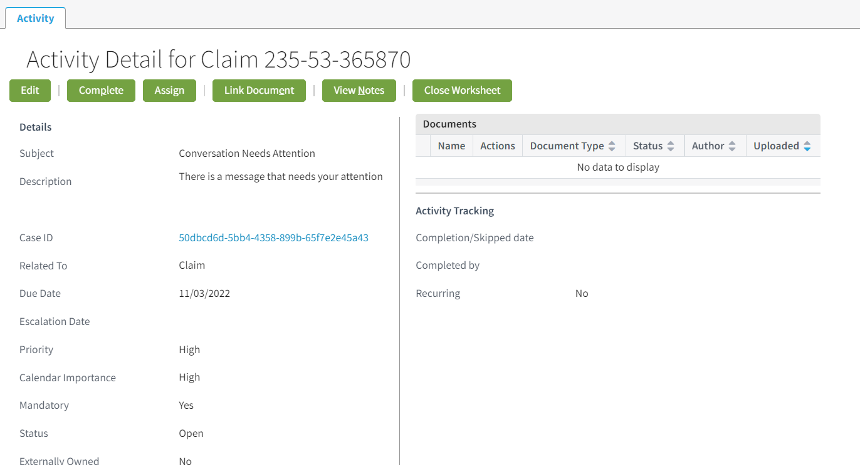

Secondary Operators
Secondary operators in the Hi Marley chat are useful to show cases in the adjuster's inbox without being assigned as the primary operator.
- See all adjusters assigned as a secondary operator to the specific case
- Update the secondary operator table to add/remove adjusters
- Sync Operators added/removed from Guidewire to Hi Marley
- Sync Operators added/removed from Hi Marley to Guidewire
Enable Secondary Operators feature
In the Claim Center on the page ‘Hi Marley Case Admin Items’ in the section HiMarleyAdmin Flag Feature there is a flag ‘Enable Secondary Operators’. it Allows the admin to disable/enable secondary operators from being added/notified. Although it has no effect on refreshing the secondary operators from the Hi Marley chat.
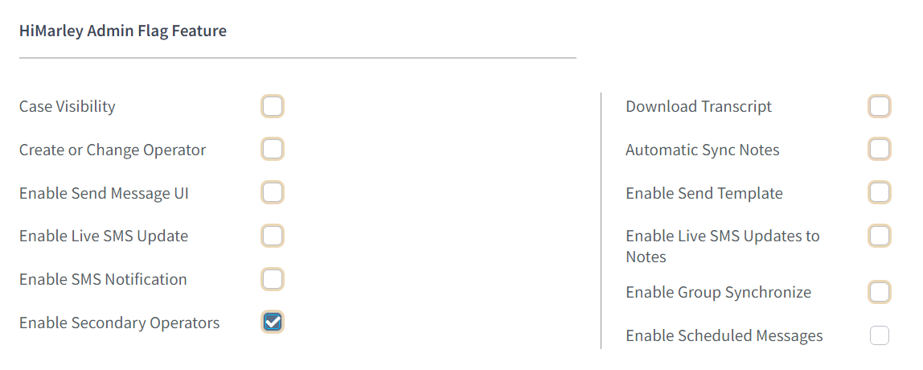
There is also an additional role - ‘Hi Marley - Secondary Operators’, which can be assigned by admin to the chosen users. It allows the user to modify the content of the table secondary operators.
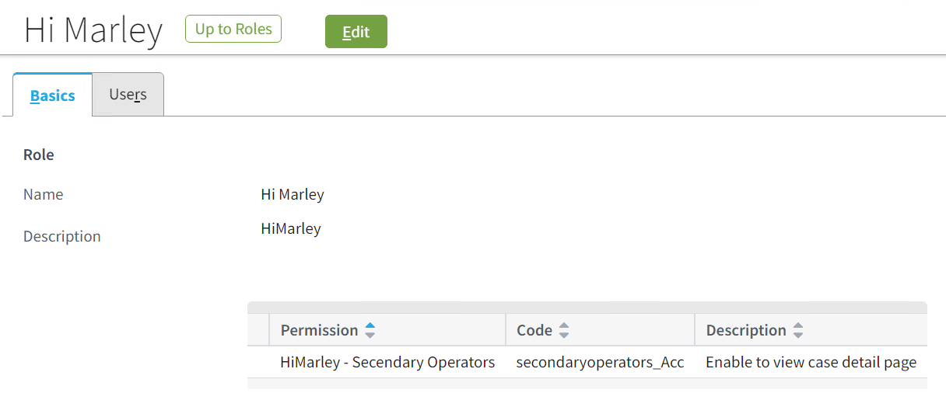
Editing Secondary Operators
For each of the cases there is an additional option to assign not only the person who will be the operator. There is also a table which contains a list of secondary operators. Those operators are the users which have access to the case without being assigned to the case as a primary operator.
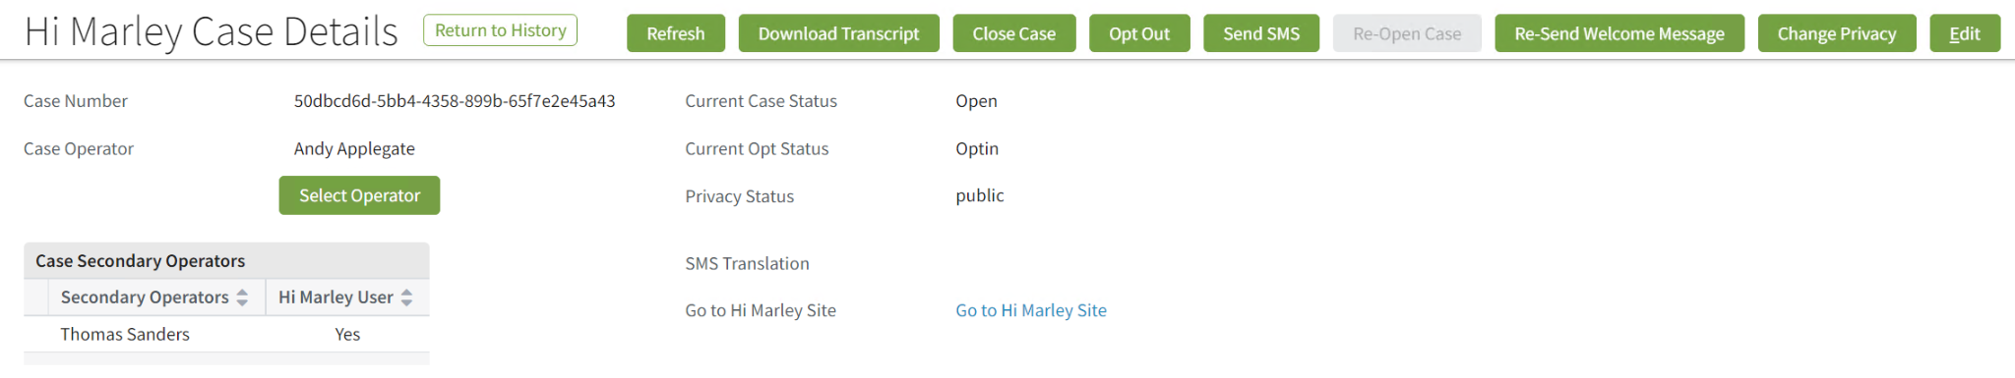
The possibility to add/remove the secondary operators to the table is visible in the edit mode, when the user clicks on the ‘edit’. To see those buttons the flag ‘Enable Secondary Operators’ on the Admin page should be set up to true and the role ‘Hi Marley -Secondary Operators’ has to be assigned to the user. The table Secondary Operators shows all the users which should be assigned as secondary operators. In the table ‘Case Secondary Operators’ there is a column ‘HiMarley User’ which shows if the user exists in Hi Marley. If not, the user can’t be assigned as a Secondary Operator. When the additional user appears in the table, for each of the users the request is sent to Hi Marley to check if the user exists there. The flag EnrolledUserInHiMarley_Acc is also updated for each of the users.
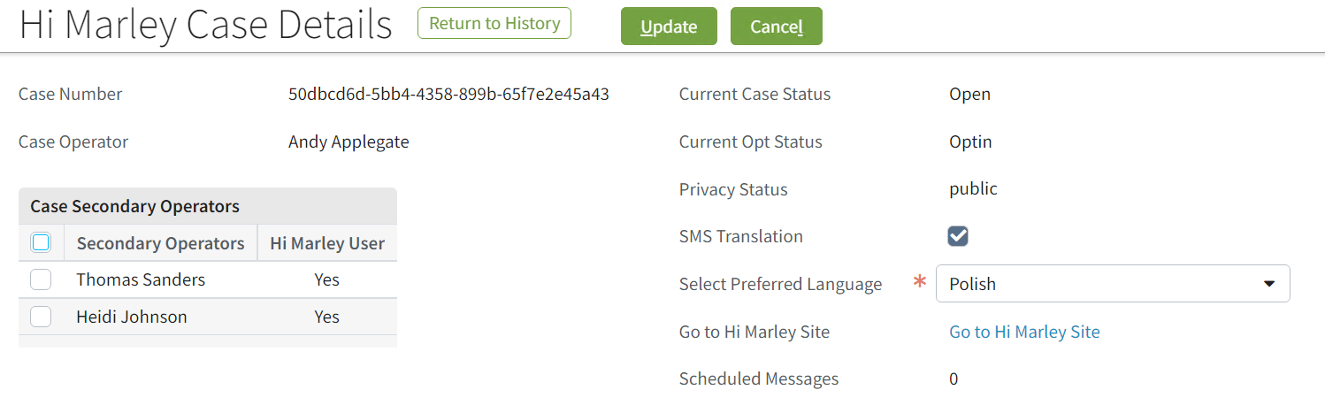
After clicking on the ‘add’ button, the user will be redirected to the ‘Search Users’ page. After selecting the secondary operator, it goes back to the ‘Hi Marley Case Details’ page. The page allows the user to select multiple users at once. If the user is already assigned to this case as a secondary operator, he/she won’t appear in the search results.
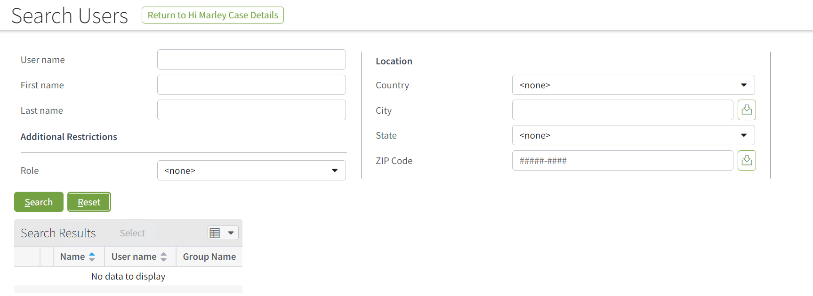
After selecting an additional secondary operator the Claim Center sends requests to HiMarley to check if each of them exists in HiMarley. For each of the users which don't exist in Hi Marley the following error will be shown. Each of the Secondary Operators which has the flag ‘Hi Marley User’ set up to false, needs to be removed from the table.
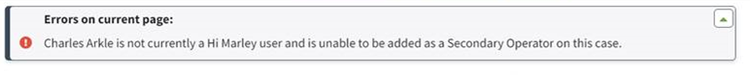
Each of the Secondary Operators which has the flag ‘Hi Marley User’ set up to false, needs to be removed from the table, otherwise the following error will appear on the bottom of the page, after clicking the ‘Update’ button:
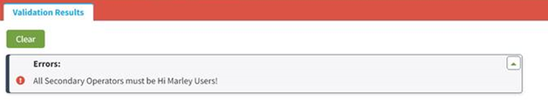

Case synchronization
Case synchronization from Hi Marley to Claim Center
On the page ‘Hi Marley Case Details' there is a ‘Refresh’ button which allows the user to synchronize the data from Hi Marley to the Claim Center. Under this button there is a method which sends two requests to Hi Marley. First is responsible for the update of the field ‘Current Opt Status’ in the Claim Center, the second sends the request to check the current status of the case. After clicking on the ‘Refresh’ button, the following data will be updated:
- Case Operator
- Case Secondary Operators
- Current Opt Status
- Privacy Status
- SMS Translation
- Preferred Language (the field is visible only when the SMS translation is set up to yes)

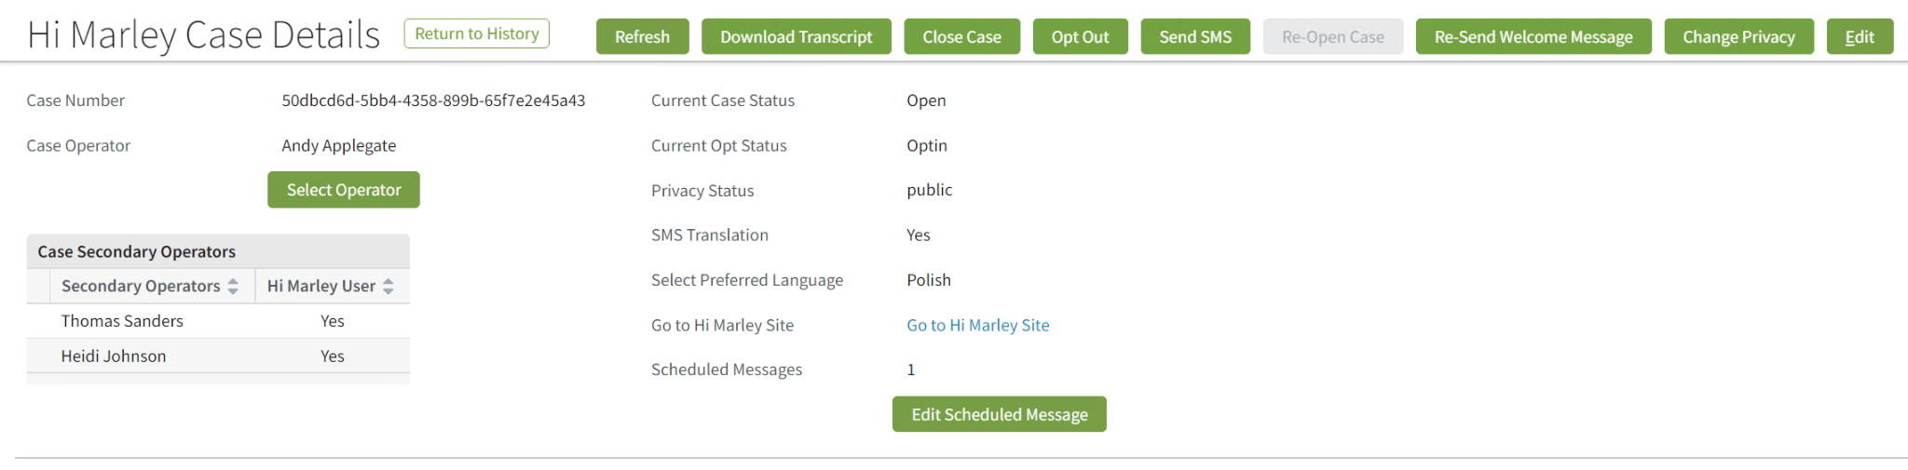
In the Claim Center there is also an automatic synchronization of the case data, when the .json file with the SMS message will be received from the webhook. It is possible when the flag ‘Live updates’ on the admin page are set to true. When this payload is received, then the work item will be added to the work queue ‘HiMarleyMessagingWorkQueue’. This synchronization updates the following fields on the case:
- Case Operator
- Case Secondary Operators
- Privacy Status
- SMS Translation
- Preferred Language
There is no information about the ’Current Opt Status’ on this kind of payload. That’s why, this field isn’t updated.
Case synchronization from Claim Center to Hi Marley
The information from the Claim Center is sent to Hi Marley after clicking on the buttons which update individual fields/tables.

The field/table | The way of synchronization
Case Operator | The information is sent to Hi Marley, after clicking the button ‘Select Operator’
Case Secondary Operators | The information is sent to Hi Marley, after clicking the button ‘Update’ in the edit mode.
Current Case Status | The information is sent to Hi Marley, after clicking the button ‘Close Case’ and ‘Reopen Case’
Current Opt Status | The information is sent to Hi Marley, after clicking the button ‘Opt Out’
Privacy Status | The information is sent to Hi Marley, after clicking the button ‘Change Privacy’
SMS translation | The information is sent to Hi Marley, after clicking the button ‘Update’ in the edit mode.
Preferred Language | The information is sent to Hi Marley, after clicking the button ‘Update’ in the edit mode.
Case activity
For each case when the message is received in the Claim Center, the new activity is created (for the operator and the secondary operators). If the activity which is not completed exists for the given case, a new activity don’t be created when the new message is received. After closing/completing the activities for all operators and secondary operators, the new activity is created, when the message is received.
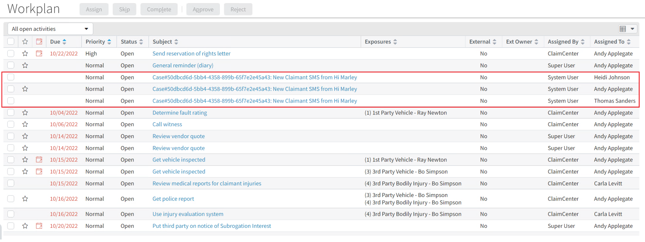

Scheduled Messages
Enable Scheduled with Hi Marley
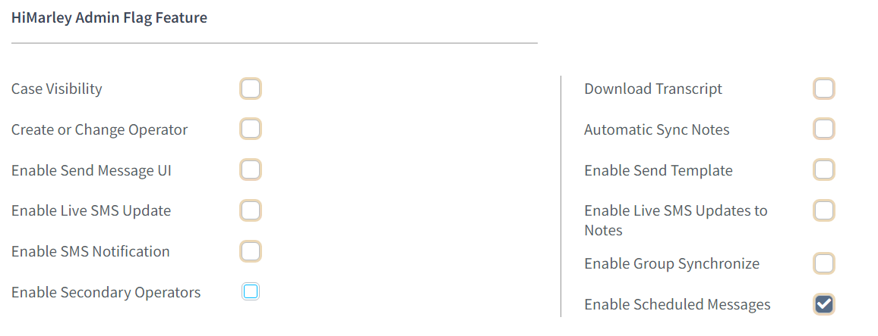
The message scheduling is possible only when the user enabled activity ‘Enable Scheduled Messages’ and. To enable a synchronization of groups with Hi Marley, mark the ‘Enable Group Synchronize’ and then select the ‘save settings’ button.
Message scheduling
On the ‘Hi Marley Case Details’ page click on the ‘Send SMS’ button (which is available when the flag ‘Enable Scheduled Messages’ is set to true) and click on the ‘Schedule Message’ button. On the page Send SMS the content of the text message needs to be entered or template message needs to be chosen first.
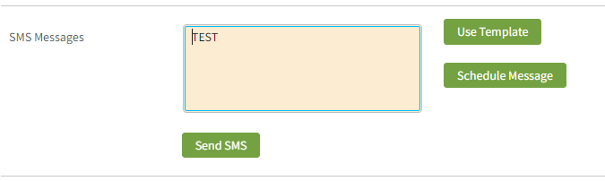
If the field with the content of the message will be empty then the following error will show up.
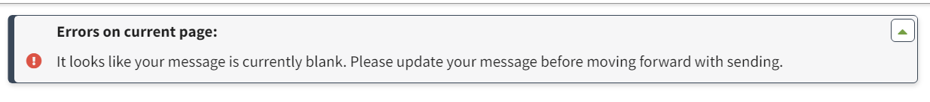

On the next page, to schedule a message click the ‘Schedule Message’ button.
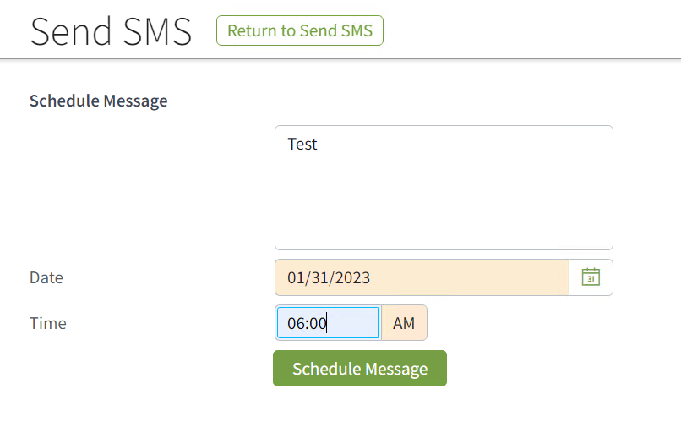
Before scheduling the message all the fields must be filled. If the fields will be empty, then the following errors for each of the fields will show up.
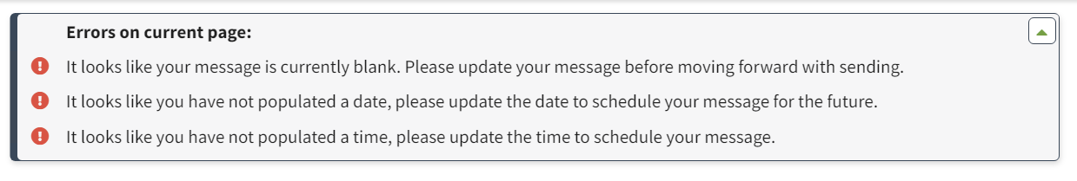
The date for the scheduled message must be in the future, if not the following error will show up.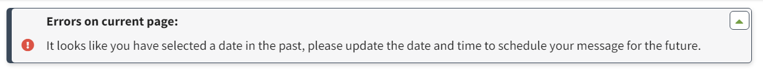
The number of Scheduled Messages can be checked on the page ‘Hi Marley Case Details’ in the field ‘Scheduled Messages’. This field is updated each time, when the user opens this page. The request GET is sent to HiMarley to get all Scheduled Messages, then the field is updated. This request also updates the scheduled messages assigned to the given case in the database.
When the flag ‘Enable Scheduled Messages’ is set to false then the ‘Scheduled Messages’ field and ‘Edit Scheduled Messages’ will disappear.
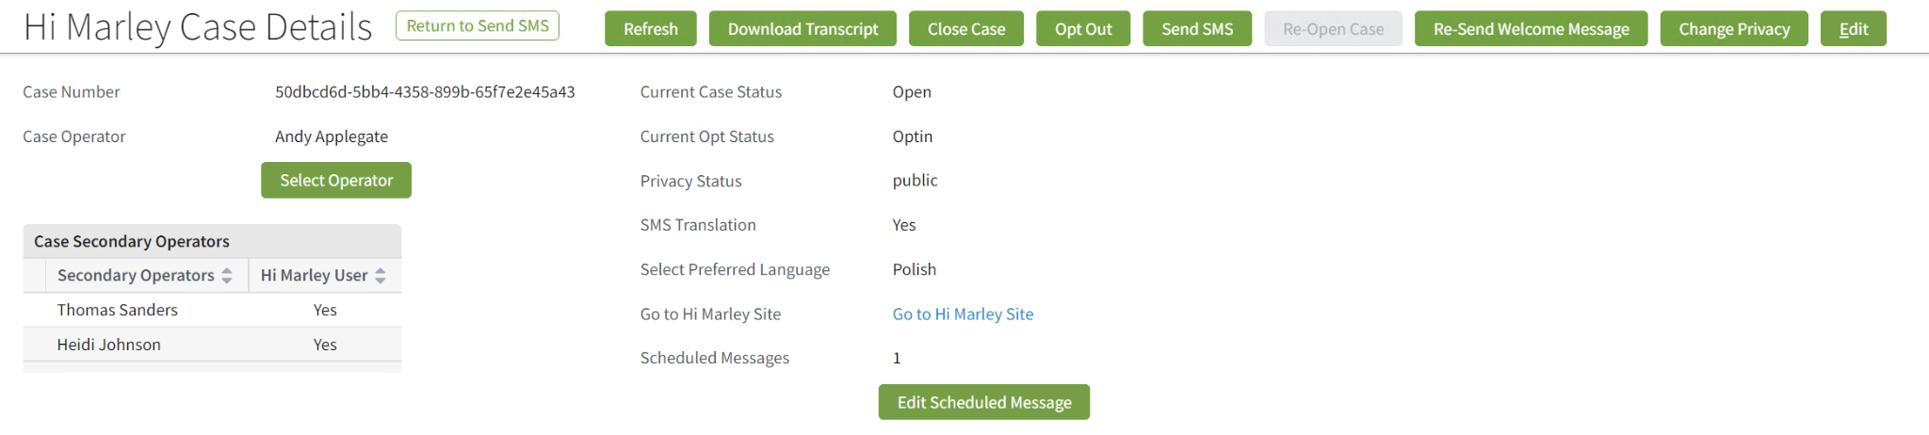
Changes on scheduled messages
The list of the scheduled messages assigned to the case is available after clicking on the button ‘Edit Scheduled Message’. On this Page each of the scheduled messages can be edited or deleted. They are sorted by scheduled date. The ‘Delete’ button is sending a DELETE request to HiMarley chat to remove the given scheduled message. When the scheduled message is successfully deleted in HiMarley, then the method removes this message from the CC database.
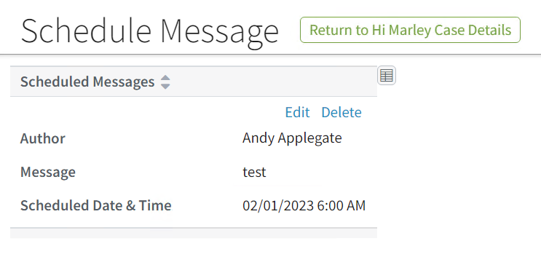
After clicking on the ‘Delete’ button, there is a confirmation message which checks if the user wants to delete the message.
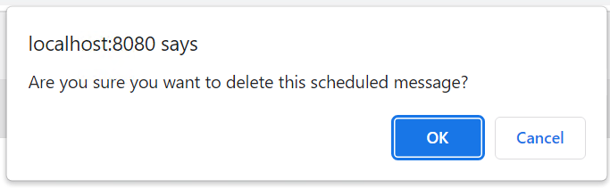
After pressing the button ‘Edit’, the following page will be loaded:
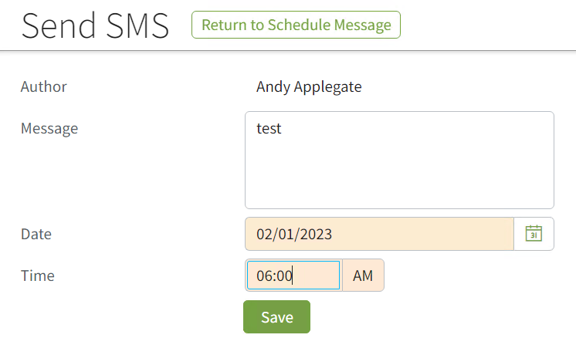
On this page, there is the same validation as on the page with scheduling messages. All the fields must be filled with data and the date and time can’t be in the past.

HiMarley Custom Events
Loading data into entities

For events to work properly, two files must be loaded into Claim Center sequentially as follows:
Administration -> Utilities -> Import Data
1. Import xml file with HiMarleyCustomEventsArray_Acc entity
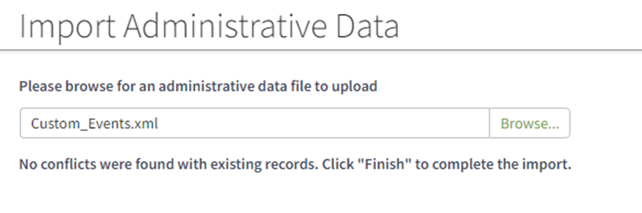
2. Import xml file with HiMarleyCustomEvents_Acc entity
After importing the files, the content of the ‘Automated Notifications’ table is visible in the HiMarley Case Admin Items tab.
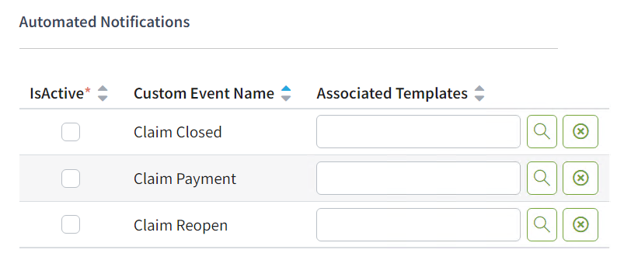
Automation Notifications on Admin Items
It is possible to enable/disable events by checking/unchecking the checkbox ‘IsActive’.
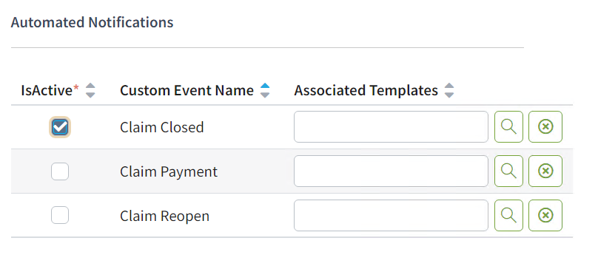
The search button allows admin to select a template.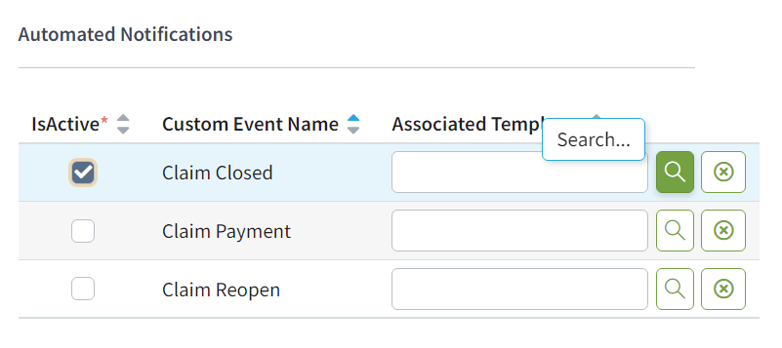
The ‘Search’ button moves a user to the page ‘Find SMS Template’ where all templates are visible, so the user can select one of them by clicking the ‘Select’ button.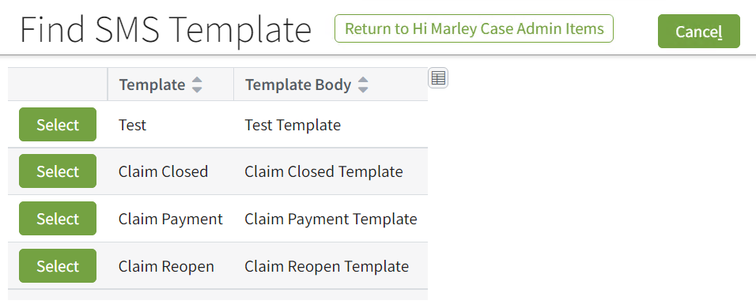
After selecting the template from the template list, the user can see the template name assigned to the event.
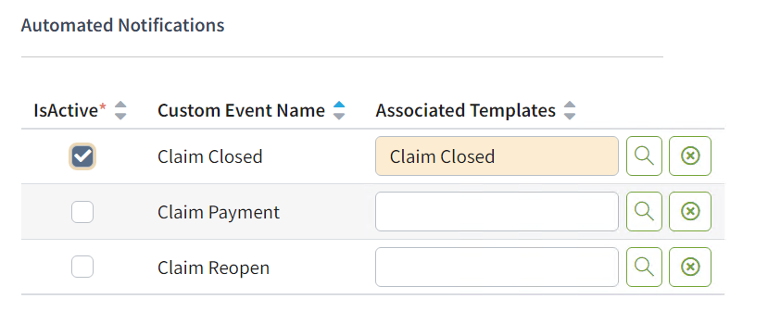

After pressing the ‘Delete’ button, ‘Associated templates' field is cleared.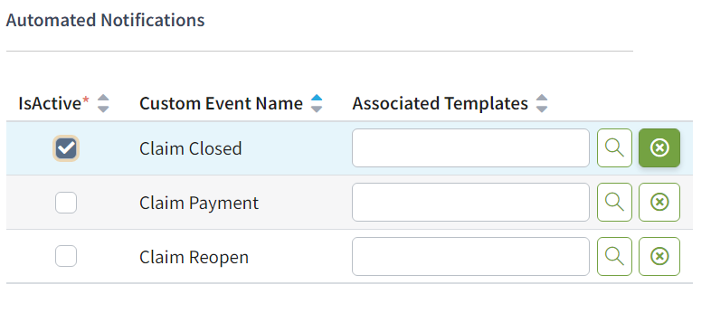
The changes can be saved by clicking on the button ‘Save Settings’ at the top of the screen.
When the changes are saved successfully there is a following information:
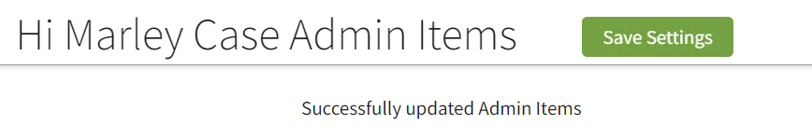
When nothing was changed and the user press ‘Save Settings’ button the following information will be displayed:
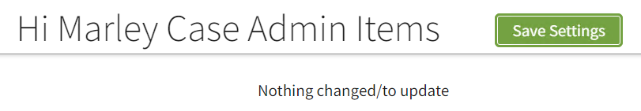
Validation
The changes can’t be saved when the event is activated and doesn’t contain any associated template. There is an error with a name of the event which needs to be corrected.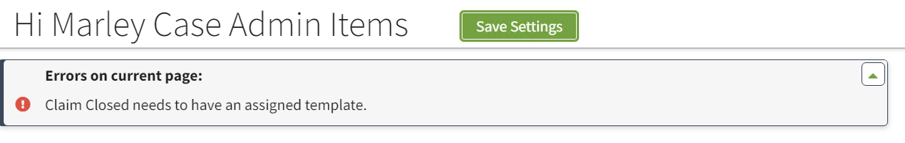
When the user tries to delete a template/templates on the ‘Hi marley Case Admin Add/Remove Template’ page there is additional confirmation after clicking on the button ‘Delete Selected’:
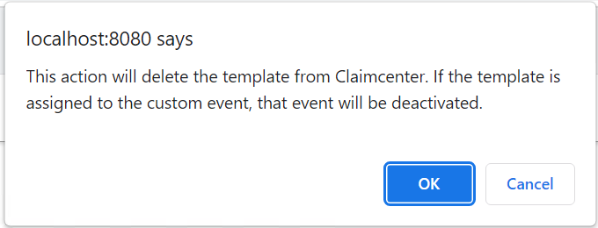
After choosing ‘OK’ the selected templates will be deleted. If the template was assigned to the custom event, the assignment of this template to the event will be removed and this custom event will be deactivated. On the screen will appear the information for each of the custom events which was deactivated:
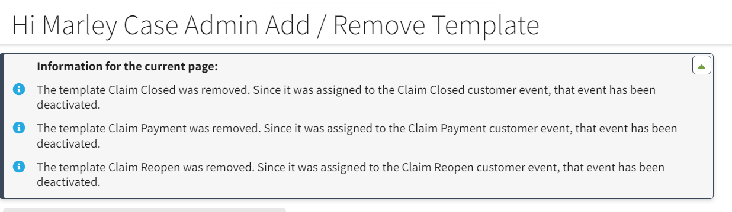
Claim Closed
When the Claim Closed event is active, the notification will be sent during the closure of the claim. The message will be sent for each of the active cases. Closing the claim which has only one active case will create two types of event messages. They can be found in the Message Queue HiMarleyAssyncCall.
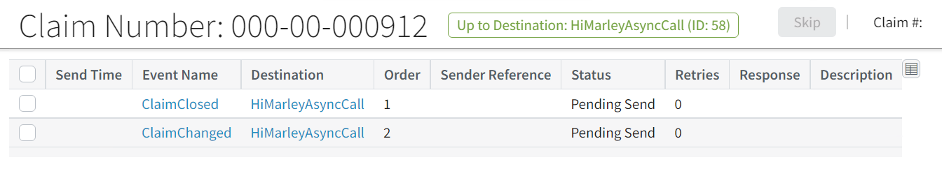
First event is the example of the custom event - Claim Closed. It contains the payload which is sending the message from the template assigned to the event. The second is the event which is closing the case. For this event it is important that the messages are processed in this order, so the message can be sent before the case will be closed.
When the messages will be processed without any errors, the message will be sent into Hi Marley Chat.
Claim Payment
When the Claim Payment event is active, the notification will be sent after the new payment in the status ‘awaiting submission’ will be created. The message will be sent for each of the active cases. They can be found in the Message Queue HiMarleyAssyncCall.
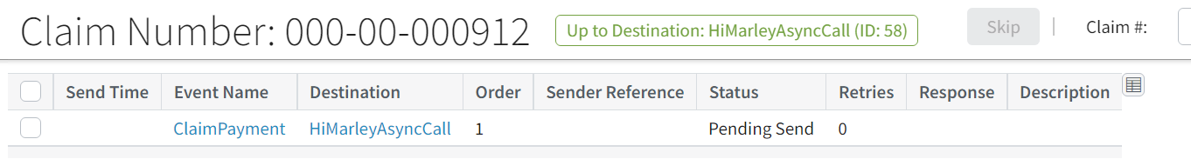
For this case we have only one event type - ClaimPayment which is one of the custom events. It contains the payload which is sending the message from the template assigned to the event.
When the messages will be processed without any errors, the message will be sent into Hi Marley Chat.
Claim Reopen
When the Claim Reopen event is active, the notification will be sent after the reopen of the claim. The message will be sent for each of the cases which will be reopened (for each of the messages one event message ClaimReopen will be created). Reopening the claim which has only one close case will create two event messages. They can be found in the Message Queue HiMarleyAssyncCall.
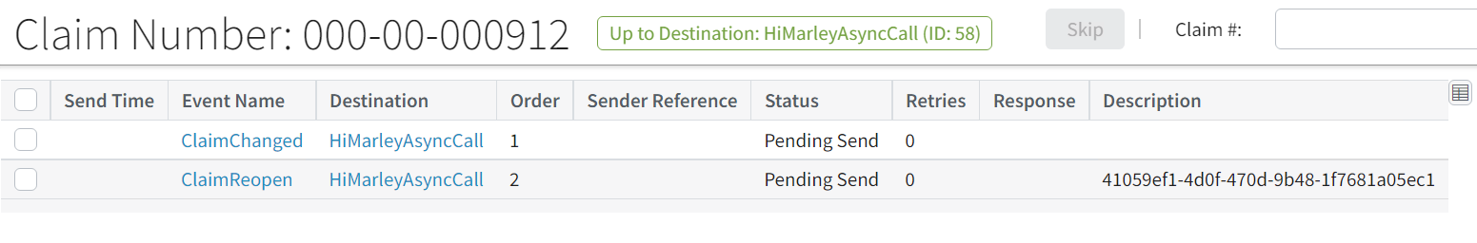
First event is ClaimChanged. This is an event which reopens the claim and all the cases which were assigned to it. The second one is a custom event which sends the notification for the case which was assigned to the claim. For this event it is important that the messages are processed in this order, so the message can be sent after the case is reopened.
When the messages will be processed without any errors, the message will be sent into Hi Marley Chat.

Technical Design
Technical Overview
Following provides a high-level overview of the architecture of this reference implementation.
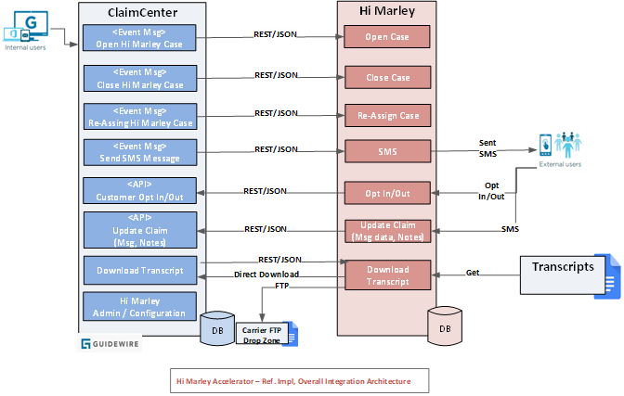

As shown in above reference implementation diagram, ClaimCenter and Hi Marley will be integrated via the Hi Marley accelerator leveraging a direct client-server architecture. Any middleware tier implementation will be the responsibility of carrier.

ClaimCenter will consume APIs exposed by Hi Marley to perform required functions (i.e. Open case, Close case, assigning case, send SMS, etc.)

ClaimCenter also will expose APIs and Plugins to allow Hi Marley to perform required functions (i.e. Send Customer data, Send messages, Download case transcripts, etc.)

Since this accelerator will be based on previous accelerator for ClaimCenter v9.x, for downward compatibility, this accelerator will inherit application and integration architecture from previous accelerator unless unique new features in ClaimCenter v9bb.x can significantly improve the functionality, reliability, and performance of the accelerator.

Open Case in Hi Marley
ClaimCenter events will trigger an integration between ClaimCenter and Hi Marley. This integration will invoke Rest webservice call and notify Hi Marley of an event and Hi Marley sends text message to the Claimant accordingly.
• Guidewire ClaimCenter has an OOTB event where, when a claim creation is finished that event gets triggered at initial stage in the Claim lifecycle (FNOL).
• When this OOTB event is triggered, an Event Fired rule will be invoked with Open status which sends a JSON Payload to a predefined messaging destination configured in ClaimCenter. The event fired rule is an OOTB feature in GW rules engine
• This Messaging destination will use a Message Asynchronous Transport plugin that will be used to send the message about the claim information to Hi Marley.
• Hi Marley will use the message sent from ClaimCenter to create a text message that will be sent to the Claimant.
Open Case from FNOL
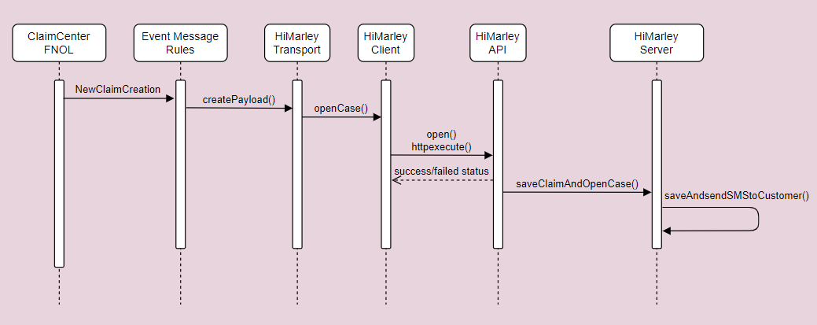
Open Case from an existing Claim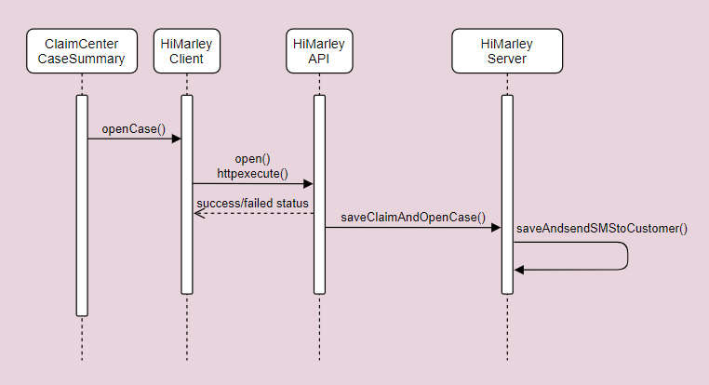

Case Close/Open status update from Hi Marley to ClaimCenter
Subscription to webhook sends updates back to carrier system based on changes in Hi Marley (case close/open).
Hi Marley sends update to ClaimCenter whether Hi Marley case is closed or reopened. Based on webhook status, ClaimCenter updates Hi Marley details in ClaimCenter.
Carrier has to subscribe to Hi Marley webhook to update Hi Marley case details in ClaimCenter.
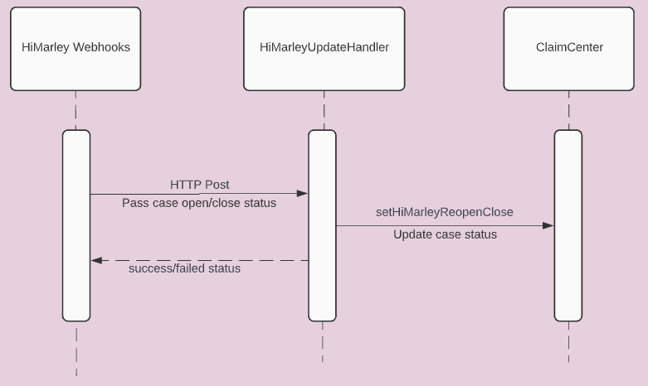

Opt-In/Opt-Out status update from Hi Marley to ClaimCenter
Subscription to webhook sends updates back to carrier system based on changes in Hi Marley (user opt in/out).
Hi Marley sends update to ClaimCenter whether Customer Opted or Opted out. Based on webhook status, ClaimCenter updates Hi Marley details in ClaimCenter.
Carrier has to subscribe to Hi Marley webhook to update Hi Marley case details in ClaimCenter.
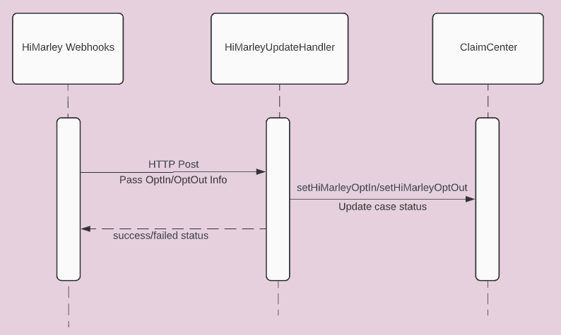

SMS Message update from Hi Marley to ClaimCenter
Subscription to webhook sends updates back to carrier system based on messages received and sent in Hi Marley.
Hi Marley sends update to ClaimCenter whenever Operator, Claimant, or Hi Marley AI sends or receives a message. Based on webhook status, ClaimCenter updates Claim Notes in ClaimCenter and adds to corresponding Case message list.
Carrier has to subscribe to Hi Marley webhook to update Hi Marley messages in ClaimCenter.
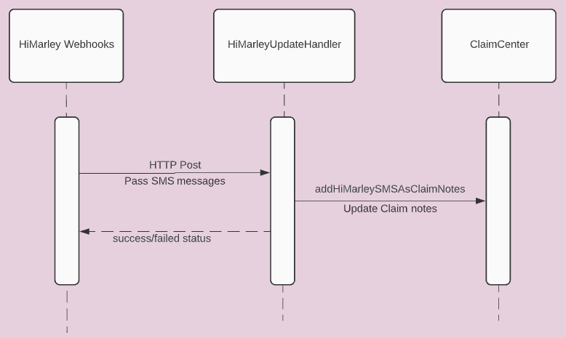

Hi Marley Note update from Hi Marley to ClaimCenter
Subscription to webhook sends updates back to carrier system based on notes updated in Hi Marley.
Hi Marley sends update to ClaimCenter whenever Operator makes a note. Based on webhook status, ClaimCenter updates Claim Notes in ClaimCenter.
Carrier has to subscribe to Hi Marley webhook to update Claim notes in ClaimCenter.
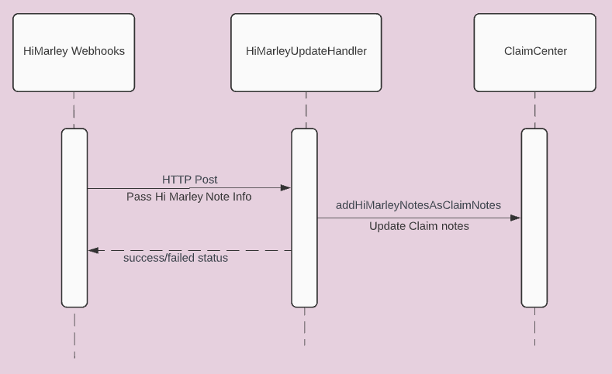

Update Claim transcript information to Hi Marley
Download transcript – Initiates the download transcript call to save case transcript PDF to ClaimCenter Documents
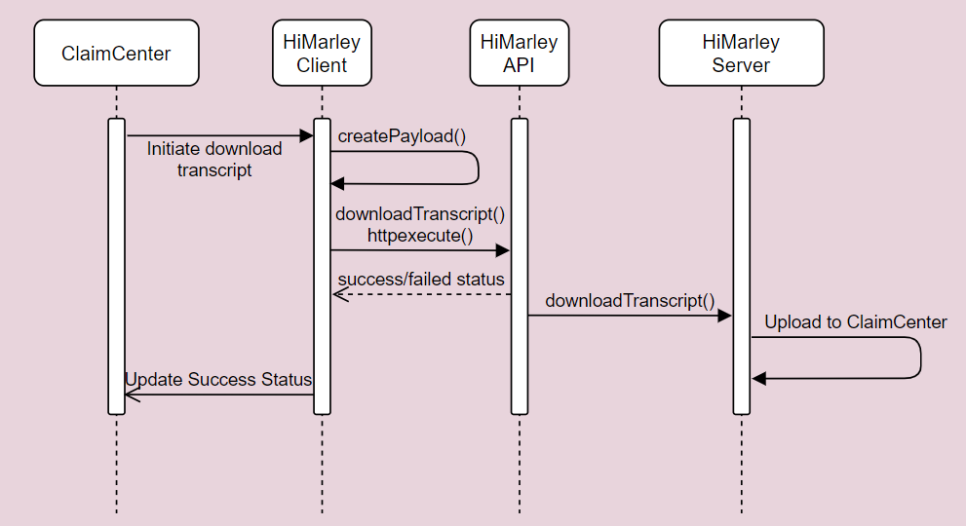

Claim updates to Hi Marley
Assign/Reassign operator, Change Privacy, Turning On/Off Auto-Translation, Claimant OptOut Status, and Case Open/Close Status –triggers update to Hi Marley
The body of the request must include a primary Contact and one of email/mobile/id for that identity and the case id which may be required in the url parameter instead.

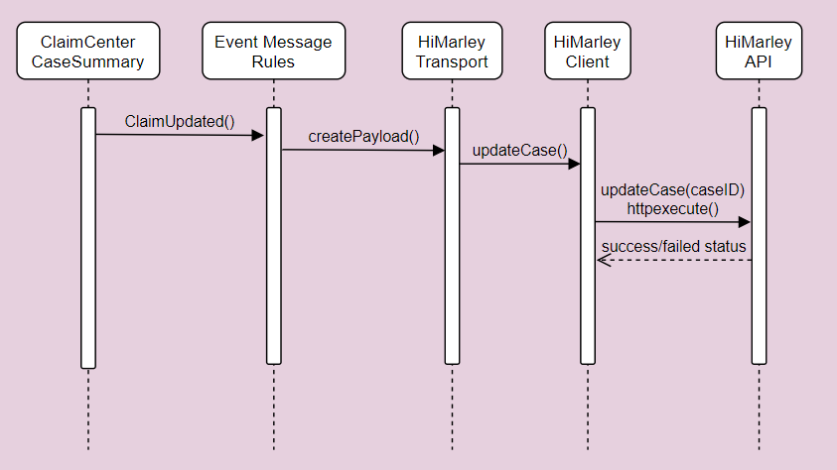

Send Claim Closure updates to Hi Marley
Close case – Once ClaimCenter closes a Claim, Claim Close request is sent to Hi Marley. Hi Marley closes the case in their application.

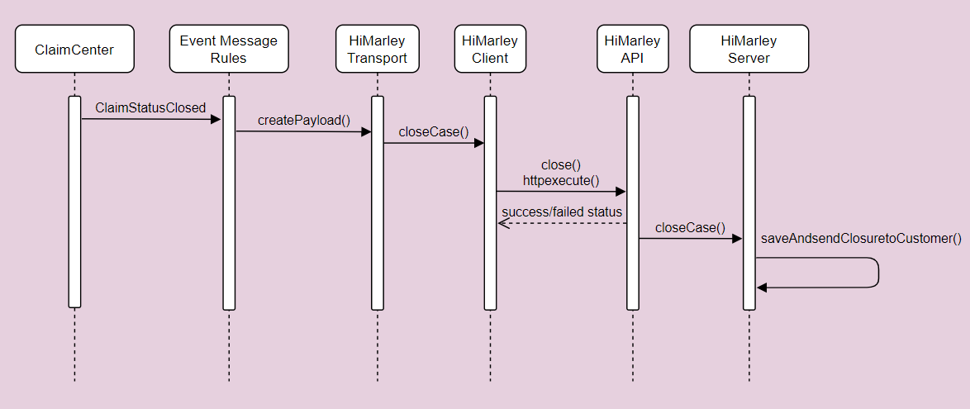

Automatic Resend Welcome Message to Hi Marley
Automatic Resend Welcome Message – Every period (default to 24 hours), Welcome message request is automatically sent to Hi Marley by batch process. Hi Marley Operator can change the time to resend Welcome message. Resend Welcome message is only sent to Claimants that have not opted in (in the request phase).

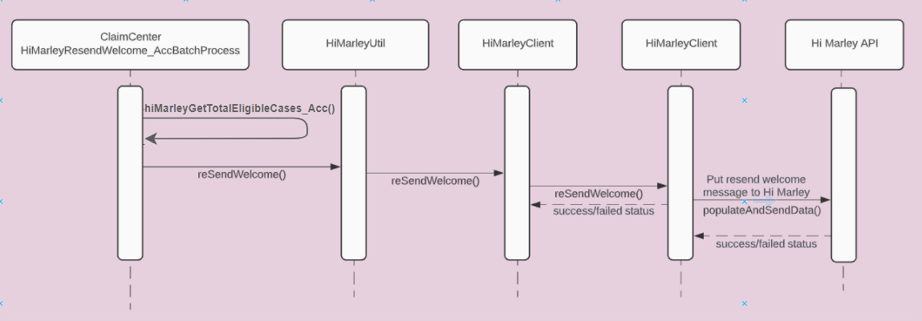

View Hi Marley Case transcript document in ClaimCenter
Once Hi Marley Transcript downloading Process is run, it creates a document entity, and attaches the document to Claim. ClaimCenter retrieves the document and displays it under Documents tab along with other documents.

Note: This approach is assuming an OOTB document management solution, and it is for reference only. Carrier must implement their own document management solution

Parties Involved - Contacts - Hi Marley Cases card
Open Case from an existing Claim - On existing claim users can create a new Case from Parties Involved tab. The Case will be sent to HiMarley to Open a new Case. If the case is open correctly, it will be visible in the case list.

Open Case from an existing Claim

Synchronize groups
Open new group – When a new group is created in the Claim Center, a group creation request is sent to Hi Marley. Hi Marley creates a new group in their application.
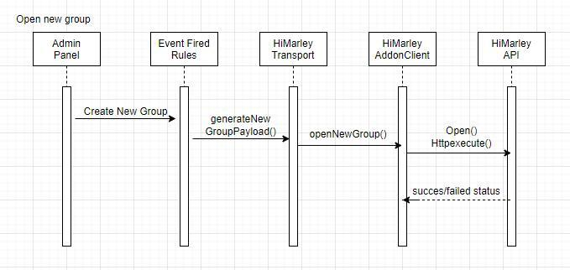
Synchronization - Open new group – For each group which was created in Claim Center and does not exist in Hi Marley, ClaimCenter sends a group creation request to Hi Marley. Hi Marley creates a new group in their application.
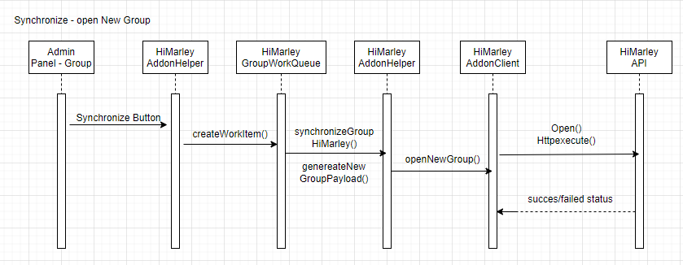
Update group – When a group is updated in the Claim Center, a group update request is sent to Hi Marley. Hi Marley updates a group in their application.
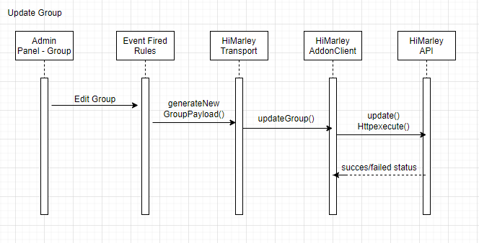
Synchronization - Update group – For each group which exists in Hi Marley and is updated in Claim Center,, ClaimCenter sends a group update request to Hi Marley. Hi Marley updates the group in their application.
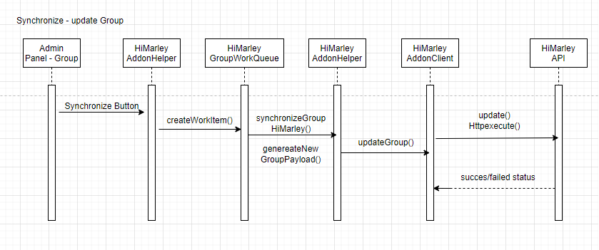

Remove Group – Once ClaimCenter closes a Group, or a group doesn’t have any active HiMarley users/supervisor, a group removal request is sent to Hi Marley from Claim Center. Hi Marley removes the group from their application.

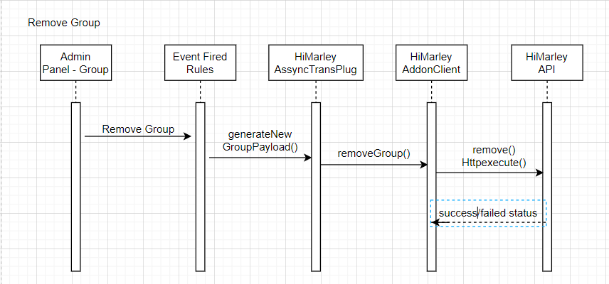

Synchronization - Remove Group – For each group which has been removed from Claim Center or doesn’t have Hi Marley users/supervisor, Claim Center sends a group removal request to Hi Marley. Hi Marley removes the group from their application.
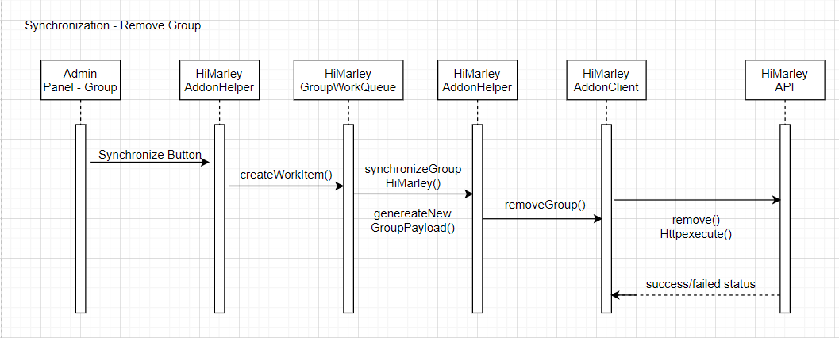

Message Alerts
When the client sends the message, there is AI in HiMarley which recognizes if the message needs the attention. Each message is sent to the Claim Center. When the message needs attention, Hi Marley sends the second json with the needs attention flag. The messages can arrive to the Claim Center in the incorrect order (first message with the flag, the original message),The Claim Center is using a work queue to avoid processing the message and the message update at the same time.
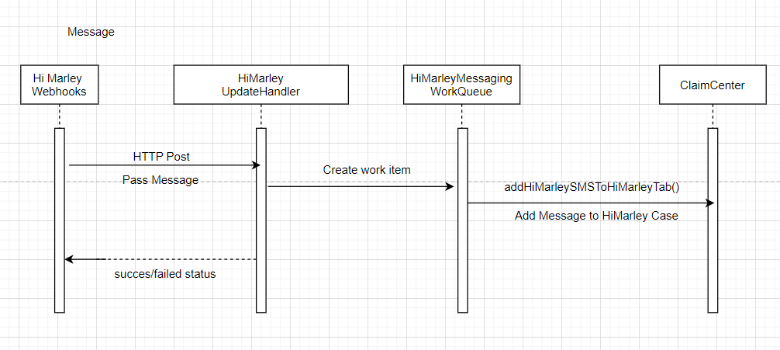
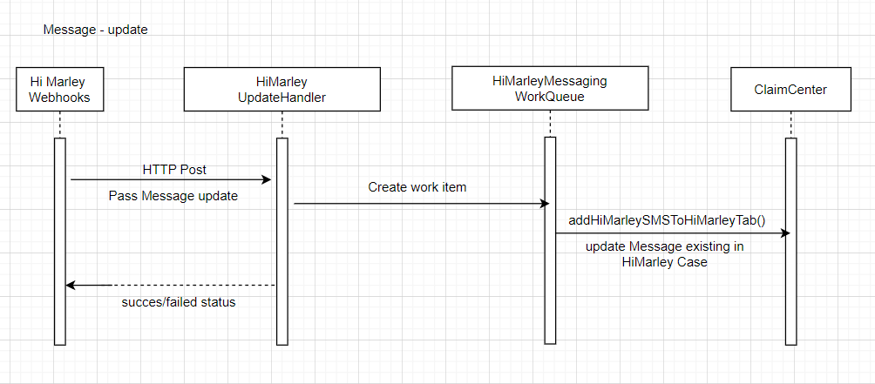

Case synchronization
When the case is changed by using the ‘Update’ button in edit mode, first the data is validated inside ValidationRules, then inside the EventFired the payload and the message is created. If the previous steps are successful, the request is sent to HiMarley with the changes in payload. When the data is correct, the successful request is received from Hi Marley API.
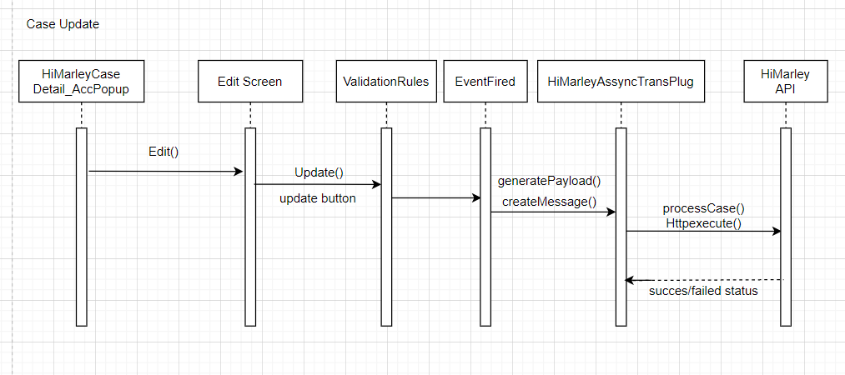
When the SMS is received in the Claim Center, the Hi Marley webhook sends the request to HiMareyUpdateHandler. Inside this class the new work item is created for each message, which is later processed by HiMarleyMessagingWorkQueue. This work queue actualises the data of the case in the Claim Center.
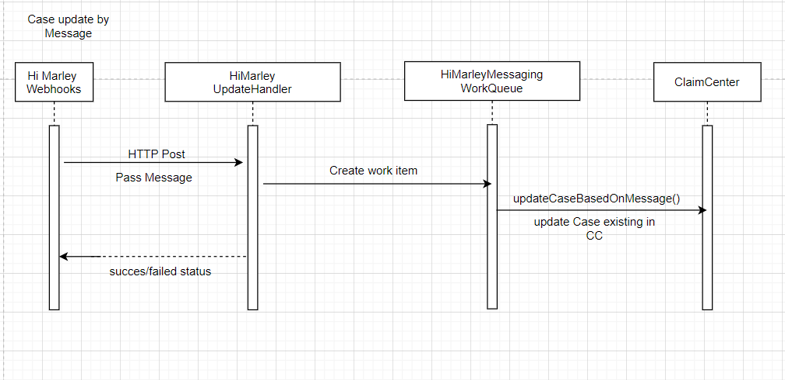
The data on the case can be also updated by using the refresh button. This button retrieves the case data and opt status of the client from Hi Marley chat. When the response is successful, the data on the case is updated in the Claim Center.
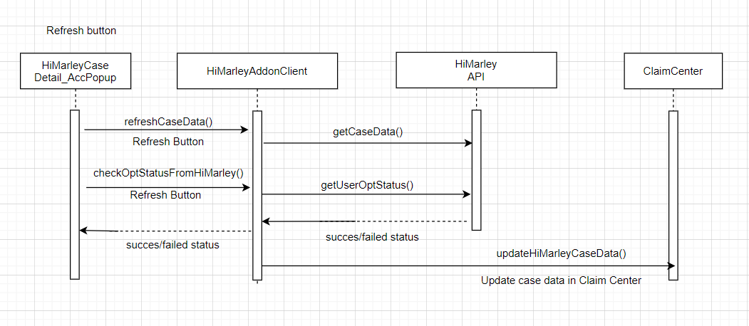

Schedule Message

Schedule Message - the user can create schedule messages on the case detail panel by clicking which moves the user to the next page. The user needs to fill the text field and then can click on the ‘Schedule Message’ button which loads the next page. When all the data on this page is correctly filled, then after clicking on the ‘Schedule Message’ button the method save is started. After that the payload is generated and a new Schedule Message is created. Then the payload is sent to Hi Marley Chat which can receive the success/ failed status

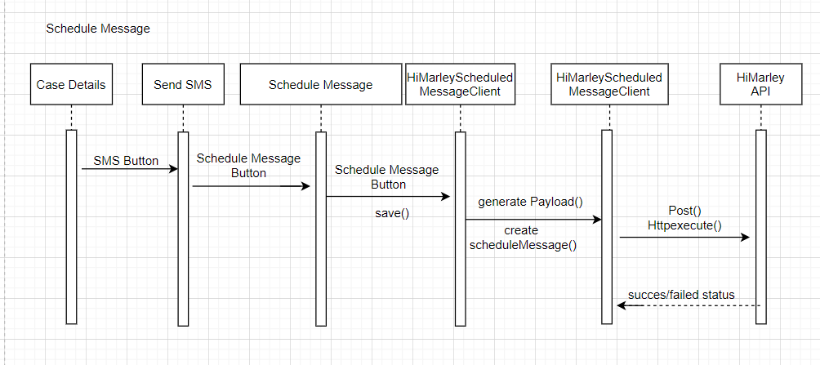

Edit Schedule Message - the user can edit schedule messages on the schedule message panel by clicking ‘Edit’ Button which moves the user to the next page. The user can change the data of the schedule message. To save changes the user has to click the ‘Save’ button. If all data is correctly filled, then methods in HiMarleyScheduledMessageClient remove the existing scheduled message from HiMarley API. Then create a new schedule message with updated data. When the response is successful, the data on the case is updated in the Claim Center.

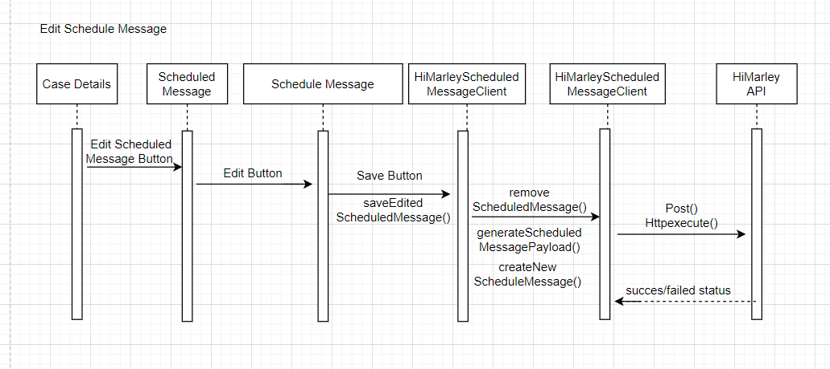

Delete Schedule Message - User can delate the schedule messages on the schedule message panel by clicking Delete Button. After clicked Delete button, methods in HiMarleyScheduledMessageClient remove a scheduled message from HiMarley API. When the response is successful, a scheduled message is deleted in the Claim Center.

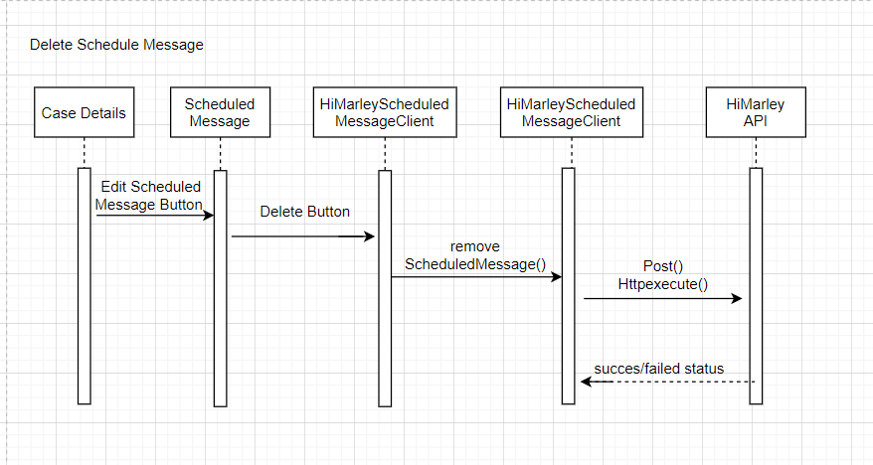

HiMarley Custom Events
Claim Closed

Users can trigger a claim closed event if the event is enabled. It will be done during closing the claim on which there is a case. The template assigned to this event is sent. After triggering the event, the payload will be sent to HiMarley chat. The send message will be visible in Hi Marley Chat. When the message will be received back from the webhook the table with the message in the ‘Hi Marley Case Detail’ page will be also updated.
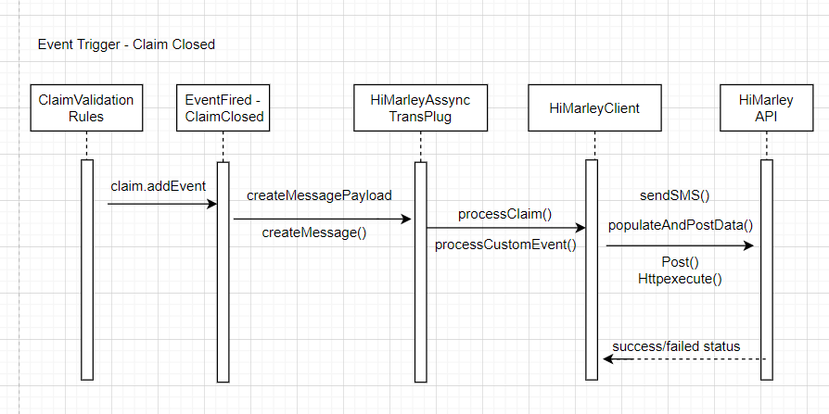

Claim Payment

Users can trigger a claim payment event if the event is enabled. If the claim case exists and the user will create a check (payment), the template assigned to this event will be sent. After the event is triggered, the message will be visible in Hi Marley chat.When the message will be received back from the webhook the table with the message in the ‘Hi Marley Case Detail’ page will be also updated.

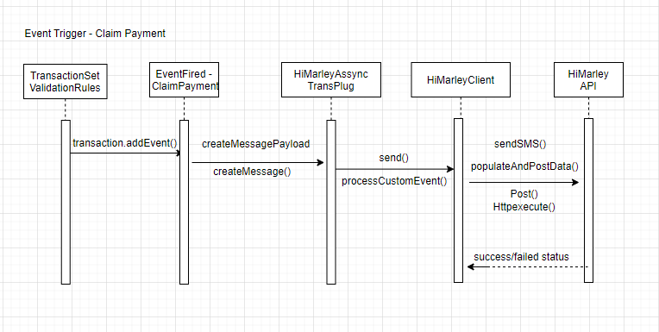
Claim Reopen

Users can trigger a claim reopen event if the event is enabled. It will be done during reopening the claim on which there is a case. The template assigned to this event is sent. After triggering the event, the payload will be sent to HiMarley chat. The send message will be visible in Hi Marley Chat. When the message will be received back from the webhook the table with the message in the ‘Hi Marley Case Detail’ page will be also updated.
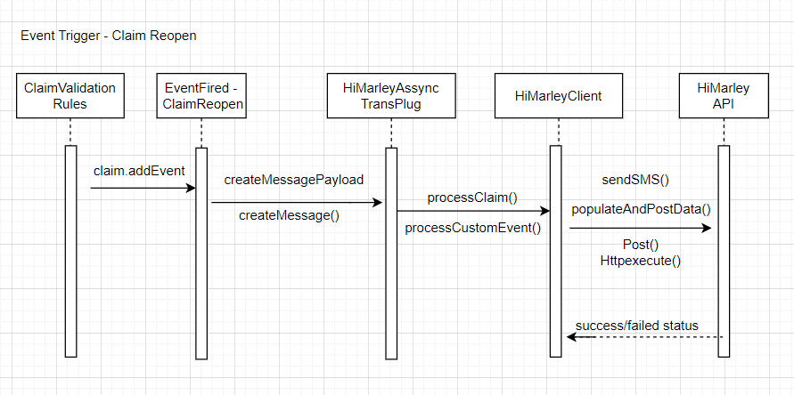

Integration Components

Messaging

Hi Marley Outbound Integration
- Uses Message Transport and event fired mechanism to send messages to Hi Marley by consuming Hi Marley REST API

Hi Marley Inbound Integration
- Servlets that subscribe to Hi Marley webhook to receive update from Hi Marley for:
  - Case Open/Close status
  - OptIn/OptOut
  - SMS detail
  - Hi Marley case notes
  - Transcript
Future JSON payload field additions would require changes to the corresponding schema:
  - Go to the corresponding schema:
<ClaimCenter Installation Root>\ modules\configuration\config\integration\schemas\acc\himarley
  - Follow the format in the schema file to add the additional field. Example:
"fieldName": {
"type": "object",
"properties": {
"property1": {
"type": "string"
}}}
  - For nested fields, do like:
"FieldName": {
"type": "object",
"properties": {
"aFieldName": {
"$ref" : "#/definitions/fieldName"
}}}

Hi Marley Batch Process Integration
- Batch Process read and generate transcript document
- Batch process resends welcome message to claimant after a number of hours, default is 24 hours

Data Model Extensions

Entity Modifications
- Activity.etx - Added new columns HiMarleyMessageID_Acc, HiMarleyCaseID_Acc
- Claim.HiMarley.etx - New entity extension added with one-to-many relation to HiMarleyCaseData_Acc entity with the new column EnrolledInHiMarley_Acc
- HiMarleyCaseData_Acc.HiMarley.eti - New entity added with following new columns: CaseID, CustomerID, PushTranscriptInitiated, UploadedToDMS, HiMarleyEnrollStatus, PreferredLanguage, Operator, Privacy, HiMarleyTranslationOnOff, HiMarleyCaseStatus, LastTimeResendWelcomeSent, HiMarleyOptStatus, FutureReOpenClaim, LastTimeManualResendWelcome, SecondaryOperators and events with new columns HiMarleyCaseDataChanged and ClaimChanged
- HiMarleyAdmin_Acc.HiMarley.eti – New entity added with following new columns: ViewCases, AutoCreateOperator, SendSMS, LiveUpdate, DownloadTranscript, AutoSyncNotes, SendTemplate, and AutoReSendWelcomeTimer, GroupUpdate, CoachingAlerts, FireActivity, FireActivityToSupervisor, SecendaryOperators
- HiMarleyNote_Acc.HiMarley.eti – New entity extension added with the following new columns: Body, Confidential, Subject, AuthoringDate, Activity, Author, Topic, SecurityType, Language, PostType, CaseId, HiMarleyAuthor, HiMarleyCase,MessageAlerts, HiMarleyMessageID
- HiMarleyTemplate_Acc.HiMarley.eti – New entity added with the following new columns: TemplateBody and TemplateName
- HiMarleyWorkItem_Acc.HiMarley.eti -- New entity added with the following new columns: Claim, ClaimNumber
- HiMarleyGroupWorkItem_Acc.HiMarley.eti -- New entity added with the following new columns: GroupItem, Operation
- HiMarleyMessagingWorkItem_Acc.HiMarley.eti - New entity added with the following new columns: Workitem,Claim, Body
- Note.HiMarley.etx - New entity extension added with the following new columns: PostType, CaseId, and HiMarleyAuthor,HiMarleyMessageID_Acc
- Group.etx - added new columns EnrolledGroupInHiMarley_Acc, HiMarleyGroup_ID_Acc, PreviousParentId_Acc
- SecondaryOperators.eti - new entity added with following new foreignkeys: HiMarleyCaseData_Acc, User
- User.etx - added new columns EnrolledUserInHiMarley

Typelist Modifications
- BatchProcessType.HiMarley.ttx-- New typelist extension added for BatchProcessType with type code HiMarleyNotification_Acc,HiMarleyGroupWorkQueue_Acc, HiMarleyMessagingWorkQueue_Acc
- HiMarleyCaseStatus_Acc.HiMarley.tti – New typelist added added to show Hi Marley case status
- HiMarleyMessageAlerts_Acc.HiMarley.tti - New typelist added to show Status of HiMarley Cases
- HiMarleyOptStatus_Acc.HiMarley.tti – New typelist added to show Hi Marley opt status
- HiMarleyPrefLanguage_Acc.HiMarley.tti – New typelist added for preferred language for translation
- NoteTopicType.HiMarley.ttx – New typelist added for adding SMS to ClaimCenter
- HiMarleyEnrollStatus_Acc.HiMarley.tti-- New typelist added it shows the HiMarley System Customer Case Enrollment Status
- SystemPermissionType.HiMarley.ttx – New typelist added for system permissions

User Interface Modifications
Entry/Exit Points
- HiMarleyText_Acc.pcf—Added a new exit point to redirect to Hi Marley System Texting
- HiMarleyTranscriptDownload_Acc.pcf — Added new exit point which redirect to download transcript

Claim Screens
- FNOLWizard_AssignSaveScreen.pcf—Added Hi Marley Enrollment Check box
- ClaimStatus.pcf-- Update Claim summary PCF with new HiMarley Details section and status details

Deployment

ClaimCenter

config
  - extensions
    - entity
      - Claim.HiMarley.etx — New entity added which extends Claim entity and having foreign key relation to HiMarleyCaseData_Acc entity with the new column EnrolledInHiMarley_Acc
      - Group.etx — The indicator EnrolledGroupInHiMarley_Acc and HiMarleyGroup_ID_Acc have been added to the group entity.
      - HiMarleyAdmin_Acc.HiMarley.eti — New entity added with following new columns: ViewCases, AutoCreateOperator, SendSMS, LiveUpdate, DownloadTranscript, AutoSyncNotes, SendTemplate, LiveSMSToNote and AutoReSendWelcomeTimer, GroupUpdate.
      - HiMarleyCaseData_Acc.HiMarley.eti — New entity added with following new columns: CaseID, CustomerID, PushTranscriptInitiated, UploadedToDMS, PreferredLanguage, Operator, Privacy, HiMarleyTranslationOnOff, LastTimeResendWelcomeSent, FutureReOpenClaim, LastTimeManualResendWelcome, an array HiMarleySMS, and events with new columns HiMarleyCaseDataChanged and ClaimChanged and typekeys HiMarleyEnrollStatus, HiMarleyCaseStatus, and HiMarleyOptStatus
      - HiMarleyTemplate_Acc.HiMarley.eti — New entity added with the following new columns: TemplateBody and TemplateName
      - Note.HiMarley.etx — New entity extension added with the following new columns: PostType, CaseId, and HiMarleyAuthor
      - HiMarleyWorkItem_Acc.HiMarley.eti – New entity for a custom work item for Hi Marley asynchronous case creation
      - HiMarleyGroupWorkItem_Acc.HiMarley.eti – New entity for a custom work item for Hi Marley asynchronous group creation
      - HiMarleyNote_Acc.HiMarley.eti - New entity added with following new columns: Body, Confidential, Subject, AuthoringDate, PostType, CaseId, and HiMarleyAuthor, typelists Topic, SecurityType, and Language, and foreignkeys HiMarleyCase, Activity, and Author
      - User.etx - The indicator EnrolledUserInHiMarley_Acc have been added to the User entity.
    - typelist
      - BatchProcessType.HiMarley.ttx -- New typelist added which extends BatchProcessType and having the type code HiMarleyNotification_Acc, extension of typelist added from BatchProcessType as HiMarleyNotification for sending welcome message after a certain time period.
      - HiMarleyCaseStatus_Acc.HiMarley.tti — New typelist added which contains the case status reference and used to add or modify
      - HiMarleyEnrollStatus_Acc.HiMarley.tti — New typelist added it shows the HiMarley System Customer Case Enrollment Status
      - HiMarleyOptStatus_Acc.HiMarley.tti — New typelist added which contains the customer Opt status reference and used to add or modify HiMarleyCaseData_Acc.HiMarley.eti entity for the field HiMarleyOptStatus
      - HiMarleyPrefLanguage_Acc.HiMarley.tti — New typelist added which contains list of HiMarley system multiple language reference and used to add or modify HiMarleyCaseData_Acc.HiMarley.eti entity for the field PreferredLanguage
      - NoteTopicType.HiMarley.ttx — Extension of typelist added from NoteTopicType for maintaining Note Topic category. As a new data, HiMarley case type has been added to distinguish HiMarley Note Topic.
      - SystemPermissionType.HiMarley.ttx — Added HiMarley case operational permission types. Those are, automaticcreateoperator, viewsendmessage, viewliveupdate, viewdownloadscript, automaticsyncnotes, viewsendtemplate, groupupdate, coachingAlerts_Acc, fireactivity_Acc, fireactivitytosupervisor_Acc, secondaryoperators_Acc. Those were used to reference the permissions required to maintain userwise.
  - integration
    - apis
      - acc
        - himarley
          - caseupdateapi
            - himarley_optin-1.0.swagger.yaml — Swagger to opt-in/opt-out Hi Marley cases with webhooks
            - himarley_sms-1.0.swagger.yaml — Swagger to receive SMS Message from Hi Marley- to ClaimCenter notes with webhooks
            - himarley_update-1.0.swagger.yaml — Swagger to close and reopen Hi Marley cases with webhooks
      - published-apis.yaml — Lists APIs to publish for Hi Marley webhooks
    - schemas
      - acc
        - himarley
          - caseupdate
            - close_reopen-1.0.schema.json — Schema to close and reopen Hi Marley cases with webhooks
            - optin-1.0.schema.json — Schema to opt-in Hi Marley cases with webhooks
            - optout-1.0.schema.json — Schema to opt-out Hi Marley cases with webhooks
            - sms-1.0.schema.json — Schema to receive SMS Messages and Notes from Hi Marley to ClaimCenter notes with webhooks
  - locale
    - display.properties — Added properties for Hi Marley Integration
  - messaging
    - messaging-config.xml — Added a Hi Marley destination and event for Cases integration, Added a Hi Marley destination for Groups
  - plugin
    - registry
      - HiMarleyAssyncTransPlug_Acc.gwp — Contains the Hi Marley asynchronous plugin configuration
  - rules
    - Event Message
      - EventFired_dir
        - HiMarleyAssyncCall.gr — Hi Marley Event rules to invoke integration
        - HiMarleyAssyncCall_dir
          - Group.grs — Hi Marley Event rules to invoke integration
            - GroupAdded.grs —Generate (add) payload for groups
            - GroupChanged.grs — Generate (change) payload for groups
            - GroupRemoved.grs — Generate (remove) payload for groups

          - ClaimChanged_dir
            - AdjusterChanged.gr — Trigger and generate adjuster changed payload
            - Order.txt — Hi Marley rule ordering
          - Claim.gr — Hi Marley Event rules to invoke integration
          - ClaimChanged.gr – Hi Marley Event rules to invoke integration
          - Claim_dir
            - ClaimChanged.gr — Trigger and generate claim changed payload, claim closed payload, and claim updates related to adjuster and claim payload
            - Order.txt — Hi Marley rule ordering

        - Order.txt — Hi Marley rule ordering
    - Closed
      - ClaimClosed_dir
        - HiMarleyAssyncCall.gr -- Trigger and generate claim reopen payload
        - order.txt – Hi Marley rule ordering
    - Reopened
      - ClaimReopened_dir
        - HiMarleyAssyncCall.gr -- Trigger and generate claim closed payload
        - order.txt – Hi Marley rule ordering
  - runtimeproperties
    - RuntimeProperties.xml – File that holds URL text for API calls as runtime properties
  - scheduler
    - scheduler-config.xml — Added process AutoResendWelcome
  - security
    - security-config.xml — Added system permissions for Hi Marley permissions
  - web
    - pcf
      - acc
        - himarley
          - admin
            - HiMarleyAdmin_Acc.pcf — Location group for Hi Marley Admin pages
            - HiMarleyAdminItems_Acc.pcf — Page to enable/disable feature flagging items for Hi Marley
            - HiMarleyAdminItems_AccDV.pcf — Detail view that has items for feature flagging for Hi Marley
            - HiMarleyAdminSendSMSTemplates_AccLV.pcf — List view to create and delete SMS templates
            - HiMarleyAdminTemplates_Acc.pcf — Page to create and delete SMS templates
            - HiMarleyCoachingItems_AccDV.pcf — Detail view that has items for feature Coaching flagging for Hi Marley
            - HiMarleyNewTemplate_AccPopup.pcf — Popup to create and add new SMS template
            - HiMarleyTemplateDetail_AccDV.pcf — Detail view to view SMS template
            - HiMarleyWelcome_Acc.pcf — Forwards to go to Hi Marley Admin pages
          - cases
            - HiMarleyAssignOperator_AccPopup.pcf — Popup to reassign Hi Marley Operator
            - HiMarleyCaseDetail_AccLV.pcf — List view to view Hi Marley case details
            - HiMarleyCaseDetail_AccPopup.pcf — Popup to view Hi Marley case details
            - HiMarleyClaimCases_Acc.pcf — Page to view list of Hi Marley cases for a claim
            - HiMarleyClaimCases_AccLV.pcf — List view of Hi Marley cases for a claim
            - HiMarleyConfirmation_AccPopup.pcf — Popup to confirm success of an API call
            - HiMarleyOpenCase_AccPopup.pcf — Popup to open new Hi Marley case in existing claim
            - HiMarleyPickSMSTemplate_AccPopup.pcf — Popup to select SMS template for SMS message
            - HiMarleySecondaryOperator_AccLV.pcf — List view of Hi Marley secondary operators for claim
            - HiMarleySendSMS_AccDV.pcf — Detail view to send SMS message
            - HiMarleySendSMS_AccPopup.pcf — Popup to send SMS message
            - HiMarleySMSMessageTemplateResult_AccLV.pcf — List view to view SMS templates
          - contact
            - HiMarleyClaimContactCases_AccLV.pcf — List view to view cases based on contact in existing claim
          - ClaimHiMarleyCasesFoward.pcf – Forward to go to Hi Marley cases

- admin
        - groups
          - GroupDetailToolbarButtonSet.pcf — Toolbar Button to synchronize users and groups with HiMarley Chat
          - GroupUsersLV.pcf — Column in Listview showing the state of the HiMarley indicator
        - newgroup
          - NewGroup.pcf — Check box to set an Hi Marley Indicator for New Group
          - NewGroupDetailDV.pcf — Check box to set an Hi Marley Indicator for New Group
        - GroupDetailPage.pcf — Check box to change an Hi Marley Indicator for Group
- shared
  - preferences
    - UserDetailInputSet.pcf — Boolean Radio Button Input to set Hi Marley Indicator for User
  - usersearch
    - HiMarleyMultiUserSearchPopup.pcf — Popup to allow multi user search of secondary operators
    - SecOperatorSearchResultsLV.pcf —List view showing the results of the search of secondary operators
- tools
  - WorkQueueWorkItemsLDV — toolbarButton to skip work items that failed
- workspace
  - activity
    - ActivityDetailsInputSet.pcf — InputSet showing the basic information about activities

- claim
        - FNOL
          - FNOLWizard_AssignSaveScreen.pcf — Added Hi Marley Enrollment Check box
        - partiesinvoled
          - ClaimContacts.pcf — Added Hi Marley Cases card to view cases based on selected contact in claim
        - summary
          - ClaimStatus.pcf — Added Hi Marley details section which contains status and , alert bar and texting details
        - Claim.pcf — Added location reference to view Hi Marley cases

      - exitpoints
        - HiMarleyText_Acc.pcf — Added new exit point which redirect to specific case
        - HiMarleyTranscriptDownload_Acc.pcf — Added new exit point which redirect to download transcript
      - TabBar.pcf — Added “Hi Marley Operator” section under the “Administration” tab
  - workqueue
    - work-queue.xml – Registers custom work queue for asynchronous case and group creation

- credentials.xml -- File to hold the API key credentials for a server

gsrc
  - acc
    - himarley
      - Integration
          - HiMarleyClient.gs — The class contains methods responsible for sending requests related to Hi Marley cases
          - HiMarleyConstants.gs — The class contains constants which are used inside Hi Marley Accelerator
          - HiMarleyHelper.gs — The class contains methods responsible for creating URLs and payloads
          - HiMarleyUtil.gs — The class contains methods connected with the buttons updating cases
        - addon
          - HiMarleyAddonClient.gs — The class contains methods responsible for sending requests related to Hi Marley groups
          - HiMarleyAddonHelper.gs — The class contains methods for handling functions related to HiMarley groups and cases
        - himarleyupdateapi
          - HiMarleyCaseUpdateHandler.gs — Class that works with Hi Marley webhooks to update Hi Marley cases after receiving the message from the webhook
          - HiMarleyUpdateHandler.gs — Class that works with Hi Marley webhooks to update Hi Marley cases
        - batchprocess
          - HiMarleyResendWelcomeBatchProcess.gs —Batch Process generate resend welcome message to claimant every set amount of hours
        - dto
          - GroupsPostRequestDto.gs — The class is responsible for creating the Json payload structure for HiMarley Groups
        - enhancement
          - HiMarleyCase_AccEnhancement.gsx — Enhancement class to hold Hi Marley integration properties
          - HiMarleyClaimEnhancement.gsx — Enhancement class to hold Hi Marley integration properties
          - HiMarleyGroupEnhancement.gsx — Enhancement class to hold Hi Marley Group integration properties
        - exception
          - HiMarleyDataValidationException.gs — Class Contains Client-side data validation errors
          - HiMarleyException.gs — Generic exception class for Hi Marley integration
        - messaging
          - HiMarleyAssyncTransPlug.gs — Asynchronous message transport class which invokes Hi Marley REST API integration for opening, closing, and reopening cases and changing adjuster for Hi Marley cases. For adding, changing, removing, synchronizing HiMarley groups.
        - workqueue
          - HiMarleyGroupWorkQueue.gs – Custom Hi Marley work queue for asynchronous Group creation
          - HiMarleyMessagingWorkQueue.gs – Custom Hi Marley work queue for asynchronous updating cases based on the received messages
          - HiMarleyWorkQueue.gs – Custom Hi Marley work queue for asynchronous case creation
        - HiMarleyClient.gs — REST API Integration class with all operation details
        - HiMarleyConstants.gs — Constants class which contains all integration related variables
        - HiMarleyHelper.gs – Class with all helper get methods related to Hi Marley integration
        - HiMarleyUtil.gs — Class with all utility methods related to Hi Marley integration
  - gw
    - plugin
      - process
        - ProcessPlugin.gs — Added new Hi Marley transcript batch process
    - surepath — Structured Logger suggested and provided by Guidewire that is distributed within the accelerator. An update must occur if there is a newer version of the Logger.

Running this Reference Implementation
- Add or merge the accelerator code into existing ClaimCenter
  - Unzip distribution package to OOTB ClaimCenter 9.10 under following directory:

<ClaimCenter Installation Root>\ modules\configuration

  - Overwrite all files with same file names

  - Make sure update the API key, end point, test user email address from following properties files:
\config\runtimeproperties\HiMarleyRuntimeProperties.xml
\config\credentials.xml

  - If not exist, following Guidewire’s instruction to create ClaimCenter database

  - Make sure update database connection information in following file:

\config\database-config.xml

  - Compile the code by running following command:
gwb compile
  - Build Tomcat package by running following command:
gwb warTomcatDbcp (or other options based on your need)

  - Deploy war file to application server

  - Restart the application server

- Update API key, end point, test user email address from following properties files:
\config\runtimeproperties\HiMarleyRuntimeProperties.xml
\config\credentials.xml

- Import the Runtime Properties by going to Administration>Utilities>Runtime Properties
  - Load the HiMarleyRuntimeProperties.xml file by clicking “Import” and navigating to the file

- Register Webhook events by consuming postman or swagger with below sample payloads
Consuming API: https://{Hi Marley URL}/api/webhooks/register

Opt-In Sample Payload:
{
"EVENT_ID": 1,
"HTTP_POST_ADDRESS": "http://{claimcenterurl}/cc/rest/acc/himarley/opt/v1/useroptin",
"HEADERS": {
"Authorization": "Basic c3U6Z3c=",
}
}

Opt-Out Sample Payload:
{
"EVENT_ID": 2,
"HTTP_POST_ADDRESS": " http://{claimcenterurl}/cc/rest/acc/himarley/opt/v1/useroptout",
"HEADERS": {
"Authorization": "Basic c3U6Z3c=",
}
}

Note Received in Hi Marley Sample Payload:
{
"EVENT_ID": 16,
"HTTP_POST_ADDRESS": " http://{claimcenterurl}/cc/rest/acc/himarley/sms/v1/notes",
"HEADERS": {
"Authorization": "Basic c3U6Z3c=",
}
}

Message Received or Sent in Hi Marley Sample Payload:
{
"EVENT_ID": 14,
"HTTP_POST_ADDRESS": " http://{claimcenterurl}/cc/rest/acc/himarley/sms/v1/messages",
"HEADERS": {
"Authorization": "Basic c3U6Z3c=",
}
}

Re-Open Case in Hi Marley Sample Payload:
{
"EVENT_ID": 18,
"HTTP_POST_ADDRESS": " http://{claimcenterurl}/cc/rest/acc/himarley/updates/v1/closeReopen",
"HEADERS": {
"Authorization": "Basic c3U6Z3c=",
}
}

Close Case in Hi Marley Sample Payload:
{
"EVENT_ID": 10,
"HTTP_POST_ADDRESS": " http://{claimcenterurl}/cc/rest/acc/himarley/updates/v1/closeReopen",
"HEADERS": {
"Authorization": "Basic c3U6Z3c=",
}
}

- Go to Hi Marley Admin entries to make sure you enabled desired:
  - Claim Level flags
  - Assigned appropriate role to user
  - Assigned appropriate Hi Marley permission to role

- After creating the case, verify Hi Marley status and Reply Yes to text message from mobile device and verify Opted status. This would allow sending SMS

Known Issues
- When a Hi Marley case is closed, if customer is not opt out, he/she will be able to continue to send SMS message to Hi Marley. Hi Marley will re-open the case and forward SMS to ClaimCenter. ClaimCenter will update the case with SMS message, however, ClaimCenter will NOT re-open the case. This is due to Hi Marley existing Web Hook does not send Re-Open call to ClaimCenter. This is expected to be fixed by Hi Marley once the Web Hook is updated.

Updates

Flexible schema
Flexible schema is designed to accept unknown elements in the body of request without the need to make changes to schema.json files.

Guidewire has a parameter that needs to be set in both the Swagger Yaml file and the Payload header (in Hi Marley’s case, in the Webhook callback header or any response header). UnknownPropertyHandling can be set to 3 different values, each of them gives different possibilities.
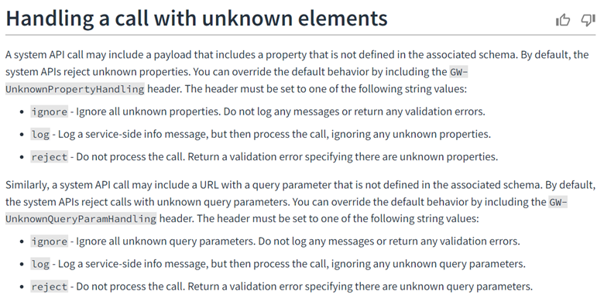
Hi Marley needs to make changes in its payload generation by adding the GW- UnknownPropertyHandling parameter in the HTTP header of the Webhook call or HTTP response from HM to CC. As shown in the screenshot below, as a test this parameter with value “ignore” was added in the POSTMAN mock up payload: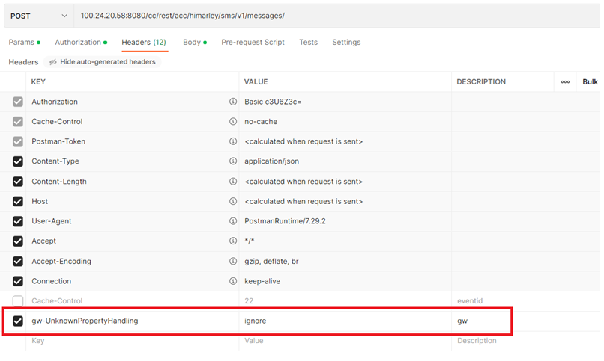
In ClaimCenter, we changed the swagger file and added a few new lines of code to it as shown below.The code allows to catch a parameter “GW-UnknownPropertyHandling” on the CC side.
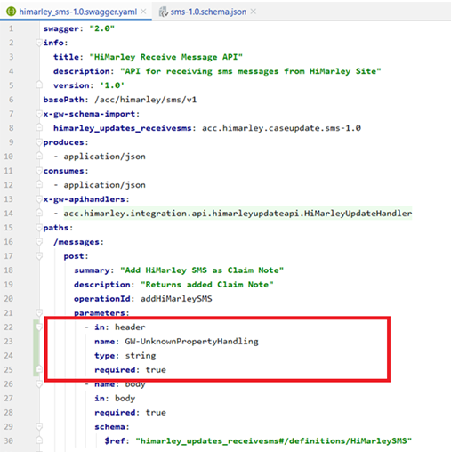
The json schema files were changed. To allow any objects of any type to be sent, the "additional properties" elements must be removed from the scheme. After removing the "additional properties" elements any type of object can be added to the request body.
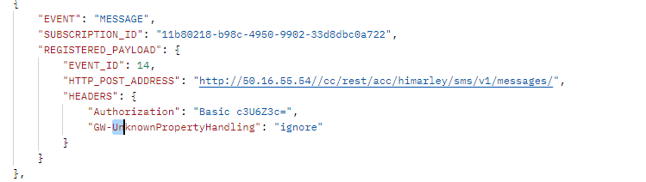

About Guidewire Software
Guidewire delivers the industry platform that Property and Casualty (P&C) insurers rely upon to adapt and succeed in a time of accelerating change. We provide the software, services, and partner ecosystem to enable our customers to run, differentiate, and grow their business. We are privileged to serve more than 350 companies in 32 countries. For more information, please visit www.guidewire.com and follow us on twitter: @Guidewire_PandC.

© 2022 Guidewire Software, Inc. All rights reserved. Guidewire, Guidewire Software, Guidewire ClaimCenter, Guidewire PolicyCenter, Guidewire BillingCenter, Guidewire InsuranceSuite, Guidewire Live, Deliver Insurance Your Way, and the Guidewire logo are trademarks or registered trademarks of Guidewire Software, Inc. in the United States and/or other countries.

